

# Epoka University

**Faculty of Engineering and Architecture Department of Computer Engineering CEN302 – Software Engineering**

TechPlaza Requirements Specification

***Date June 09*, 2023**

***TechPlaza Requirements Specification Version 2.0***

***Date June 09, 2023***

**Prepared by:**

Jon Mukaj

Fabio Marku

Joana Jaupi

Kevin Tenolli

Joni Dajçi

Lorenc Rrapaj

Mateo Tuku

**Received by:**

Msc. Ari Gjerazi

# Executive Summary

### Project Overview

In today's fast-paced digital age, technology is reshaping many facets of our lives, with commerce being one of the most profoundly transformed sectors. The rise of e-commerce is a remarkable testament to this change. Despite the global presence of industry giants like Amazon, there remains a vast potential to innovate and design platforms that cater to the unique needs and preferences of specific markets. In Albania, this opportunity is particularly significant.

Albania, with its growing digital infrastructure and burgeoning online consumer base, presents a fertile ground for e-commerce expansion. However, the current landscape of online shopping in Albania is characterized by limited choices, a lack of personalization, and a demand for more robust security measures.

Existing platforms have indeed simplified shopping by making a plethora of products accessible at a click. However, Albanian consumers are increasingly seeking more than just product availability. They are looking for seamless navigation, personalized shopping experiences, swift checkout processes, robust security, and reliable post-purchase support.

Moreover, numerous Albanian businesses, particularly small and medium-sized enterprises, are yet to tap into the vast potential of online sales channels. These businesses continue to rely on traditional sales methods, missing out on the broad customer base and increased sales that e-commerce offers.

The goal of our project is to build an e-commerce web application tailored specifically for the Albanian market. We aim to create not just a marketplace, but a comprehensive solution that leverages cutting-edge technology to offer an unparalleled user experience, bolsters the growth of Albanian businesses, and promotes the broader adoption of online shopping in the country.

Our vision is to develop a platform that transcends the boundaries of traditional e-commerce in Albania. By integrating advanced technologies, we intend to offer personalized shopping experiences, predict market trends, ensure robust security, and provide a diverse range of products.

***Purpose and Scope of this Specification***

The purpose of this specification is to outline the framework for the development and functionality of an advanced e-commerce web application, designed specifically for the Albanian market. This document serves to provide a comprehensive understanding of the project's scope, objectives, and expected outcomes to all stakeholders, which includes the development team, project managers, potential investors, participating businesses, and intended users.

This e-commerce platform aims to redefine online shopping in Albania, providing a robust platform for businesses of all sizes to expand their reach and offer their products online. Simultaneously, it aspires to present consumers with a broad range of products from various categories, delivering an efficient, secure, and intuitive online shopping experience.

Key features and functionalities of the application will include:

* User-friendly Interface: An intuitive, easy-to-navigate interface that simplifies the shopping process, making it enjoyable and efficient for users of all tech-proficiency levels.
* Extensive Product Catalog: A diverse range of products from various local and international sellers, enabling users to browse and purchase items across numerous categories.
* Secure Payment and Checkout Process: Implementation of robust security measures to ensure that all transactions are secure and that users' personal and financial information is protected.
* Personalized Shopping Experience: Use of advanced technology to provide personalized product recommendations based on users' browsing history, preferences, and previous purchases, enhancing user engagement and satisfaction.
* Seller Dashboard: A comprehensive seller dashboard that allows businesses to manage their product listings, track sales, interact with customers, and analyze performance data.
* Customer Support: A dedicated customer support system to assist users with queries, complaints, and issues, ensuring a satisfying and trustworthy shopping experience.

The scope of this specification covers all aspects of the application, from the user interface and experience to the backend systems, including the database design, security features, and administrative functionalities. It serves as a guiding document throughout the development process, ensuring that the project stays on track and aligns with the intended vision and goals.

***Product/Service Description***

E-commerce has become an integral part of the global retail framework. The rise in digital buyers is a primary factor contributing to this growth, and Albania is no exception. Despite the global growth of e-commerce, the online retail market in Albania has traditionally been a highly centralized system that struggles to meet the digital needs of its citizens.

Online marketplaces play a crucial role in this digital landscape. They are web-based platforms that provide a comprehensive shopping experience for individuals across the country. However, the current state of e-commerce in Albania reveals that the system could be more efficient. One of the main issues that needs an immediate solution is the creation of a localized, user-friendly, and secure online marketplace. Until now, customers have had to rely on international platforms for their online shopping needs, which often lead to longer delivery times and higher shipping costs.

Our proposed solution, TechPlaza, is an innovative platform designed to address this issue. TechPlaza is designed to be a comprehensive online marketplace, with three main actors: sellers, buyers, and administrators. It aims to provide a localized solution for online shopping in Albania, streamlining the process and making it more convenient for both customers and businesses.

The TechPlaza platform is a web application built using cutting-edge technologies like React for the frontend and Express for the backend. React, a JavaScript library developed by Facebook, enables the creation of a dynamic, high-performing user interface. On the other hand, Express is a fast, unopinionated, and minimalist web framework for Node.js, ideal for building robust APIs and web applications.

With this tech stack, TechPlaza aspires to offer a seamless and secure online shopping experience for all users, setting a new standard for e-commerce in Albania.

***Product Context***

TechPlaza is set to operate within the dynamic and rapidly evolving context of e-commerce in Albania. As a digital marketplace, it functions as an intermediary platform that bridges the gap between buyers and sellers of various technology products and services. The platform is poised to cater to a wide audience, ranging from individual consumers looking for the latest tech gadgets to businesses seeking bulk orders of IT equipment. TechPlaza is not just an isolated e-commerce website; it is part of a broader digital ecosystem. This ecosystem includes various stakeholders such as product vendors, delivery service providers, payment gateways, customer service providers, and the users themselves. The platform must interact seamlessly with these entities to ensure a smooth shopping experience.

From the buyer's perspective, TechPlaza is a one-stop shop for their technology needs. They can browse through a wide variety of products, compare prices, read reviews, place orders, track their shipments, and get customer support—all within a single platform. From the seller's perspective, TechPlaza offers a robust platform to list their products, manage inventory, track sales, and engage with customers. It also provides them with a wider audience reach and an opportunity to grow their business.

There are three types of users that will interact with the TechPlaza system:

Buyer:

* Can browse general information about TechPlaza
* Can create an account and log in
* Can view and update personal information
* Can browse products by category or through search
* Can view detailed information about products, including reviews and ratings
* Can add products to a shopping cart and complete purchases • Can track orders and view order history
* Can download order invoices in PDF files
* Can contact sellers or TechPlaza's customer service
* Can leave feedback and reviews for products and sellers
* Can change account password
* Can log out

Seller:

* Can view general information about TechPlaza
* Can create a seller account and log in
* Can view and update personal and business information
* Can list products to sell, including detailed product descriptions, photos, and pricing
* Can manage product inventory and track sales
* Can view buyer queries and respond to them
* Can view feedback and reviews from buyers
* Can handle order fulfilment and provide tracking information
* Can download sales reports and invoice details in PDF files
* Can change account password
* Can log out

Administrator:

* Can view general information about TechPlaza
* Can log in to the admin account • Can view and update personal information
* Can view the list of all buyers and sellers
* Can view and manage product listings across the platform
* Can update, approve, or remove product listings
* Can handle user queries and complaints
* Can monitor user activity and transactions for any suspicious behavior
* Can add or remove privileges for sellers
* Can view and generate sales and user activity reports
* Can change account password
* Can log out

***Assumptions***

* It is assumed that all products listed on the TechPlaza platform are available and can be sold legally in all regions where TechPlaza operates.
* It is assumed that the profile of the seller is initially created by the seller themselves and approved by the TechPlaza administration. If the seller's business information changes, it is their responsibility to update it on the platform.
* It is assumed that while listing a new product or changing its information, the seller should verify all the details, such as the product's description, pricing, and inventory. Therefore, the seller is the only one who can do this. • It is assumed that the administrator is responsible for removing sellers or products from TechPlaza if they violate the platform's terms of service.
* It is assumed that the personal information of the buyer is fully confidential. Apart from the buyer themselves, it can be read only by the TechPlaza administration for administrative and support purposes. Sellers can only access information necessary for order fulfillment and not any other personal data.
* It is assumed that while placing an order, the buyer is the only one responsible for ensuring the accuracy of the order details, such as the shipping address and product quantities. Once an order is confirmed, changes may not be possible depending on the seller's policy.
* It is assumed that sellers and administrators will be trained to use this software, in order not to have any misconceptions. As for the buyers, they should find the interface intuitive and user-friendly, but customer support will be available to assist with any difficulties.
* It is assumed that all the sellers, administrators, and buyers have access to a device connected to the internet, in order to be able to access the TechPlaza platform.
* It is assumed that all transactions on TechPlaza will be conducted in the supported payment methods and currencies, and that all users have access to these payment methods. This includes credit cards, debit cards, and any digital wallets or online banking systems supported by the platform.

***Constraints***

* Every seller and administrator on TechPlaza should have a device with internet access available during their working hours in order to manage their operations on the platform.
* All users of TechPlaza, including buyers, sellers, and administrators, should understand how to use the platform. They should be aware of their capabilities and obligations in order to respect the rights and privacy of other users. Efficient and correct use of the platform will enhance its performance and user experience.
* The project is constrained by the availability and quality of internet connection. As a web application, TechPlaza requires a stable internet connection to function effectively. Internet is needed primarily to fetch data from the database, process transactions, communicate between buyers and sellers, and for other features such as product images and user reviews.
* The availability and functionality of integrated services, such as payment gateways and delivery tracking, is dependent on their respective providers. TechPlaza requires these services to be operational for the smooth functioning of transactions and order fulfillment processes.
* For features like product recommendations and personalized user experience, TechPlaza relies on data analytics and machine learning algorithms, which require substantial computational resources. The performance of these features is therefore constrained by the availability and capacity of these resources.

Given the interconnected nature of the TechPlaza platform, there are some dependencies among various roles and functions:

* No new product can be listed for sale if the vendor is not registered on the system or is not available.
* An existing product cannot be removed from the platform if the vendor is not available or has not granted permission.
* The product description or details cannot be updated if the vendor is not available.
* A customer cannot place an order if the product's vendor is not active or if the product is out of stock.

There also exist dependencies between the customer and the vendor:

* The vendor cannot view the customer profile or order history if they are not connected through a transaction.
* The customer cannot see the latest product updates or changes if the vendor has not updated the product listing.
* A customer cannot make a purchase if there is no vendor assigned to the product listing.

And, between all three roles (the administrator, the vendor, and the customer):

* The vendor cannot add a new product listing if the administrator has not granted them permission.
* The customer cannot complete a purchase if the vendor has not confirmed the product's availability.
* The administrator cannot remove a vendor or customer from the platform without following the established procedures and protocols.

**Requirements**

***Functional Requirements***

|  |  |  |  |  |  |
| --- | --- | --- | --- | --- | --- |
| **Req#** | **Requirement** | **Comments** | **Priority\*** | **Date** | **Reviewed/ Approved** |
| FR_01 | The system shall allow users to create an account using a valid email address. | This is a fundamental requirement for user identification and account management. It helps in providing personalized services to the user. | 1 | 01/04/2023 | Jon Mukaj, Fabio Marku |
| FR_02 | The system shall support password recovery via email for users who have forgotten their passwords. | Password recovery is an essential security feature to ensure that users can regain access to their accounts in case they forget their passwords. | 1 | 01/04/2023 | Kevin Tenolli, Joana Jaupi |
| FR_03 | The system shall allow vendors to list new products with relevant details, such as product name, description, price, and available stock. | This feature is crucial for vendors to manage their product listings effectively. It helps in maintaining an up-to-date catalog on the platform. | 1 | 01/04/2023 | Mateo Tuku, Joni Dajçi |
| FR_04 | The system shall allow vendors to edit or remove their listed products. | Vendors need to be able to control their product listings, including making necessary edits or removing products as required. This requirement facilitates vendor autonomy and flexibility. | 1 | 01/04/2023 | Lorenc Rrapaj, Jon Mukaj |
| FR_05 | The system shall allow customers to search for products using keywords and filter results by various parameters such as price, category, and vendor. | A robust search and filter system enhances the user experience by making it easier to find specific products. This is especially important given the typically large number of products on e-commerce platforms. | 1 | 01/04/2023 | Fabio Marku, Kevin Tenolli |
| FR_06 | The system shall provide a shopping cart feature for customers to add their desired products. | The shopping cart is a key feature of e-commerce platforms. It allows customers to manage their selected products before proceeding to checkout. | 1 | 01/04/2023 | Joana Jaupi, Mateo Tuku |
| FR_07 | The system shall allow customers to place orders and choose their preferred payment method and shipping address. | This is critical for transaction processing. Providing multiple payment methods increases convenience for customers, while allowing customers to specify a shipping address ensures correct product delivery. | 1 | 01/04/2023 | Joni Dajçi, Lorenc Rrapaj |
| FR_08 | The system shall support various payment methods such as credit cards, debit cards, and digital wallets. | By offering multiple payment options, the system caters to a wider range of customers with different preferences and financial capabilities. This can potentially lead to increased sales. | 1 | 01/04/2023 | Jon Mukaj, Joana Jaupi |
| FR_09 | The system shall send a confirmation email to customers upon successful order placement. | Order confirmation emails are essential for reassuring customers that their transaction was successful. They also provide a reference point for any future queries or issues. | 1 | 01/04/2023 | Fabio Marku, Mateo Tuku |
| FR_10 | The system shall allow vendors to view and manage the orders received for their products. | This is crucial for vendors to keep track of their sales, fulfill orders promptly, and manage their inventory effectively. It also facilitates better customer service by keeping vendors informed about their customers' orders. | 1 | 02/04/2023 | Kevin Tenolli, Joni Dajçi |
| FR_11 | The system shall enable vendors to update the status of orders (e.g., processing, shipped, delivered). | This feature allows vendors to communicate progress on orders to customers, improving the transparency of the transaction and enhancing customer experience. | 1 | 02/04/2023 | Joana Jaupi, Lorenc Rrapaj |
| FR_12 | The system shall provide a customer review and rating system for products and vendors. | Reviews and ratings are important for building trust in the platform's products and vendors. They give customers valuable insights into product quality and vendor reliability. | 2 | 02/04/2023 | Mateo Tuku, Jon Mukaj |
| FR_13 | The system shall allow customers to view their order history and track their current orders. | An order history and tracking feature helps customers manage their purchases, anticipate delivery times, and facilitates repeat purchases. | 2 | 02/04/2023 | Joni Dajçi, Fabio Marku |
| FR_14 | The system shall display related or recommended products to customers based on their browsing history. | This feature aids in upselling and cross-selling, potentially increasing sales. It also enhances the customer experience by personalizing their shopping experience. | 2 | 02/04/2023 | Lorenc Rrapaj, Kevin Tenolli |
| FR_15 | The system shall provide an administrative interface for managing users, products, and orders. | An administrative interface is necessary for overseeing and managing the platform's operations. It enables efficient handling of users, products, and orders, ensuring smooth operations. | 1 | 02/04/2023 | Jon Mukaj, Mateo Tuku |
| FR_16 | The system shall include a reporting feature for administrators to monitor sales, user activity, and vendor performance. | A reporting feature allows administrators to monitor the performance of the platform, making informed decisions based on user activity, sales, and vendor performance. | 2 | 02/04/2023 | Fabio Marku, Joni Dajçi |
| FR_17 | The system shall implement security measures to protect user and transaction data. | Security measures are crucial to protect sensitive user and transaction data, fostering trust in the platform. | 1 | 03/04/2023 | Kevin Tenolli, Lorenc Rrapaj |
| FR_18 | The system shall allow customers to request for returns or refunds in compliance with the return policy. | A return or refund feature is important for customer satisfaction and retention. It must comply with the platform's return policy. | 2 | 03/04/2023 | Joana Jaupi, Jon Mukaj |
| FR_19 | The system shall support a 'favorites' or 'wishlist' feature where customers can save products they are interested in but not ready to purchase. | A 'favorites' or 'wishlist' feature enhances the user experience by allowing customers to save products they are interested in but not ready to purchase. | 3 | 03/04/2023 | Mateo Tuku, Fabio Marku |
| FR_20 | The system shall provide customer support features, such as a FAQ section, help articles, and a system for submitting support tickets. | Customer support features are essential to assist users and resolve any issues or inquiries they may have. | 2 | 03/04/2023 | Joni Dajçi, Kevin Tenolli |
| FR_21 | The system shall provide a notification feature to inform customers about order status updates, special offers, and newly listed products. | A notification feature keeps customers informed about their order status and updates on special offers or new products, enhancing the user experience. | 2 | 03/04/2023 | Lorenc Rrapaj, Joana Jaupi |
| FR_22 | The system shall support promotional codes or coupons that customers can apply for discounts on their purchases. | Support for promotional codes or coupons provides an incentive for customers to make purchases, potentially increasing sales. | 3 | 03/04/2023 | Jon Mukaj, Mateo Tuku |
| FR_23 | The system shall facilitate secure messaging between customers and vendors for inquiries about products. | Secure messaging between customers and vendors allows for safe and private communication about product inquiries, improving customer service. | 2 | 03/04/2023 | Fabio Marku, Joni Dajçi |
| FR_24 | The system shall include an option for customers to subscribe to product updates or newsletters from their preferred vendors. | An option for customers to subscribe to updates or newsletters keeps them engaged with their preferred vendors and aware of new product offerings. | 3 | 03/04/2023 | Kevin Tenolli, Lorenc Rrapaj |
| FR_25 | The system shall allow customers to compare similar products by their specifications and prices. | A product comparison feature helps customers make informed purchasing decisions by allowing them to evaluate similar products based on specifications and prices. | 3 | 03/04/2023 | Joana Jaupi, Jon Mukaj |
| FR_26 | The system shall implement an automated inventory management system for vendors to track their product stock levels. | An automated inventory management system helps vendors keep track of their product stock, reducing the risk of overselling or underselling. | 1 | 03/04/2023 | Mateo Tuku, Fabio Marku |
| FR_27 | The system shall provide an option for customers to request for products that are currently out of stock. | An option for customers to request out-of-stock products can help vendors gauge demand for certain items and plan their inventory accordingly. | 3 | 07/04/2023 | Joni Dajçi, Kevin Tenolli |
| FR_28 | The system shall offer multiple shipping options with different costs and delivery times. | Offering multiple shipping options gives customers flexibility in choosing the cost and delivery time that best suit their needs. | 2 | 07/04/2023 | Lorenc Rrapaj, Joana Jaupi |
| FR_29 | The system shall allow vendors to run sales or promotional campaigns on their products. | Allowing vendors to run sales or promotional campaigns can drive sales and attract more customers to their products. | 3 | 07/04/2023 | Jon Mukaj, Mateo Tuku |
| FR_30 | The system shall include a feature for gift purchases, allowing customers to send products to different addresses with gift messages. | A gift purchase feature allows customers to send products to different addresses with gift messages, adding a personal touch to their gifts and enhancing the shopping experience. | 3 | 07/04/2023 | Fabio Marku, Joni Dajçi |

***\* The priority of each requirement are defined based on the specific goals and priorities of the project stakeholders, which in our case are the members of the whole team.***

**Non-Functional Requirements**

**Product Requirements**

**User Interface Requirements**

The user interface for the Techplaza e-commerce app should be compatible with any browser for users to access it from a desktop or mobile device.

The User interface could be grouped into 4 main interfaces:

* **Log In Interface which will contain:**

1. The header bar containing Techplaza logo.
2. In the body, two icons will be displayed, one for customers and another for vendors. These icons will serve as buttons to log in to the system. When the button is pressed, the login form is displayed.
3. The login form contains fields <Username> and <Password>, a reCaptcha to ensure the user is not a robot, and a button <Log In>. When that button is pressed, the information is validated, and the respective interface is shown to the user (customer/vendor), or an error notification indicating a wrong username or password will be shown.

* **Customer Interface which will contain:**

1. The header bar containing Techplaza logo, “Customer <Name> <Surname>” and a menu icon, which when pressed shows all available menus.
2. The “My Profile” menu will allow the customer to see all their personal information and their order history.
3. The “My Orders” menu will show to the customer all the orders they have placed, with an option to track the status of each order.
4. The “My Cart” menu will show all the items that the customer has added to their shopping cart.
5. The “Browse Products” menu will allow the customer to browse the product catalogue, search for specific products, and filter the results based on various criteria.
6. The “Contact Vendor” menu will allow the customer to communicate with the vendors via a secure messaging system integrated within the app. o The “Logout” will terminate the current session and will resend the user to the main page.

* **Vendor Interface which will contain:**

1. The header bar containing Techplaza logo, “Vendor <Name>” and a menu icon, which when pressed shows all available menus.
2. The “Home” menu directs the vendor to a page where they can see their business information, their listed products, and any orders that have been placed for their products.
3. The “My Products” menu will display a list of all the products that the vendor has listed for sale, with options to add, edit, or delete products.
4. The “My Orders” menu will show all the orders that customers have placed for the vendor's products, with options to update the status of each order.
5. The “Statistics” menu will show various statistics related to the vendor's sales, such as total sales, average sales, most popular products, etc.
6. The “Logout” will terminate the current session and will resend the user to the main page.

* **Admin Interface which will contain:**

1. The header bar containing Techplaza logo and “Admin <Name>”, a “Home” button, and a “Logout” button.
2. The main view (“Home”) contains several buttons: “Manage Users”, “Manage Products”, “Manage Orders”, and “View Statistics”.
3. The “Manage Users” button will allow the admin to view and manage all the users of the platform, with options to add, edit, or delete users.
4. The “Manage Products” button will allow the admin to view and manage all the products listed on the platform, with options to add, edit, or delete products.
5. The “Manage Orders” button will allow the admin to view and manage all the orders that have been# There seems to be a cut-off in the response. I'll complete the response from where it got cut-off. placed on the platform, with options to update the status of each order.
6. The “View Statistics” button will show various statistics related to the platform's usage, such as total sales, most popular products, most active vendors, etc. o The “Logout” will terminate the current session and will resend the user to the main page.

**Learnability**

* Techplaza’s staff should be able to master using the system within a few hours of training.
* Customers should find the app intuitive and easy to use without requiring any specific training.
* Online help and FAQs should be available to assist users in understanding how to use the app.
* In case of an error, detailed error messages will guide users on how to rectify the problem.
* Users are responsible for their own actions within the app.

**Accessibility**

* Each user is provided with a username and password when they register on the app.
* The app should be accessible to customers, Techplaza staff, and administrators.
* Registered users can access the app at any time and from any location with internet access.

**Efficiency**

* The app should be able to handle multiple simultaneous transactions swiftly.
* Users should be able to navigate through the app and perform desired operations within a few clicks.

**Memorability**

* The user interface should be intuitive and easy to navigate, allowing users to remember how to perform tasks even if they return after a period of not using the app.

**Errors**

* The app should have mechanisms in place to reduce the error rate, such as validation checks on user inputs.
* Users should be able to easily correct mistakes made during the shopping or checkout process.

**Satisfaction**

* The app should provide a user-friendly and enjoyable shopping experience.

**Capacity**

* The app should be able to handle a large number of concurrent users without performance degradation.
* The app should be designed to handle peak traffic periods, such as during sales or holiday seasons.

**Integration with Azure Cloud Services**

* The app should be deployed as a Docker container on Azure Web App service. GitHub Actions should be set up to automatically update the Docker container image, ensuring that the latest version of the app is always deployed. This allows for continuous integration and deployment, leading to a faster and more efficient development workflow.
* Azure's storage services, like Azure Blob Storage and Azure Queue Storage, should be used to manage the data generated by the app, ensuring that it is stored securely and can be scaled as required​.
* Azure's networking services, like Azure Virtual Network and Azure VPN gateway, should be used to build secure and efficient connections between the app and other services​.
* Azure's AI and machine learning services should be used to provide features such as personalized product recommendations and predictive analytics​​.
* The app should take advantage of Azure's security features to ensure the protection of user data and transactions​.
* Azure's integration services should be used to connect different services and components of the app, ensuring seamless operation​.

**Database Management**

* The app should utilize Azure's PostgreSQL server for managing the database. This will ensure high performance, reliability, and scalability. Azure PostgreSQL server also provides in-built protection with Azure Security Center, which includes threat protection and alerts, thereby ensuring that the data stored is secure and safe.

**Scalability**

* The app should be able to handle a high number of concurrent users without performance degradation. This includes the ability to scale up or down based on user demand, ensuring that the app remains responsive even during peak usage times.

**Compatibility**

* The app should be compatible across different devices and operating systems, ensuring that it can be used by a wide range of customers. It should be responsive and provide a consistent user experience regardless of the device or platform being used.

**Performance**

* The app should load quickly and respond promptly to user interactions. This includes fast load times for pages and quick retrieval of data from the database.

**Usability**

* The app should be easy to use and navigate, with a user-friendly interface and clear instructions. It should also include features that enhance the user experience, such as search functionality, personalized product recommendations, and easy checkout processes.

**Organizational Requirements**

**Availability**

* The Techplaza e-commerce app should be available 24/7 to accommodate the shopping habits of users across different time zones.
* The app should be accessible from any device with internet connectivity, ensuring that users can shop at their convenience from anywhere.
* To maintain a high standard of service, the app must be designed to minimize downtime. Any necessary scheduled maintenance should be performed during off-peak hours to minimize impact on users.
* In the event of unexpected issues, the application should not be down for more than an hour. Prompt response to any service interruptions is critical for maintaining user trust and satisfaction.

**Latency**

* The latency of the e-commerce application will depend on factors such as server performance, internet connectivity, and efficiency of data retrieval processes.
* Efforts should be made to optimize these factors, ensuring a fast and smooth user experience.

**Monitoring**

* The application should include robust monitoring and error reporting mechanisms to quickly identify and rectify any problems.
* Regular reports should be generated to analyze system performance and user behavior, providing insights for potential improvements.
* The system should validate user inputs and transactions to prevent errors and security issues. Clear and helpful error messages should be provided to users when necessary.

**Maintenance**

* The app should be built using modular principles, allowing for easy updates and extensions. New features or modules can be added with minimal disruption to the existing system.
* Regular software updates and bug fixes should be performed to ensure the app remains secure and up-to-date. Users should be informed of any significant updates or maintenance activities.

**Operations**

* Some of the operations that will be provided to the users are:
* Users can create an account, log in, and manage their personal information.
* Users can browse products, add them to a shopping cart, and make purchases.
* Users can view their order history and track the status of their orders.
* Users can write reviews for products they have purchased.
* Users can contact customer service for assistance or to report issues.
* Administrators can manage product listings, process orders, and respond to customer inquiries. Administrators can generate reports on sales, user activity, and other key performance indicators.

**Standards Compliance**

* The application should comply with all relevant laws and regulations related to e-commerce, data protection, and consumer rights.
* The application should also adhere to industry best practices for online retail and customer service.

**Portability**

* The e-commerce app should be compatible with various operating systems and devices, including PCs, smartphones, and tablets. This ensures that users can access the app whether they are at home, at work, or on the go.
* The app should be designed with a responsive layout that adapts to different screen sizes and resolutions for optimal user experience.

**External Requirements**

**Security**

* The Techplaza e-commerce application will handle sensitive user information, including personal details and payment information. As such, ensuring high-level security is a priority. In compliance with applicable laws and regulations, such as the General Data Protection Regulation (GDPR), all personal data should be securely stored and accessible only to authorized personnel.
* All transactional data and communication between the user's device and the servers must be encrypted using strong encryption algorithms.
* Users' passwords will be hashed and stored securely, and the application will never store raw, unhashed passwords.

**Protection**

To safeguard the system from unauthorized access, alteration, disclosure, destruction, or misuse, the following measures will be employed:

* Sensitive information, such as passwords and payment details, will be encrypted.
* A robust logging system will be implemented to track user activities, enabling swift response to any security incidents and holding users accountable for their actions.
* Input validation and sanitization measures will be implemented to prevent SQL injection, cross-site scripting, and other forms of attacks.
* Two-factor authentication (2FA) will be made available for users who wish to enhance their account security.
* Access controls will be strictly enforced. Users can only access their own account details and order history.

**Authorization and Authentication**

The following measures will ensure proper authorization and authentication:

* User authentication will be performed through a combination of username, password, and possibly additional security measures like reCaptcha or 2FA.
* Authorization will be role-based. Regular users can browse products, make purchases, and view their own order history. Administrators have additional privileges to manage product listings, process orders, and perform other administrative tasks.
* Sessions will be used to maintain user state after successful login. If a user enters incorrect login credentials, they will be presented with an appropriate error message.
* All actions that involve changes to user account or order details will require re-authentication to ensure the user is still present and has authorized the action.
* Account lockout policies will be implemented to prevent brute force attacks. After a certain number of failed login attempts, the account will be temporarily locked.

**Data Integrity and Backup**

* The Techplaza e-commerce application will ensure the integrity of data stored in its systems. This includes checks and validations to prevent the insertion of corrupted or inaccurate data into the database.
* Regular backups of the system's data will be performed to safeguard against data loss or damage. Backup procedures will comply with best practices for frequency, storage, and testing of backups.
* In the event of a system failure or data loss incident, a disaster recovery plan will be in place to restore system operations with minimal disruption to users and business processes. The plan will outline procedures for data restoration, communication with users, and identification and rectification of the issue that led to the incident.
* The system will also implement mechanisms for transaction rollbacks, ensuring that in the event of a failed transaction (such as a payment failure), the system state can be reverted to its state before the transaction.
* Users will be given the ability to download or request a copy of their personal data stored by the Techplaza e-commerce application, in compliance with data portability rights under regulations like the GDPR.

**Domain Requirements**

The Techplaza e-commerce application operates in the field of online retail and aims to provide a secure and efficient platform for customers to browse and purchase products. The following domain requirements are applicable to the e-commerce context:

**Product Catalog**

* The application shall maintain a comprehensive and well-organized product catalog with accurate and detailed information.
* Each product listing shall include essential details such as product name, description, price, available stock, and high-quality product images.
* The catalog shall be categorized into relevant product categories and subcategories to facilitate easy navigation and product discovery.
* Product listings shall support additional features such as product variants (e.g., size, color) and customer reviews/ratings.

**Shopping Cart and Checkout**

* The application shall provide a user-friendly shopping cart feature that allows customers to add, remove, and modify products before proceeding to checkout.
* The checkout process shall be streamlined and intuitive, guiding customers through the necessary steps to complete their purchases.
* The application shall support various payment options, including credit cards, debit cards, digital wallets, and other popular payment gateways.
* Customer information entered during the checkout process shall be securely encrypted and protected to ensure data privacy.

**User Accounts and Authentication**

* The application shall require customers to create user accounts or sign in to make purchases, ensuring that only registered users can access certain features and complete transactions.
* User authentication shall be implemented securely, using strong encryption and hashing techniques to protect user credentials.
* The application shall allow customers to securely manage their account information, including profile details, shipping addresses, and payment methods.
* Password reset and recovery mechanisms shall be in place to assist users in regaining access to their accounts in case of forgotten passwords.

**Order Management**

* The application shall provide an efficient order management system for administrators and vendors to track and process customer orders.
* Order statuses shall be clearly defined and updated in real-time, allowing customers to track the progress of their orders.
* Administrators and vendors shall have access to order details, including customer information, products purchased, and shipping information.
* The application shall generate order invoices and receipts for customers, providing them with a record of their purchases.

**Customer Support**

* The application shall offer customer support features, such as a dedicated help center, frequently asked questions (FAQs), and a contact form for inquiries and assistance.
* Customer support inquiries shall be promptly addressed, with timely responses and resolutions provided by the support team.
* The application shall maintain a system for customers to submit and track support tickets, ensuring efficient communication and issue resolution.

**Integration with Third-Party Services**

* The application may integrate with external services, such as payment gateways, shipping providers, and analytics tools, to enhance functionality and improve the customer experience.
* Integration with third-party services shall be seamless and reliable, ensuring smooth data exchange and interoperability between systems.

**Localization and Internationalization**

* The application may support multiple languages, allowing customers from different regions to access and navigate the app in their preferred language.
* Localization features, such as localized currency, date formats, and measurement units, may be implemented to cater to diverse international audiences.
* International shipping options and customs requirements, where applicable, shall be considered to enable seamless cross-border transactions

**Software Design / Diagrams**

**Requirements Analysis**

**User Scenarios**

**User Scenarios List**

|  |  |  |
| --- | --- | --- |
| **Nr** | **Name** | **Description** |
| **US_01** | User Registration | A new user registers on TechPlaza by providing a valid email address and creating a password. |
| **US_02** | Change password | The user changes their password through the account settings option. |
| **US_03** | Vendor Registration | An administrator creates a new vendor account, allowing the vendor to list products on TechPlaza. |
| **US_04** | Adding a New Product | A vendor lists a new product on TechPlaza, filling out the product details and uploading images. |
| **US_05** | Customer Listing | An administrator views all registered customers on TechPlaza. |
| **US_06** | Vendor Listing | An administrator views all registered vendors on TechPlaza. |
| **US_07** | Searching for a Product | A customer searches for a specific product using the search functionality. |
| **US_08** | Searching for a Vendor | A customer or an administrator searches for a specific vendor using the search functionality. |
| **US_09** | Update Vendor Details | An administrator updates the personal and business information of a specific vendor. |
| **US_10** | Update Product Details | A vendor updates the details of a listed product. |
| **US_11** | Deactivate Account | An administrator deactivates an account of a customer or vendor. |
| **US_12** | Add Product to Shopping Cart | A customer adds a product to their shopping cart, marking it for purchase. |
| **US_13** | Customer's Shopping Cart | A customer views the list of products added to their shopping cart. |
| **US_14** | Purchase Products | A customer proceeds to checkout, confirms their shipping address, chooses a payment method, and places an order. |
| **US_15** | Export User Information | An administrator exports user information (a CSV or XML file), for internal use or sharing with partnering platforms. |
| **US_16** | View User Profile | A customer or vendor views their profile, checking their personal and account information. |
| **US_17** | View Order History | Customers view their order history, showing all the products they have purchased from TechPlaza. Vendors view all orders received for their products. |
| **US_18** | Contact Vendor | A customer contacts a vendor for queries about a product or order by completing a form. An email is then sent to the vendor. |
| **US_19** | Download Order Details | Customers, vendors, or administrators can download order details for record-keeping or review. |
| **US_20** | Leave Product Review | A customer leaves a review on a product they have purchased, rating it and writing about their experience. |
| **US_21** | Manage Product Inventory | Vendors manage their product inventory, adjusting stock levels as necessary. |
| **US_22** | Apply Promotional Code | Customers apply a promotional code at checkout for a discount on their purchase. |
| **US_23** | Track Shipment | Customers track the shipment of their purchased products, checking the current status and estimated delivery date. |
| **US_24** | Receive Notifications | Customers receive notifications about updates to their orders, new products, or special offers. |
| **US_25** | Return or Refund Request | Customers initiate a return or refund request for a product they have purchased. |
| **US_26** | Subscribe to Vendor | Customers subscribe to a vendor to receive updates and newsletters about their products. |
| **US_27** | Request Out-of-Stock Product | Customers request for notification when an out-of-stock product becomes available again. |
| **US_28** | Choose Shipping Option | Customers choose a shipping option during checkout based on cost and delivery time. |
| **US_29** | Add to Wishlist | Customers add products they are interested in but not ready to purchase to their wishlist for future reference. |
| **US_30** | Gift Purchase | Customers make a gift purchase, sending products to a different address with a personalized gift message. |
| **US_31** | Bulk Purchase | Customers make a bulk purchase, ordering larger quantities of a product at discounted prices. |
| **US_32** | Vendor Analytics | Vendors access an analytics dashboard to review their product performance, sales trends, and customer behavior. |
| **US_33** | Personalized Product Recommendations | Based on a user's browsing and purchase history, the system generates personalized product recommendations. |
| **US_34** | Customer Loyalty Program | Users participate in a customer loyalty program, earning points for purchases that can be redeemed for discounts or special offers. |
| **US_35** | Payment Methods Management | Customers add, remove or update their payment methods, including credit/debit cards and digital wallets. |
| **US_36** | Address Book Management | Users manage their saved addresses, adding new ones, and setting a default address. |
| **US_37** | Vendor Rating | Customers rate a vendor based on their overall experience with product quality, shipping, and customer service. |
| **US_38** | Live Chat Support | Users utilize the live chat feature to contact customer support for immediate assistance. |
| **US_39** | Email Subscription Management | Users manage their email subscriptions, choosing which types of communications they want to receive from TechPlaza. |
| **US_40** | Pre-Ordering | Customers pre-order products that are not yet available but will be released in the future. |
| **US_41** | Privacy Settings | Users manage their privacy settings, choosing what information they share and how it's used. |
| **US_42** | Report a Problem | Users report a problem with the website or a specific product, contributing to the overall improvement of TechPlaza. |
| **US_43** | Sale Alert | Customers create alerts for sales on their favorite products or brands. |
| **US_44** | Two-Step Verification | For enhanced security, users enable two-step verification on their accounts. |
| **US_45** | View and Respond to Reviews | Vendors view customer reviews on their products and respond to them. |
| **US_46** | Price Comparison | Users utilize a price comparison feature to compare the prices of a product from different vendors. |
| **US_47** | Create and Share Wishlist | Users create a wishlist and share it with others. |
| **US_48** | Setting up Sales/Promotions | Vendors set up sales or promotions on their products, reducing prices for a limited time. |
| **US_49** | Marketplace Blog | Users read blog posts on TechPlaza about new product releases, vendor spotlights, and shopping tips. |
| **US_50** | Manage Notifications | Users manage their notification settings, choosing when and how they receive updates from TechPlaza. |

**User Scenarios Extended**

**US_01 User Registration:**

a. The new user navigates to TechPlaza registration page.

b. User inputs a valid email address.

c. User creates a password.

d. User checks the reCaptcha ‘I am not a robot’.

e. User clicks on the register button.

f. If the data is correct, the user receives a confirmation email to validate their account.

g. If data is not correct, an error message is shown and user repeats the process from step b.

**US_02 Change Password:**

a. User logs in following the steps in US_01.

b. User navigates to the account settings option.

c. User selects the "Change Password" option.

d. User types in their old password and the new password twice for confirmation.

e. User presses the "Save Changes" button.

f. If the old password is correct and the new passwords match, the user sees an alert: "Password was changed successfully!"

g. If the old password is incorrect or the new passwords do not match, the user sees an alert: "Password change unsuccessful. Please try again."

**US_03 Vendor Registration:**

a. Administrator logs into TechPlaza.

b. Administrator navigates to vendor registration page.

c. Administrator fills out required fields including company name, company description, and vendor contact information.

d. Administrator checks the reCaptcha 'I am not a robot'.

e. Administrator submits the form to create the new vendor account.

f. If the data is correct, a confirmation email is sent to the vendor for account activation.

g. If the data is incorrect, an error message is shown, and the administrator repeats the process from step c.

**US_04 Adding a New Product:**

a. Vendor logs into their account on TechPlaza.

b. Vendor navigates to the "Add New Product" section.

c. Vendor fills out the product details including product name, description, price, and category.

d. Vendor uploads images for the product.

e. Vendor clicks on the "Submit" button to list the product.

f. If all data and images are uploaded successfully, a confirmation message appears: "Product listed successfully!"

g. If there is an error with the data or images, an error message appears, and the vendor needs to repeat the process from step c.

**US_05 Customer Listing:**

a. Administrator logs into their account on TechPlaza.

b. Administrator navigates to the "Customers" section.

c. Administrator clicks on the "View All Customers" button to display the list of registered customers.

d. If the list loads successfully, the administrator can see all registered customers on TechPlaza.

e. If the list does not load successfully, an error message appears, and the administrator may need to refresh the page or try again later.

**US_06 Vendor Listing:**

a. Administrator logs into their account on TechPlaza.

b. Administrator navigates to the "Vendors" section.

c. Administrator clicks on the "View All Vendors" button to display the list of registered vendors.

d. If the list loads successfully, the administrator can see all registered vendors on TechPlaza.

e. If the list does not load successfully, an error message appears, and the administrator may need to refresh the page or try again later.

**US_07 Searching for a Product:**

a. User logs into their account on TechPlaza.

b. User navigates to the search bar on the top of the page.

c. User types in the specific product they are searching for.

d. User presses enter or clicks on the search button.

e. If the search is successful, the page displays a list of products that match the search criteria.

f. If the search does not yield any results, a message appears stating "No products match your search."

**US_08 Searching for a Vendor:**

a. User (customer or administrator) logs into their account on TechPlaza.

b. User navigates to the vendor search bar or vendor section.

c. User types in the specific vendor they are searching for.

d. User presses enter or clicks on the search button.

e. If the search is successful, the page displays a list of vendors that match the search criteria.

f. If the search does not yield any results, a message appears stating "No vendors match your search."

**US_09 Update Vendor Details:**

a. Administrator logs into their account on TechPlaza.

b. Administrator navigates to the specific vendor's profile page.

c. Administrator clicks on the "Update Vendor Details" button.

d. Administrator edits the necessary personal and business information.

e. Administrator clicks on the "Save Changes" button.

f. If the changes are saved successfully, a confirmation message appears: "Vendor details updated successfully!"

g. If there is an error in saving the changes, an error message appears, and the administrator needs to repeat the process from step d.

**US_10 Update Product Details:**

a. Vendor logs into their account on TechPlaza.

b. Vendor navigates to their product listings.

c. Vendor selects the product they wish to update.

d. Vendor clicks on the "Edit Product" button.

e. Vendor updates the product details as necessary.

f. Vendor clicks on the "Save Changes" button.

g. If the changes are saved successfully, a confirmation message appears: "Product details updated successfully!"

h. If there is an error in saving the changes, an error message appears, and the vendor needs to repeat the process from step e.

**US_11 Deactivate Account:**

a. Administrator logs into their account on TechPlaza.

b. Administrator navigates to the user's profile (customer or vendor) they wish to deactivate.

c. Administrator clicks on the "Deactivate Account" button.

d. Administrator confirms the deactivation in the dialog box that appears.

e. If the account is deactivated successfully, a confirmation message appears: "Account deactivated successfully!"

f. If there is an error in deactivating the account, an error message appears, and the administrator needs to repeat the process from step c.

**US_12 Add Product to Shopping Cart:**

a. Customer logs into their account on TechPlaza.

b. Customer browses for products.

c. Customer clicks on the product they wish to purchase.

d. Customer clicks on the "Add to Cart" button on the product page.

e. If the product is added successfully to the shopping cart, a confirmation message appears: "Product added to your cart!"

f. If there is an error in adding the product to the shopping cart, an error message appears, and the customer needs to repeat the process from step c.

**US_13 Customer's Shopping Cart:**

a. Customer logs into their account on TechPlaza.

b. Customer navigates to the "Shopping Cart" section.

c. Customer views the list of products added to their shopping cart.

d. If the customer wishes to change the quantity or remove any product, they adjust accordingly.

e. Customer clicks on the "Update Cart" button to save changes.

f. If the changes are saved successfully, a confirmation message appears: "Cart updated successfully!"

g. If there is an error in saving the changes, an error message appears, and the customer needs to repeat the process from step d.

**US_14 Purchase Products:**

a. Customer logs into their account on TechPlaza.

b. Customer navigates to the "Shopping Cart" section.

c. Customer clicks on the "Proceed to Checkout" button.

d. Customer confirms their shipping address and chooses a payment method.

e. Customer reviews their order and clicks on the "Place Order" button.

f. If the order is placed successfully, a confirmation message appears along with the order details.

g. If there is an error in placing the order, an error message appears, and the customer needs to repeat the process from step c.

**US_15 Export User Information:**

a. Administrator logs into their account on TechPlaza.

b. Administrator navigates to the "Users" section.

c. Administrator selects the user information they wish to export.

d. Administrator clicks on the "Export" button and chooses the desired format (CSV or XML).

e. If the information is exported successfully, a confirmation message appears: "User information exported successfully!"

f. If there is an error in exporting the information, an error message appears, and the administrator needs to repeat the process from step c.

**US_16 View User Profile:**

a. User (customer/vendor) logs into their account on TechPlaza.

b. User navigates to the "My Profile" section.

c. User checks their personal and account information.

d. If the user wishes to update any information, they can do so by clicking on the "Edit Profile" button.

**US_17 View Order History:**

a. User (customer/vendor) logs into their account on TechPlaza.

b. User navigates to the "Order History" section.

c. User views their order history, showing all the products they have purchased from (or sold on) TechPlaza.

d. If the user wishes to view more details of a particular order, they can do so by clicking on the order number.

**US_18 Contact Vendor:**

a. Customer logs into their account on TechPlaza.

b. Customer navigates to the desired product page or vendor profile.

c. Customer clicks on the "Contact Vendor" button or link.

d. Customer completes the contact form, entering their query about a product or order.

e. Customer clicks the "Submit" button to send the query.

f. If the query is sent successfully, a confirmation message appears: "Your message has been sent to the vendor!"

g. If there is an error in sending the query, an error message appears, and the customer needs to repeat the process from step d.

**US_19 Download Order Details:**

a. User (customer/vendor/administrator) logs into their account on TechPlaza.

b. User navigates to the "Order History" or "Orders" section.

c. User selects the order for which they want to download details.

d. User clicks on the "Download Order Details" button.

e. If the order details are downloaded successfully, a confirmation message appears: "Order details downloaded successfully!"

f. If there is an error in downloading the details, an error message appears, and the user needs to repeat the process from step c.

**US_20 Leave Product Review:**

a. Customer logs into their account on TechPlaza.

b. Customer navigates to the page of a product they have purchased.

c. Customer clicks on the "Leave a Review" button or link.

d. Customer rates the product and writes about their experience in the provided text box.

e. Customer clicks the "Submit" button to post the review.

f. If the review is posted successfully, a confirmation message appears: "Your review has been posted!"

g. If there is an error in posting the review, an error message appears, and the customer needs to repeat the process from step d.

**US_21 Manage Product Inventory:**

a. Vendor logs into their account on TechPlaza.

b. Vendor navigates to the "Product Inventory" section.

c. Vendor views their listed products and their current stock levels.

d. Vendor adjusts the stock levels as necessary and clicks the "Save Changes" button.

e. If the changes are saved successfully, a confirmation message appears: "Inventory updated successfully!"

f. If there is an error in saving the changes, an error message appears, and the vendor needs to repeat the process from step d.

**US_22 Apply Promotional Code:**

a. Customer logs into their account on TechPlaza.

b. Customer adds products to their cart and proceeds to the checkout page.

c. Customer enters their promotional code in the provided field and clicks the "Apply" button.

d. If the code is valid and applied successfully, a confirmation message appears: "Promotional code applied successfully!"

e. If the code is not valid or there's an error, an error message appears, and the customer needs to try again.

**US_23 Track Shipment:**

a. Customer logs into their account on TechPlaza.

b. Customer navigates to the "Order History" section.

c. Customer selects the order for which they want to track the shipment.

d. Customer clicks on the "Track Shipment" button or link.

e. Customer views the current status and estimated delivery date of their shipment.

f. If there is an error in retrieving the shipment details, an error message appears, and the customer needs to repeat the process from step c.

**US_24 Receive Notifications:**

a. Customer logs into their account on TechPlaza.

b. Customer navigates to the "Notifications" section or checks their linked email for notifications from TechPlaza.

c. Customer views notifications about updates to their orders, new products, or special offers.

d. If there is an issue with the notifications system, an error message appears, and the customer should contact TechPlaza support.

**US_25 Return or Refund Request:**

a. Customer logs into their account on TechPlaza.

b. Customer navigates to the "Order History" section.

c. Customer selects the order for which they want to initiate a return or refund request.

d. Customer clicks on the "Request Return/Refund" button or link and fills out the necessary form.

e. If the request is sent successfully, a confirmation message appears: "Your return/refund request has been sent!"

f. If there is an error in sending the request, an error message appears, and the customer needs to repeat the process from step d.

**US_26 Subscribe to Vendor:**

a. Customer logs into their account on TechPlaza.

b. Customer navigates to the desired vendor's profile.

c. Customer clicks on the "Subscribe" button or link.

d. If the subscription is successful, a confirmation message appears: "You have subscribed to the vendor!"

e. If there is an error in the subscription process, an error message appears, and the customer needs to repeat the process from step c.

**US_27 Request Out-of-Stock Product:**

a. Customer logs into their account on TechPlaza.

b. Customer navigates to the page of an out-of-stock product.

c. Customer clicks on the "Notify Me" button or link.

d. If the notification request is successful, a confirmation message appears: "You will be notified when this product becomes available again!"

e. If there is an error in the notification process, an error message appears, and the customer needs to repeat the process from step c.

**US_28 Choose Shipping Option:**

a. Customer logs into their account on TechPlaza.

b. Customer adds desired products to their shopping cart.

c. Customer navigates to the "Checkout" page.

d. Customer reviews their order and proceeds to the "Shipping Options" section.

e. Customer selects a shipping option based on cost and delivery time.

f. If the selection is successful, the customer proceeds to the payment stage.

g. If there is an error during selection, an error message is shown and the customer repeats the process from step e.

**US_29 Add to Wishlist:**

a. Customer logs into their account on TechPlaza.

b. Customer browses the product catalogue.

c. Customer selects a product they are interested in but not ready to purchase.

d. Customer clicks on the "Add to Wishlist" button or link.

e. If the product is successfully added, a confirmation message appears: "Product added to your Wishlist!"

f. If there is an error in adding the product to the Wishlist, an error message appears, and the customer needs to repeat the process from step d.

**US_30 Gift Purchase:**

a. Customer logs into their account on TechPlaza.

b. Customer adds desired products to their shopping cart.

c. Customer navigates to the "Checkout" page.

d. Customer selects the "Gift Purchase" option and fills out the recipient's address and a personalized gift message.

e. Customer reviews their order and proceeds to the payment stage.

f. If the gift purchase is successful, a confirmation message appears: "Your gift purchase is successful!"

g. If there is an error during the gift purchase process, an error message is shown, and the customer repeats the process from step d.

**US_31 Bulk Purchase**

a. Customer navigates to the product they want to buy in bulk.

b. Customer adjusts the quantity to a bulk amount.

c. The website updates the price to reflect the bulk discount, if applicable.

d. Customer adds the bulk product to their shopping cart and proceeds to checkout.

e. If the order is successful, a confirmation message is displayed; if not, an error message appears and the user is advised to try again.

**US_32 Vendor Analytics**

a. The vendor logs into their account.

b. The vendor navigates to their analytics dashboard.

c. The vendor views data about product performance, sales trends, and customer behavior.

d. The vendor can filter and sort this data based on various parameters.

e. If the vendor wants to save or print this data, they can export it to a CSV or PDF file.

**US_33 Personalized Product Recommendations**

a. User logs into their account.

b. As the user browses products and makes purchases, the system collects this data.

c. The system generates personalized product recommendations based on this data.

d. These recommendations are displayed on the user's homepage or suggested to them in emails.

e. The user can click on these recommendations to view the products and potentially make a purchase.

**US_34 Customer Loyalty Program**

a. User logs into their account.

b. User navigates to the customer loyalty program page and enrolls in the program.

c. As the user makes purchases, they earn points based on the amount spent.

d. User can view their points balance on their account page.

e. User can redeem these points for discounts or special offers during checkout.

**US_35 Payment Methods Management**

a. Customer logs into their account.

b. Customer navigates to their account settings and selects the 'Payment Methods' option.

c. Customer can view their saved payment methods, add a new payment method, remove an existing one, or update the details of an existing one.

d. If the changes are successful, the customer receives a confirmation message; if not, an error message is displayed and the customer is asked to try again.

**US_36 Address Book Management**

a. User logs into their account.

b. User navigates to their account settings and selects the 'Address Book' option.

c. User can view their saved addresses, add a new address, remove an existing one, or update the details of an existing one.

d. User can also set one of the addresses as their default shipping address.

e. If the changes are successful, the user receives a confirmation message; if not, an error message is displayed and the user is asked to try again.

**US_37 Vendor Rating**

a. Customer logs into their account.

b. After a purchase or interaction with a vendor, the customer navigates to the vendor's page.

c. Customer selects the option to rate the vendor.

d. Customer provides a rating based on their experience with product quality, shipping, and customer service.

e. If the rating is submitted successfully, a confirmation message is displayed; if not, an error message appears and the customer is advised to try again.

**US_38 Live Chat Support**

a. User visits the TechPlaza website and selects the 'Live Chat Support' option.

b. User enters their query or issue in the live chat box.

c. A customer support representative responds to the user's query in real time.

d. User can end the chat at any time, and if desired, can request a transcript of the chat for their records.

**US_39 Email Subscription Management**

a. User logs into their account.

b. User navigates to their account settings and selects the 'Email Subscriptions' option.

c. User can view their current subscriptions and change their preferences, choosing which types of communications they wish to receive from TechPlaza.

d. If the changes are successful, the user receives a confirmation message; if not, an error message is displayed and the user is asked to try again.

**US_40 Pre-Ordering**

a. Customer logs into their account.

b. Customer navigates to a product that is not yet available but can be pre-ordered.

c. Customer adds the product to their shopping cart and proceeds to checkout.

d. During checkout, the customer is reminded that the product is a pre-order and will be shipped when it becomes available.

e. If the pre-order is successful, a confirmation message is displayed; if not, an error message appears and the customer is advised to try again.

**US_41 Privacy Settings Management**

a. User logs into their account.

b. User navigates to their account settings and selects the 'Privacy Settings' option.

c. User can view their current privacy settings and change them as needed, choosing what information they share and how it's used.

d. If changes are successful, the user receives a confirmation message; if not, an error message is displayed and the user is asked to try again.

**US_42 Report a Problem**

a. User logs into their account or as a visitor identifies a problem with the website or a specific product.

b. User navigates to the 'Report a Problem' option and describes the issue in detail.

c. User submits the report for review by the TechPlaza team.

d. If the report is submitted successfully, a confirmation message is displayed; if not, an error message appears and the user is advised to try again.

**US_43 Sale Alert**

a. Customer logs into their account.

b. Customer navigates to a product or brand they're interested in and selects the 'Create Sale Alert' option.

c. Customer confirms the creation of the alert.

d. When the product or brand goes on sale, the customer receives an alert via their chosen notification method.

e. If the alert creation is successful, a confirmation message is displayed; if not, an error message appears and the customer is advised to try again.

**US_44 Two-Step Verification**

a. User logs into their account.

b. User navigates to their account settings and selects the 'Security' option.

c. User enables two-step verification and sets up a second verification method, such as a mobile phone number or backup email.

d. If the setup is successful, the user receives a confirmation message; if not, an error message is displayed and the user is asked to try again.

**US_45 View and Respond to Reviews**

a. Vendor logs into their account.

b. Vendor navigates to their product page and views customer reviews.

c. Vendor selects a review to respond to and writes a reply.

d. If the reply is posted successfully, a confirmation message is displayed; if not, an error message appears and the vendor is advised to try again.

**US_46 Price Comparison**

a. User searches for a specific product on TechPlaza.

b. User selects the product of interest.

c. User clicks on the "Compare Prices" button.

d. A list of different vendors offering the same product along with their prices is displayed.

e. User can compare prices and make an informed decision on which vendor to choose.

**US_47 Create and Share Wishlist**

a. User logs into their account.

b. User browses through products on TechPlaza and selects the ones they are interested in.

c. User adds selected products to their wishlist.

d. User can view and manage their wishlist, including adding or removing items.

e. User has the option to share their wishlist with others via email, social media, or a unique link.

**US_48 Setting up Sales/Promotions**

a. Vendor logs into their account.

b. Vendor selects the "Sales/Promotions" option from their dashboard.

c. Vendor enters the details of the sale or promotion, including the discounted price, duration, and any specific conditions.

d. Vendor applies the sale or promotion to the selected products.

e. The discounted prices are updated on the product listings, and customers can see the sale or promotion information.

**US_49 Marketplace Blog**

a. User visits the TechPlaza website.

b. User navigates to the "Blog" section.

c. User can browse through various blog posts about new product releases, vendor spotlights, shopping tips, and other related content.

d. User can read and engage with the blog posts by leaving comments or sharing them on social media.

e. User can subscribe to the blog to receive updates when new posts are published.

**US_50 Manage Notifications**

a. User logs into their account.

b. User goes to the account settings and selects the "Notifications" option.

c. User can customize their notification preferences, choosing the types of notifications they want to receive (e.g., order updates, promotions, product recommendations).

d. User can select their preferred notification channels, such as email, SMS, or push notifications.

e. User can save the changes to update their notification settings.

**User Cases**

|  |  |
| --- | --- |
| Name | User Registration |
| Summary | New user registers on the TechPlaza website. |
| Actor | New User |
| Description | User gains access on his account after typing his  correct username and password. |
| Precondition | New user navigates to the registration page, inputs valid email address, creates password, verifies Captcha, and clicks register. If successful, they receive a confirmation email to validate their account. |
| Alternatives | User can choose to not register at this time and browse the site as a guest. |
| Post Condition | User is registered and can now log into their account. |

***UC_01 – US_01 -*** User Registration

|  |  |
| --- | --- |
| Name | Change Password |
| Summary | User changes their account password. |
| Actor | User |
| Description | User logs in, navigates to account settings, selects "Change Password", inputs old and new password, and clicks save. If successful, they receive an alert confirming the change. |
| Precondition | User must have an active account and know their existing password. |
| Alternatives | User can choose to not change their password at this time. |
| Post Condition | User's account password is updated. |

***UC_02 – US_02 -*** Change Password

|  |  |
| --- | --- |
| Name | Vendor Registration |
| Summary | Administrator registers a new vendor on TechPlaza. |
| Actor | Administrator |
| Description | Administrator logs in, navigates to vendor registration page, fills out required fields, verifies reCaptcha, and submits form. If successful, a confirmation email is sent to the vendor. |
| Precondition | Administrator must have an active account and vendor information must not already exist in the system. |
| Alternatives | Administrator can choose to not register a new vendor at this time. |
| Post Condition | Vendor is registered and can now log into their account. |

***UC_03 – US_03 -*** Vendor Registration

|  |  |
| --- | --- |
| Name | Adding a New Product |
| Summary | Vendor adds a new product to TechPlaza. |
| Actor | Vendor |
| Description | Vendor logs in, navigates to the "Add New Product" section, fills out product details, uploads images, and submits the listing. If successful, they receive a confirmation message. |
| Precondition | Vendor must have an active account and must provide valid product details and images. |
| Alternatives | Vendor can choose to not add a new product at this time. |
| Post Condition | Product is listed on TechPlaza. |

***UC_04 – US_04 -*** Adding a New Product

|  |  |
| --- | --- |
| Name | Customer Listing |
| Summary | Administrator views a list of registered customers. |
| Actor | Administrator |
| Description | Administrator logs in, navigates to the "Customers" section, and views all registered customers. |
| Precondition | Administrator must have an active account |
| Alternatives | Administrator can choose to view individual customer profiles instead of the full list. |
| Post Condition | Administrator has viewed the list of registered customers. |

***UC_05 – US_05 -*** Customer Listing

|  |  |
| --- | --- |
| Name | Vendor Listing |
| Summary | Administrator views a list of registered vendors. |
| Actor | Administrator |
| Description | Administrator logs in, navigates to the "Vendors" section, and views all registered vendors. |
| Precondition | Administrator must have an active account. |
| Alternatives | Administrator can choose to view individual vendor profiles instead of the full list. |
| Post Condition | Administrator has viewed the list of registered vendors. |

***UC_06 – US_06 -*** Vendor Listing

|  |  |
| --- | --- |
| Name | Searching for a Product |
| Summary | User searches for a specific product on TechPlaza. |
| Actor | User |
| Description | User logs in, navigates to the search bar, types in a specific product, and presses enter or clicks on the search button. If successful, a list of matching products is displayed. |
| Precondition | User must have an active account. |
| Alternatives | User can browse products by category instead of searching. |
| Post Condition | User has viewed a list of products that match their search criteria. |

***UC_07 – US_07 -*** Searching for a Product

|  |  |
| --- | --- |
| Name | Searching for a Vendor |
| Summary | User searches for a specific vendor on TechPlaza. |
| Actor | User (customer or administrator) |
| Description | User logs in, navigates to the vendor search bar or vendor section, types in a specific vendor, and presses enter or clicks on the search button. If successful, a list of matching vendors is displayed. |
| Precondition | User must have an active account. |
| Alternatives | User can browse vendors by category instead of searching. |
| Post Condition | User has viewed a list of vendors that match their search criteria. |

***UC_08 – US_08 -*** Searching for a Vendor

|  |  |
| --- | --- |
| Name | Update Vendor Details |
| Summary | Administrator updates a vendor's details. |
| Actor | Administrator |
| Description | Administrator logs in, navigates to a specific vendor's profile page, clicks on "Update Vendor Details", edits necessary information, and clicks "Save Changes". If successful, a confirmation message is displayed. |
| Precondition | Administrator must have an active account and access to edit vendor profiles. |
| Alternatives | Administrator can choose to not update vendor details at this time. |
| Post Condition | Vendor's details have been updated. |

***UC_09 – US_09 -*** Update Vendor Details

|  |  |
| --- | --- |
| Name | Update Product Details |
| Summary | Vendor updates their product's details. |
| Actor | Vendor |
| Description | Vendor logs in, navigates to their product listings, selects a product to update, clicks on "Edit Product", updates product details, and clicks "Save Changes". If successful, a confirmation message is displayed. |
| Precondition | Vendor must have an active account |
| Alternatives | Vendor can choose to not update product details at this time. |
| Post Condition | Product details have been updated. |

***UC_10 – US_10 -*** Update Product Details

|  |  |
| --- | --- |
| Name | Deactivate Account |
| Summary | Administrator deactivates a user's account. |
| Actor | Administrator |
| Description | Administrator logs in, navigates to a user's profile they wish to deactivate, clicks on "Deactivate Account", and confirms the deactivation. If successful, a confirmation message is displayed. |
| Precondition | Administrator must have an active account and permission to deactivate user accounts. |
| Alternatives | Administrator can choose to not deactivate the account at this time. |
| Post Condition | The user's account has been deactivated. |

***UC_11 – US_11 -*** Deactivate Account

|  |  |
| --- | --- |
| Name | Add Product to Shopping Cart |
| Summary | Customer adds a product to their shopping cart. |
| Actor | Customer |
| Description | Customer logs in, browses for products, selects a product, and clicks "Add to Cart". If successful, a confirmation message is displayed. |
| Precondition | Customer must have an active account. |
| Alternatives | Customer can choose to not add the product to the cart at this time. |
| Post Condition | The product has been added to the customer's shopping cart. |

***UC_12 – US_12 -*** Add Product to Shopping Cart

|  |  |
| --- | --- |
| Name | Customer's Shopping Cart |
| Summary | Customer views and manages their shopping cart. |
| Actor | Customer |
| Description | Customer logs in, navigates to the "Shopping Cart" section, views their products, changes quantities or removes products, and clicks "Update Cart". If successful, a confirmation message is displayed. |
| Precondition | Customer must have an active account and at least one product in their cart. |
| Alternatives | Customer can choose to not update their cart at this time. |
| Post Condition | The customer's cart has been updated. |

***UC_13 – US_13 -*** Customer's Shopping Cart

|  |  |
| --- | --- |
| Name | Purchase Products |
| Summary | Customer purchases products from their shopping cart. |
| Actor | Customer |
| Description | Customer logs in, navigates to the "Shopping Cart" section, clicks "Proceed to Checkout", confirms their shipping address, chooses a payment method, reviews their order, and clicks "Place Order". If successful, a confirmation message is displayed. |
| Precondition | Customer must have an active account and at least one product in their cart. |
| Alternatives | Customer can choose to not proceed to checkout at this time. |
| Post Condition | The customer's order has been placed. |

***UC_14 – US_14 -*** Purchase Products

|  |  |
| --- | --- |
| Name | Export User Information |
| Summary | Administrator exports user information. |
| Actor | Administrator |
| Description | Administrator logs in, navigates to the "Users" section, selects the user information to export, clicks "Export", and chooses the desired format. If successful, a confirmation message is displayed. |
| Precondition | Administrator must have an active account and permission to export user data. |
| Alternatives | Administrator can choose to not export user information at this time. |
| Post Condition | The selected user information has been exported. |

***UC_15 – US_15 -*** Export User Information

|  |  |
| --- | --- |
| Name | View User Profile |
| Summary | User views and optionally edits their profile information. |
| Actor | Customer / Vendor |
| Description | User logs in, navigates to "My Profile", views their personal and account information. If needed, they edit their information by clicking "Edit Profile". |
| Precondition | User must have an active account. |
| Alternatives | Customer can choose to not proceed to checkout at this time. |
| Post Condition | User has viewed their profile and possibly updated their profile information. |

***UC_16 – US_16 -*** View User Profile

|  |  |
| --- | --- |
| Name | View Order History |
| Summary | Administrator exports user information. |
| Actor | Administrator |
| Description | Administrator logs in, navigates to the "Users" section, selects the user information to export, clicks "Export", and chooses the desired format. If successful, a confirmation message is displayed. |
| Precondition | Administrator must have an active account and permission to export user data. |
| Alternatives | Administrator can choose to not export user information at this time. |
| Post Condition | The selected user information has been exported. |

***UC_17 – US_17 -*** View Order History

|  |  |
| --- | --- |
| Name | Contact Vendor |
| Summary | Customer contacts a vendor about a product or order. |
| Actor | Customer |
| Description | Customer logs in, navigates to a product page or vendor profile, clicks "Contact Vendor", fills out a contact form, and submits the form. If successful, a confirmation message is displayed. |
| Precondition | Customer must have an active account. |
| Alternatives | Customer can choose to not send the message at this time. |
| Post Condition | The vendor has been contacted about the customer's message. |

***UC_18 – US_18 -*** Contact Vendor

|  |  |
| --- | --- |
| Name | Download Order Details |
| Summary | User downloads the details of a specific order. |
| Actor | Customer / Vendor / Administrator |
| Description | User logs in, navigates to "Order History" or "Orders", selects an order, and clicks "Download Order Details". If successful, a confirmation message is displayed. |
| Precondition | User must have an active account and permission to download order details. |
| Alternatives | User can choose to not download order details at this time. |
| Post Condition | The details of the selected order have been downloaded. |

***UC_19 – US_19 -*** Download Order Details

|  |  |
| --- | --- |
| Name | Leave Product Review |
| Summary | Customer leaves a review for a product they have purchased. |
| Actor | Customer |
| Description | Customer logs in, navigates to the product page, clicks "Leave a Review", rates the product, writes a review, and submits the review. If successful, a confirmation message is displayed. |
| Precondition | Customer must have an active account and have purchased the product they are reviewing. |
| Alternatives | Customer can choose to not submit the review at this time. |
| Post Condition | The customer's review has been posted. |

***UC_20 – US_20 -*** Leave Product Review

|  |  |
| --- | --- |
| Name | Manage Product Inventory |
| Summary | Vendor manages their product inventory on TechPlaza. |
| Actor | Vendor |
| Description | Vendor logs in, navigates to the "Product Inventory", views their listed products and stock levels. They adjust stock levels as necessary and save changes. |
| Precondition | Vendor must have an active account. |
| Alternatives | Vendor can choose to not manage the inventory at this time |
| Post Condition | Vendor has managed their product inventory. |

***UC_21 – US_21 -*** Manage Product Inventory

|  |  |
| --- | --- |
| Name | Apply Promotional Code |
| Summary | Customer applies a promotional code during checkout. |
| Actor | Customer |
| Description | Customer logs in, adds products to their cart, proceeds to checkout, enters a promotional code and applies it. |
| Precondition | Customer must have an active account and a valid promotional code. |
| Alternatives | Customer can choose to not apply the promotional code at this time |
| Post Condition | The promotional code has been applied to the customer's order. |

***UC_22 – US_22 -*** Apply Promotional Code

|  |  |
| --- | --- |
| Name | Track Shipment |
| Summary | Customer tracks the shipment of an order. |
| Actor | Customer |
| Description | Customer logs in, navigates to "Order History", selects an order, and tracks the shipment. |
| Precondition | Customer must have an active account and at least one shipped order. |
| Alternatives | Customer can choose to not track shipment at this time |
| Post Condition | The customer has tracked their shipment. |

***UC_23 – US_23 -*** Track Shipment

|  |  |
| --- | --- |
| Name | Receive Notifications |
| Summary | Customer receives notifications from TechPlaza. |
| Actor | Customer |
| Description | Customer logs in, navigates to the "Notifications" section or checks their linked email for notifications from TechPlaza. |
| Precondition | Customer must have an active account. |
| Alternatives | Customer can choose to not view their notification at this time |
| Post Condition | The customer has viewed their notifications. |

***UC_24 – US_24 -*** Receive Notifications

|  |  |
| --- | --- |
| Name | Return or Refund Request |
| Summary | Customer initiates a return or refund request for an order. |
| Actor | Customer |
| Description | Customer logs in, navigates to "Order History", selects an order, and requests a return or refund. |
| Precondition | Customer must have an active account and at least one previous order. |
| Alternatives | Customer can choose to not make refund request at this time |
| Post Condition | The customer has initiated a return or refund request. |

***UC_25 – US_25 -*** Return or Refund Request

|  |  |
| --- | --- |
| Name | Subscribe to Vendor |
| Summary | Customer subscribes to a vendor. |
| Actor | Customer |
| Description | Customer logs in, navigates to a vendor's profile, and subscribes to the vendor. |
| Precondition | Customer must have an active account. |
| Alternatives | Customer can choose to not subscribe to a vendor at this time |
| Post Condition | The customer has subscribed to the vendor. |

***UC_26 – US_26 -*** Subscribe to Vendor

|  |  |
| --- | --- |
| Name | Request Out-of-Stock Product |
| Summary | Customer requests notification for an out-of-stock product. |
| Actor | Customer |
| Description | Customer logs in, navigates to an out-of-stock product, and requests a notification for when it becomes available again. |
| Precondition | Customer must have an active account. |
| Alternatives | Customer can choose to not make request of Out-of-Stock Product at this time |
| Post Condition | The customer will be notified when the product becomes available. |

***UC_27 – US_27 -*** Request Out-of-Stock Product

|  |  |
| --- | --- |
| Name | Choose Shipping Option |
| Summary | Customer chooses a shipping option during checkout. |
| Actor | Customer |
| Description | Customer logs in, adds products to their cart, navigates to checkout, and chooses a shipping option. |
| Precondition | Customer must have an active account and items in their shopping cart. |
| Alternatives | Customer can choose to not choose shipping option at this time |
| Post Condition | The customer has chosen a shipping option. |

***UC_28 – US_28 -*** Choose Shipping Option

|  |  |
| --- | --- |
| Name | Add to Wishlist |
| Summary | Customer adds a product to their wishlist. |
| Actor | Customer |
| Description | Customer logs in, browses the product catalogue, selects a product, and adds it to their wishlist. |
| Precondition | Customer must have an active account. |
| Alternatives | Customer can choose to not add product to his wishlist at this time |
| Post Condition | The selected product is added to the customer's wishlist. |

***UC_29 – US_29 -*** Add to Wishlist

|  |  |
| --- | --- |
| Name | Gift Purchase |
| Summary | Customer makes a gift purchase. |
| Actor | Customer |
| Description | Customer logs in, adds products to their cart, navigates to checkout, selects the "Gift Purchase" option, fills out the recipient's address and a personalized message, and proceeds to payment. |
| Precondition | Customer must have an active account and items in their shopping cart. |
| Alternatives | Customer can choose to not make gift purchase at this time |
| Post Condition | The customer has made a gift purchase. |

***UC_30 – US_30 -*** Gift Purchase

|  |  |
| --- | --- |
| Name | Bulk Purchase |
| Summary | Customer makes a bulk purchase. |
| Actor | Customer |
| Description | Customer navigates to the product they want to buy in bulk, adjusts the quantity, adds the bulk product to their shopping cart, and proceeds to checkout. |
| Precondition | Customer must have an active account. |
| Alternatives | Customer can choose to not make bulk purchase of product at this time |
| Post Condition | The customer has made a bulk purchase. |

***UC_31 – US_31 -*** Bulk Purchase

|  |  |
| --- | --- |
| Name | Vendor Analytics |
| Summary | Vendor views analytics about their products and sales. |
| Actor | Vendor |
| Description | Vendor logs in, navigates to their analytics dashboard, views data, filters and sorts this data, and can export it to a CSV or PDF file. |
| Precondition | Vendor must have an active account. |
| Alternatives | Vendor can choose to not export data at this time |
| Post Condition | Vendor has accessed and possibly exported their analytics data. |

***UC_32 – US_32 -*** Vendor Analytics

|  |  |
| --- | --- |
| Name | Personalized Product Recommendations |
| Summary | User receives personalized product recommendations based on their browsing and purchasing behavior. |
| Actor | Customer |
| Description | As the customer browses products and makes purchases, the system collects this data and generates personalized product recommendations. |
| Precondition | Customer must have an active account. |
| Alternatives | Customer can choose to ignore personalized product recommendations |
| Post Condition | The customer has received personalized product recommendations. |

***UC_33 – US_33 -*** Personalized Product Recommendations

|  |  |
| --- | --- |
| Name | Customer Loyalty Program |
| Summary | Customer participates in a customer loyalty program. |
| Actor | Customer |
| Description | Customer logs in, enrolls in the loyalty program, earns points on purchases, views their points balance, and redeems points during checkout. |
| Precondition | Customer must have an active account. |
| Alternatives | Customer can choose to not participate to loyalty program at this time |
| Post Condition | Customer has earned or spent loyalty points. |

***UC_34 – US_34 -*** Customer Loyalty Program

|  |  |
| --- | --- |
| Name | Payment Methods Management |
| Summary | Customer manages their saved payment methods. |
| Actor | Customer |
| Description | Customer logs in, navigates to their account settings, views their saved payment methods, and can add, remove, or update them. |
| Precondition | Customer must have an active account. |
| Alternatives | Customer can choose to not manage their payment methods at this time. |
| Post Condition | Customer has managed their payment methods. |

***UC_35 – US_35 -*** Payment Methods Management

|  |  |
| --- | --- |
| Name | Address Book Management |
| Summary | Customer manages their saved addresses. |
| Actor | Customer |
| Description | Customer logs in, navigates to their account settings, views their saved addresses, and can add, remove, update, or set a default shipping address. |
| Precondition | Customer must have an active account. |
| Alternatives | Customer can choose to not manage their addresses at this time |
| Post Condition | Customer has managed their saved addresses. |

***UC_36 – US_36 -*** Address Book Management

|  |  |
| --- | --- |
| Name | Vendor Rating |
| Summary | Customer rates a vendor. |
| Actor | Customer |
| Description | After a purchase or interaction, customer logs in, navigates to the vendor's page, and rates the vendor. |
| Precondition | Customer must have an active account and have interacted with the vendor. |
| Alternatives | Customer can choose to not rate vendor at this time. |
| Post Condition | Customer has rated a vendor. |

***UC_37 – US_37 -*** Vendor Rating

|  |  |
| --- | --- |
| Name | Live Chat Support |
| Summary | User receives support through live chat. |
| Actor | User (Customer or Vendor) |
| Description | User accesses live chat, enters their query or issue, receives a real-time response, and can request a transcript. |
| Precondition | User must have an active account. |
| Alternatives | User can choose to not use live chat support at this time. |
| Post Condition | User has received support through live chat. |

***UC_38 – US_38 -*** Live Chat Support

|  |  |
| --- | --- |
| Name | Email Subscription Management |
| Summary | User manages their email subscriptions. |
| Actor | User (Customer or Vendor) |
| Description | User logs in, navigates to their account settings, views their current subscriptions, and changes their preferences. |
| Precondition | User must have an active account. |
| Alternatives | User can choose to not manage email subscriptions at this time. |
| Post Condition | User has managed their email subscriptions. |

***UC_39 – US_39 -*** Email Subscription Management

|  |  |
| --- | --- |
| Name | Pre-Ordering |
| Summary | Customer places a pre-order for a product. |
| Actor | Customer |
| Description | Customer logs in, navigates to a product that can be pre-ordered, adds it to their shopping cart, and proceeds to checkout. |
| Precondition | Customer must have an active account. |
| Alternatives | Customer can choose to not make pre-order of product at this time. |
| Post Condition | Customer has placed a pre-order. |

***UC_40 – US_40 -*** Pre-Ordering

|  |  |
| --- | --- |
| Name | Privacy Settings Management |
| Summary | User manages their privacy settings. |
| Actor | User (Customer or Vendor) |
| Description | User logs in, navigates to their account settings, views their current privacy settings, and changes them as needed. |
| Precondition | User must have an active account. |
| Alternatives | User can choose to not manage their privacy settings at this time. |
| Post Condition | User has managed their privacy settings. |

***UC_41 – US_41 -*** Privacy Settings Management

|  |  |
| --- | --- |
| Name | Report a Problem |
| Summary | User reports a problem with the website or a product. |
| Actor | User (Customer or Vendor or Guest) |
| Description | User logs in (or as a guest), identifies a problem, navigates to the 'Report a Problem' option, describes the issue, and submits the report. |
| Precondition | User must have access to the TechPlaza website. |
| Alternatives | User can choose to not make report at this time. |
| Post Condition | User has reported a problem. |

***UC_42 – US_42 -*** Report a Problem

|  |  |
| --- | --- |
| Name | Sale Alert |
| Summary | Customer creates a sale alert for a product or brand. |
| Actor | Customer |
| Description | Customer logs in, navigates to a product or brand, creates a sale alert, and receives notifications when the item goes on sale. |
| Precondition | Customer must have an active account. |
| Alternatives | Customer can choose to not create a sale alert about a product at this time. |
| Post Condition | Customer has created a sale alert. |

***UC_43 – US_43 -*** Sale Alert

|  |  |
| --- | --- |
| Name | Two-Step Verification |
| Summary | User sets up two-step verification. |
| Actor | User (Customer or Vendor) |
| Description | User logs in, navigates to their account settings, enables two-step verification, and sets up a second verification method. |
| Precondition | User must have an active account. |
| Alternatives | User can choose to not set up 2FA at this time. |
| Post Condition | User has set up two-step verification. |

***UC_44 – US_44 -*** Two-Step Verification

|  |  |
| --- | --- |
| Name | View and Respond to Reviews |
| Summary | Vendor views customer reviews and responds to them. |
| Actor | Vendor |
| Description | Customer logs in, navigates to a product or brand, creates a sale alert, and receives notifications when the item goes on sale. |
| Precondition | Vendor must have an active account. |
| Alternatives | Vendor can choose to not respond to reviews at this time. |
| Post Condition | Vendor has viewed and possibly responded to reviews. |

***UC_45 – US_45 -*** View and Respond to Reviews

|  |  |
| --- | --- |
| Name | Price Comparison |
| Summary | User compares prices for a specific product. |
| Actor | User (Customer or Guest) |
| Description | User searches for a product, selects it, clicks on the "Compare Prices" button, and views a list of vendors and their prices. |
| Precondition | User must have access to the TechPlaza website. |
| Alternatives | User can choose to not compare prices between vendors offering a product at this time. |
| Post Condition | User has compared prices. |

***UC_46 – US_46 -*** Price Comparison

|  |  |
| --- | --- |
| Name | Create and Share Wishlist |
| Summary | Customer creates and shares a wishlist. |
| Actor | Customer |
| Description | Customer logs in, browses products, adds them to a wishlist, manages their wishlist, and can share it with others. |
| Precondition | Customer must have an active account. |
| Alternatives | Customer can choose to not share the link of wishlist at this time. |
| Post Condition | Customer has created and possibly shared a wishlist. |

***UC_47 – US_47 -*** Create and Share Wishlist

|  |  |
| --- | --- |
| Name | Setting up Sales/Promotions |
| Summary | Vendor sets up a sale or promotion. |
| Actor | Vendor |
| Description | Vendor logs in, navigates to the "Sales/Promotions" option, enters the details of the sale or promotion, and applies it to selected products. |
| Precondition | Vendor must have an active account. |
| Alternatives | Vendor can choose to not set up sale or promotion at this time. |
| Post Condition | Vendor has set up a sale or promotion. |

***UC_48 – US_48 -*** Setting up Sales/Promotions

|  |  |
| --- | --- |
| Name | Marketplace Blog |
| Summary | User engages with the TechPlaza blog. |
| Actor | User (All) |
| Description | User visits the TechPlaza website, navigates to the blog, reads posts, leaves comments or shares posts, and can subscribe to the blog. |
| Precondition | User must have access to the TechPlaza website. |
| Alternatives | User can choose to not engage with the blog at this time. |
| Post Condition | User has engaged with the blog. |

***UC_49 – US_49 -*** Marketplace Blog

|  |  |
| --- | --- |
| Name | Manage Notifications |
| Summary | User manages their notification preferences. |
| Actor | User (Customer or Vendor) |
| Description | User logs in, goes to account settings, selects the "Notifications" option, customizes their preferences, and selects their preferred channels. |
| Precondition | User must have an active account. |
| Alternatives | User can choose to not manage its notifications at this time. |
| Post Condition | User has managed their notifications. |

***UC_50 – US_50 -*** Manage Notifications

**Behavioral Diagrams**

**Use Case Diagrams**

**ERD**

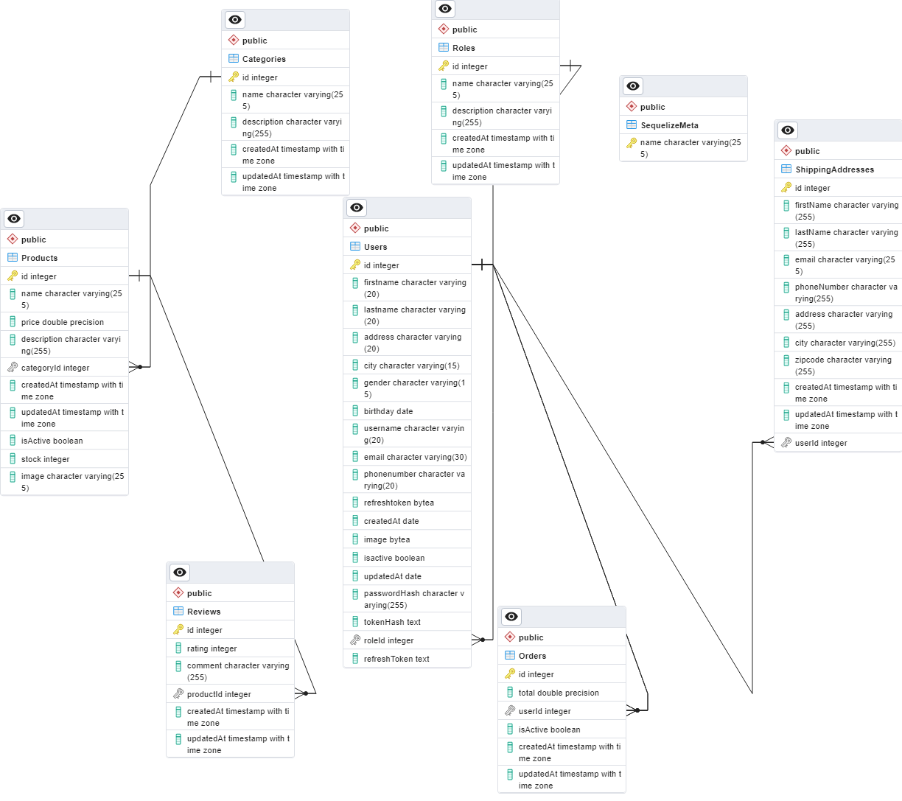

**Activity Diagrams**

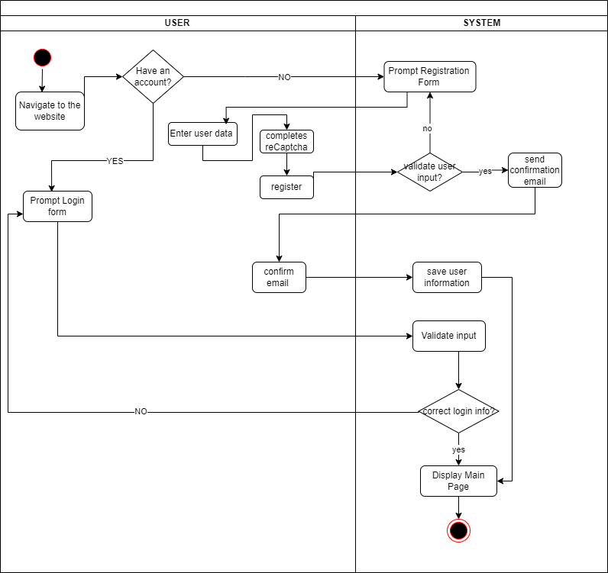

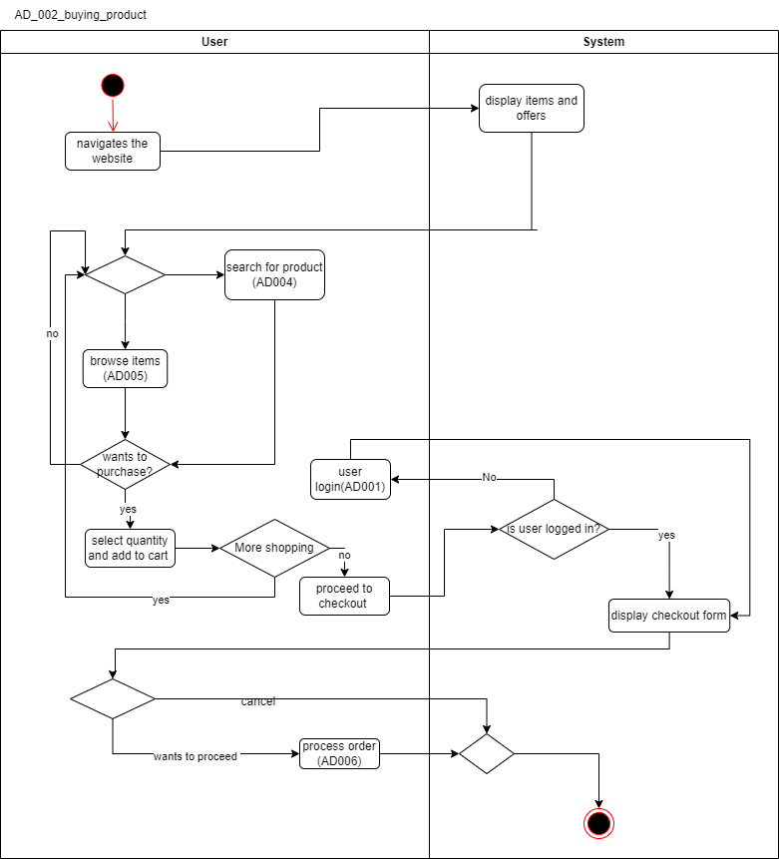

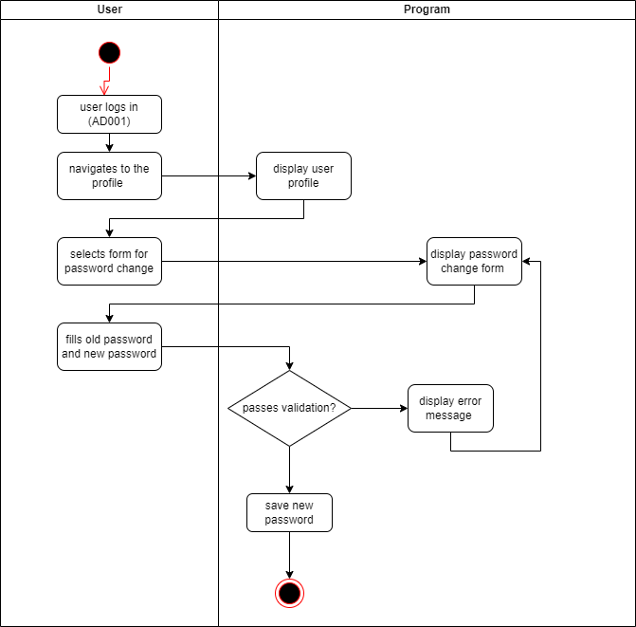

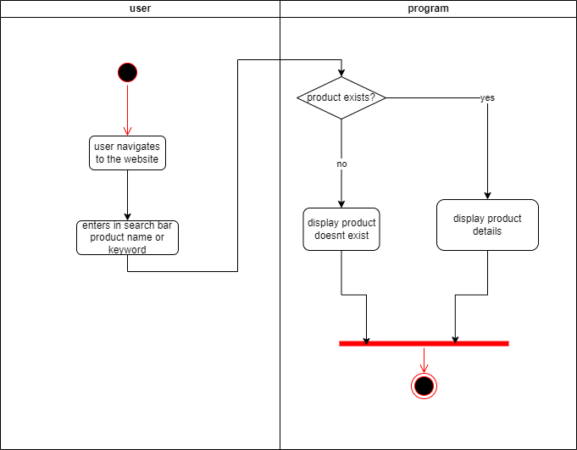

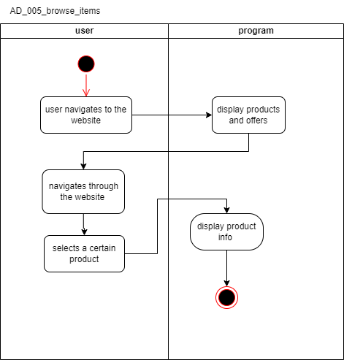

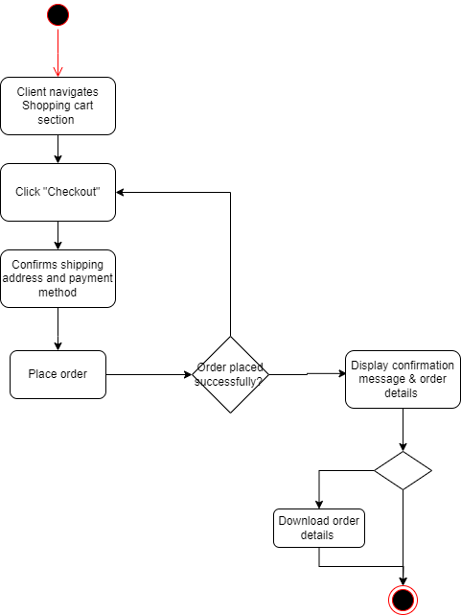

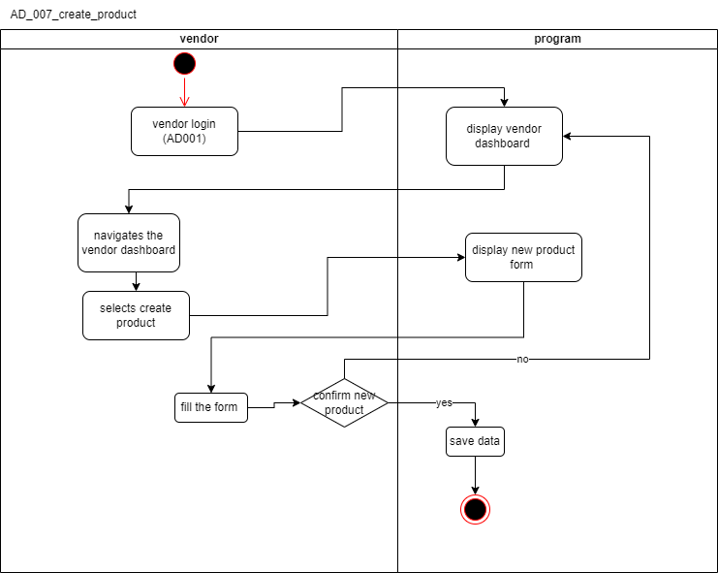

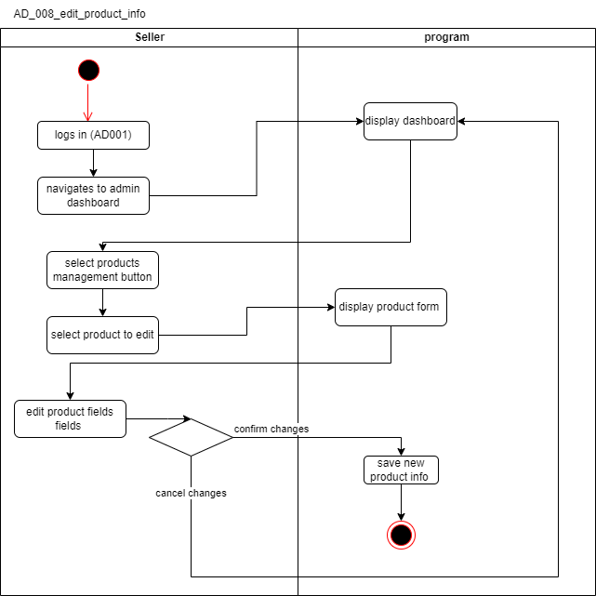

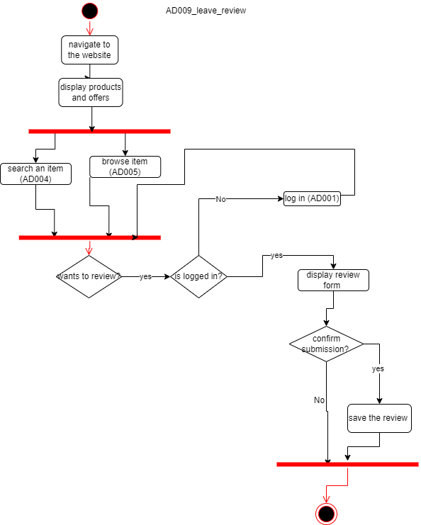

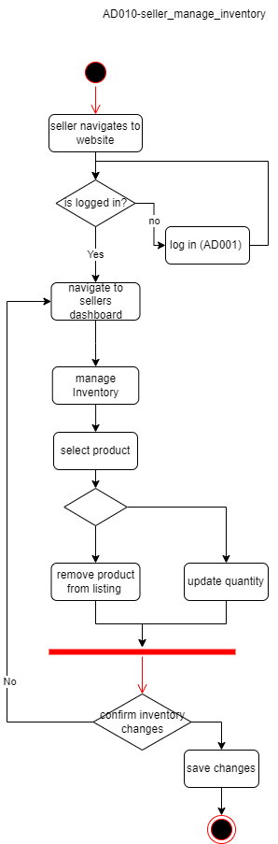

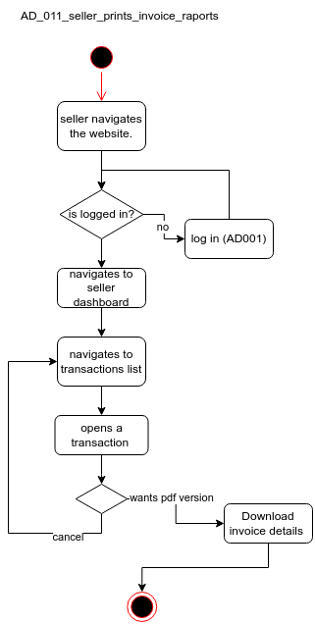

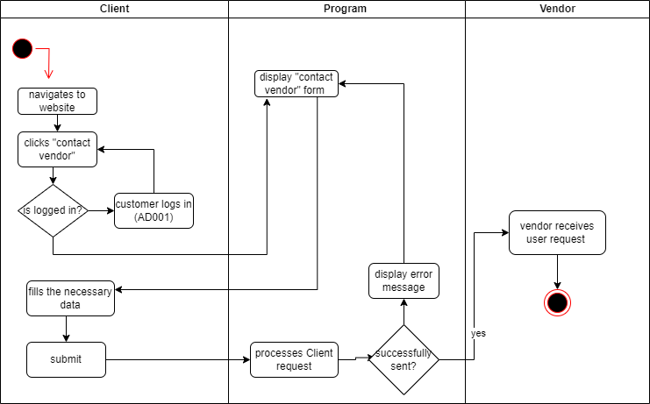

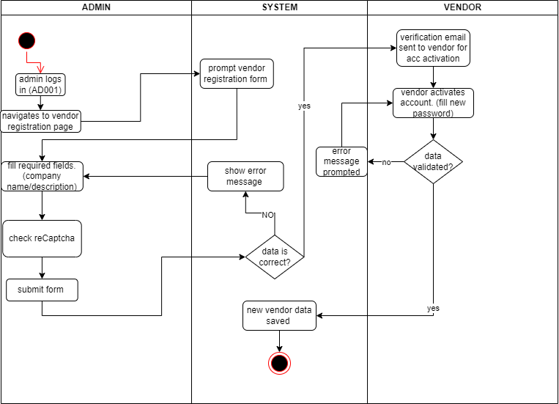

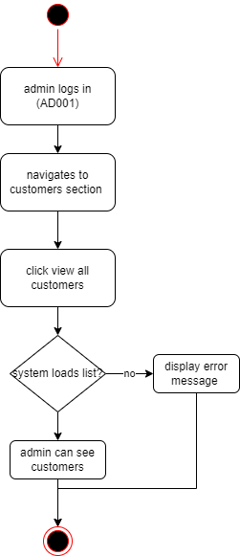

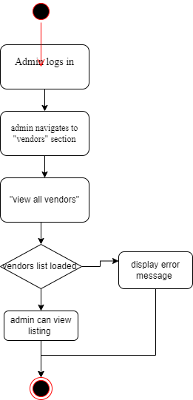

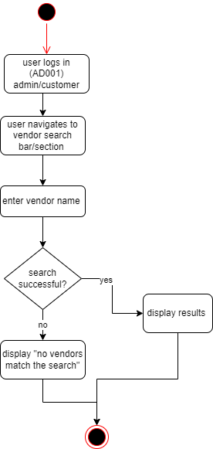

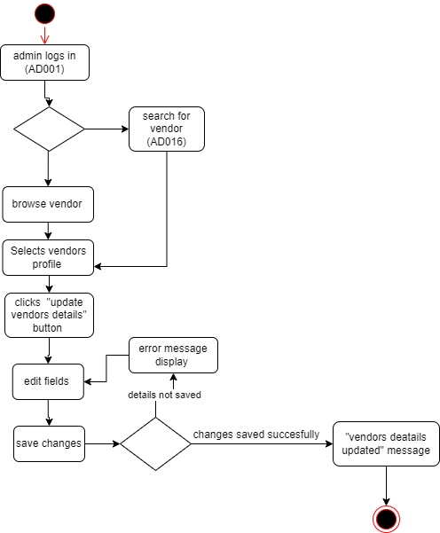

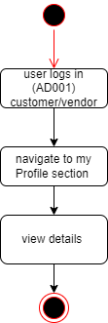

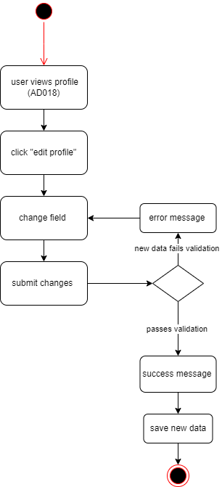

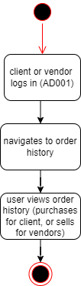

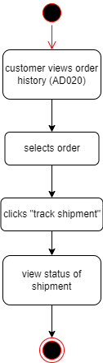

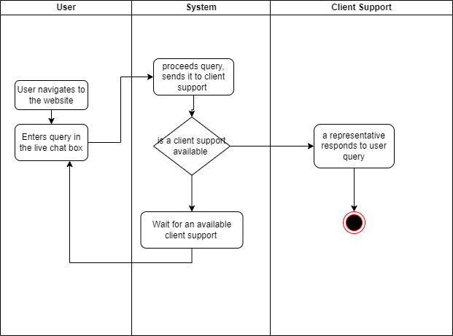

**State Diagrams**

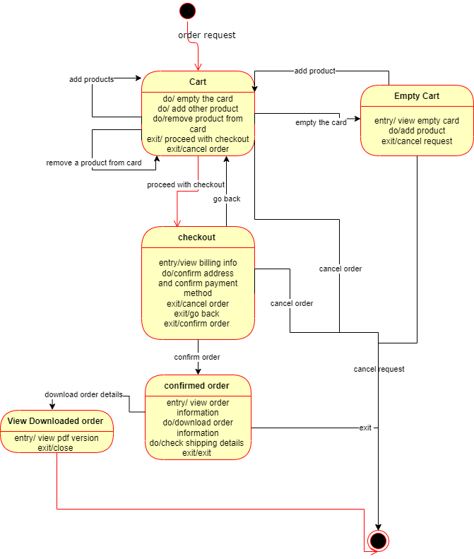

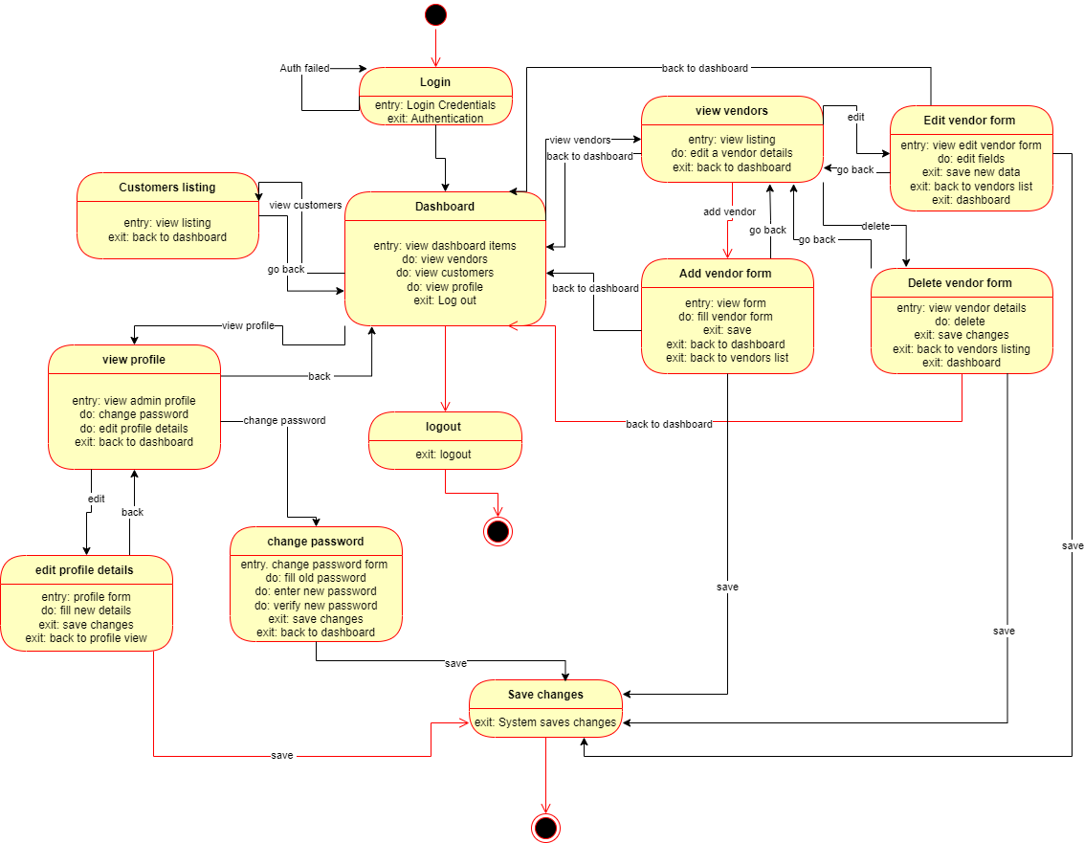

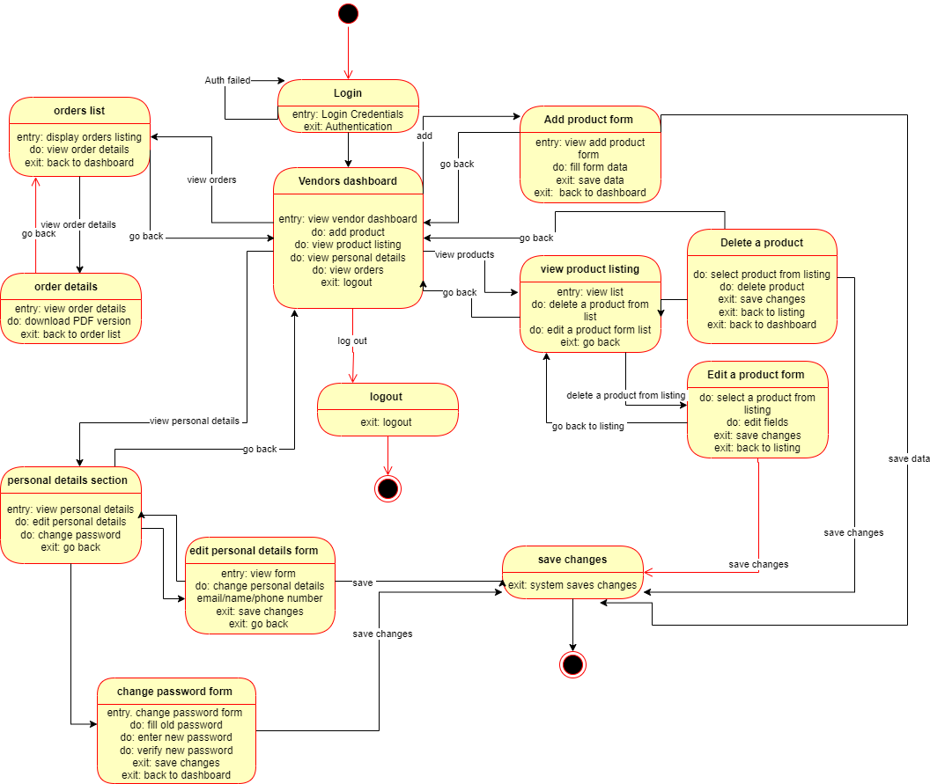

***Structural Diagrams*Class Diagram**

**Data Transfer Objects**

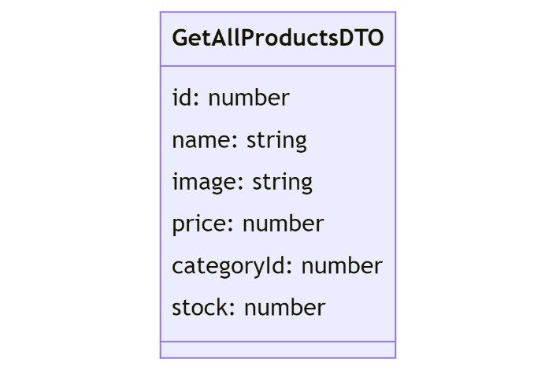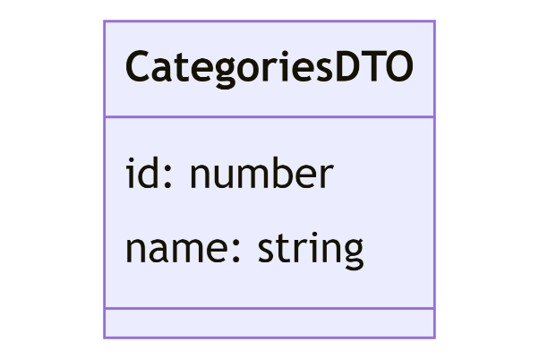

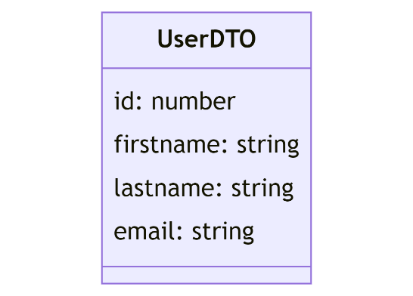

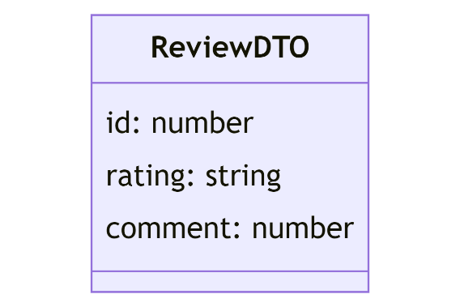

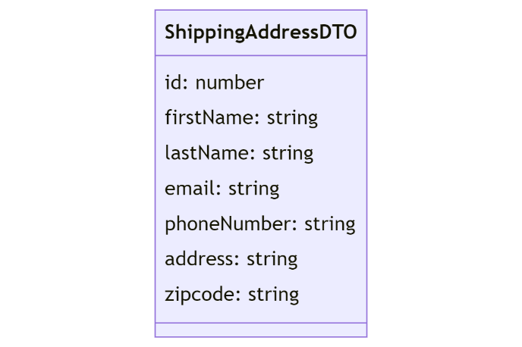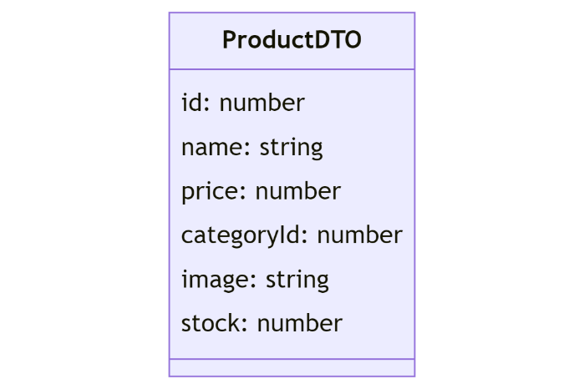

**Entities**

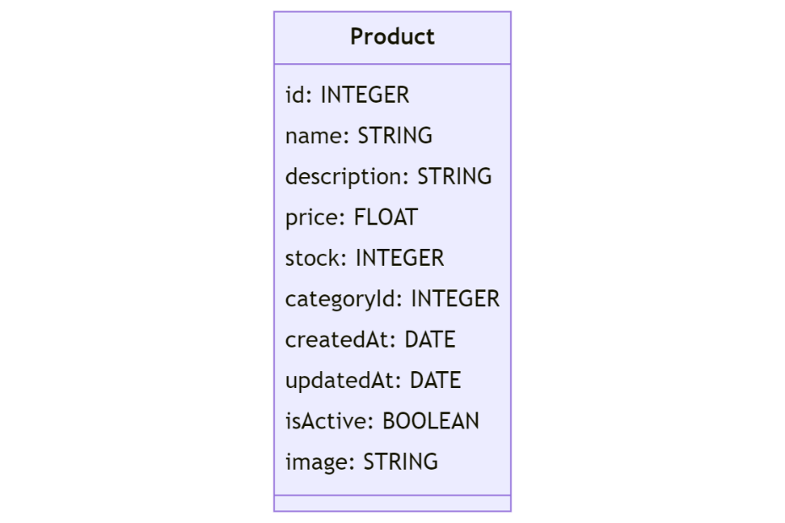

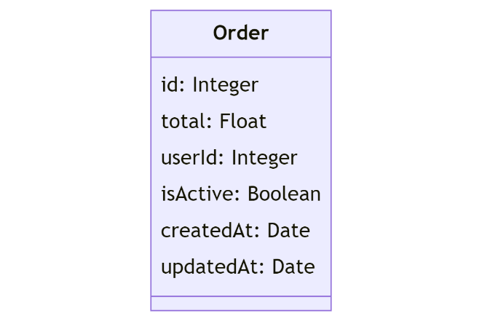

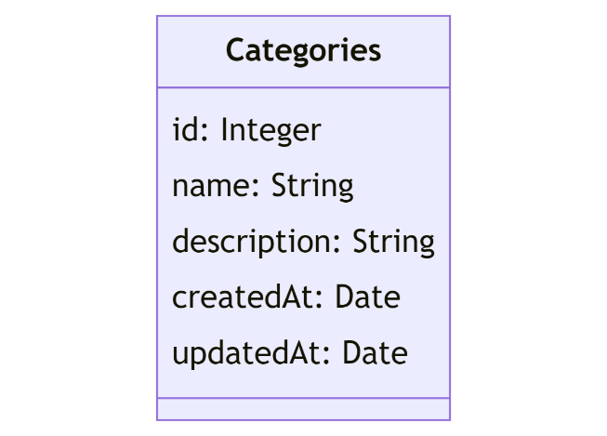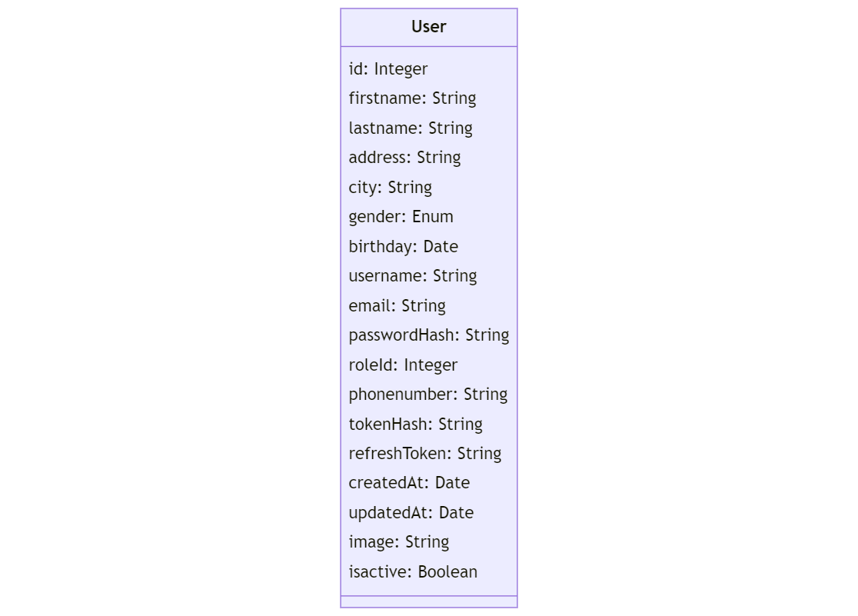

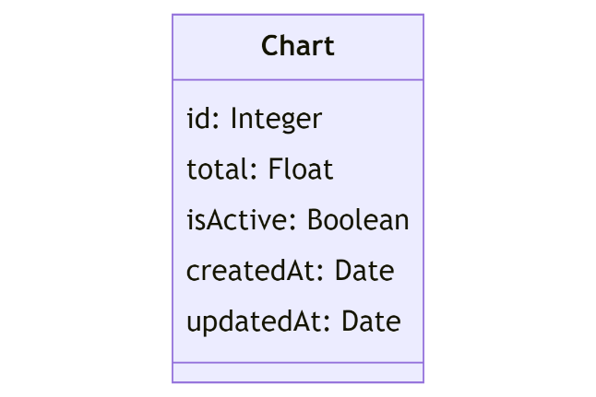

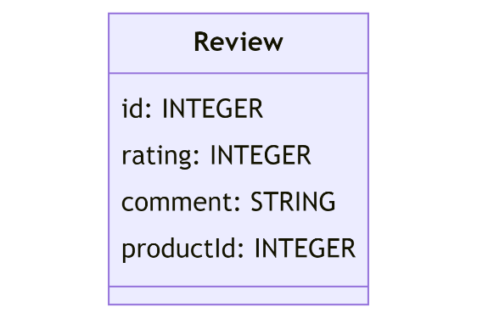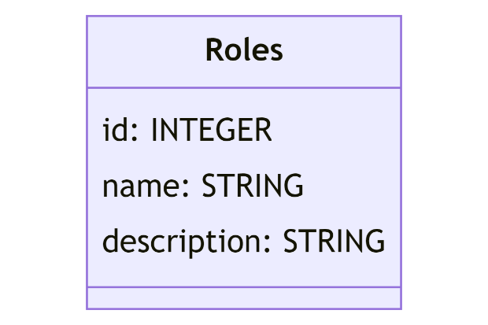

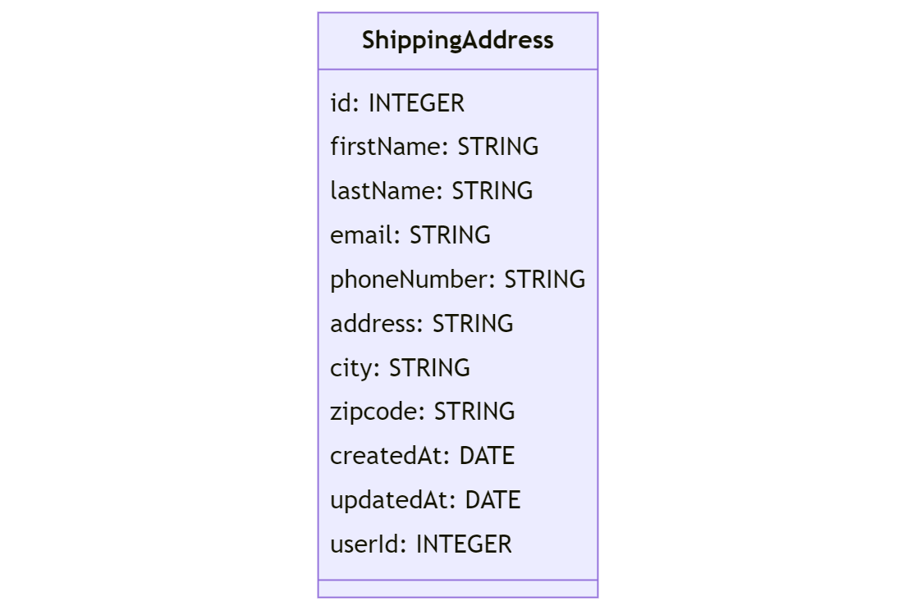

**Errors**

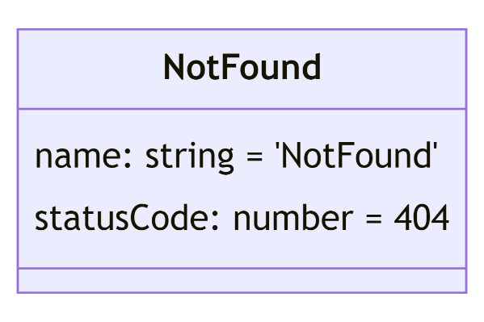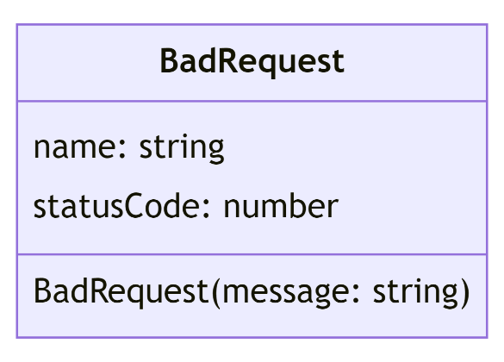

**Controllers**

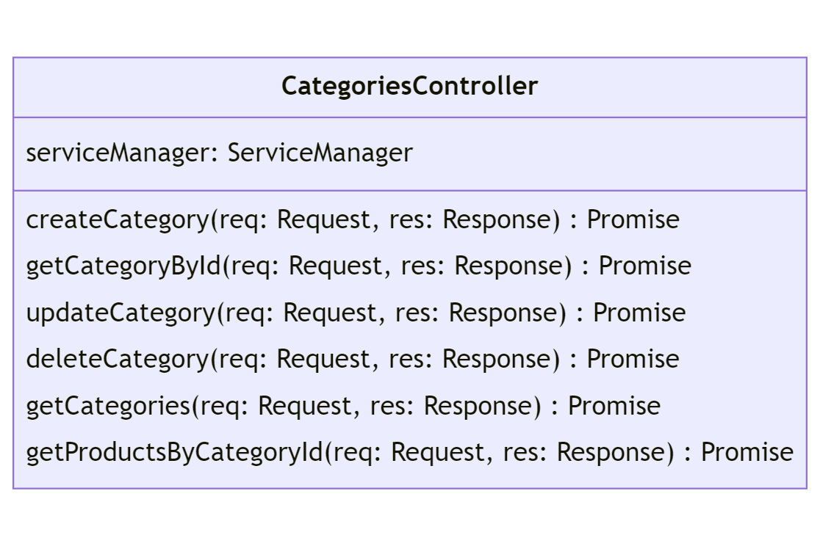

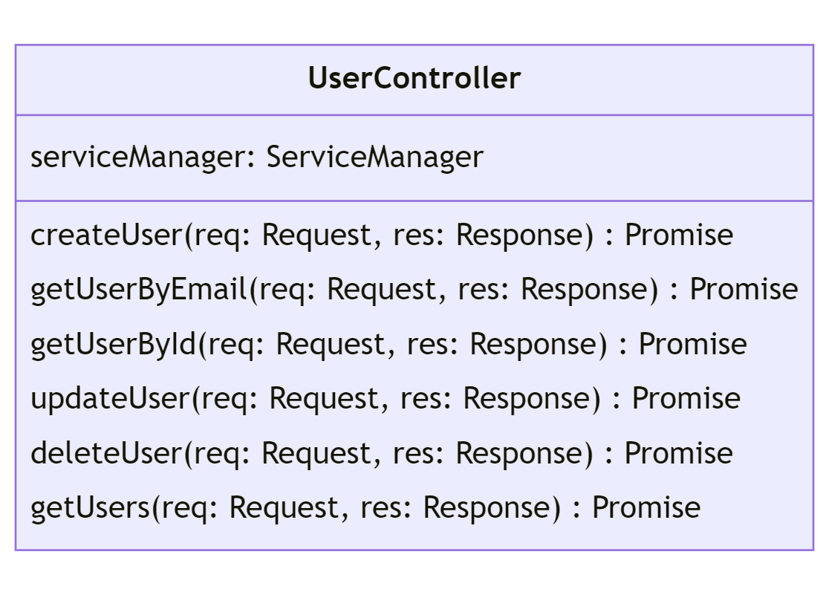

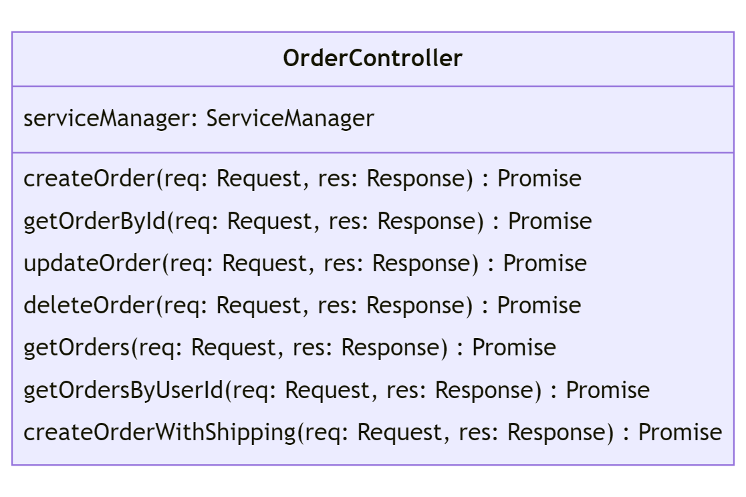

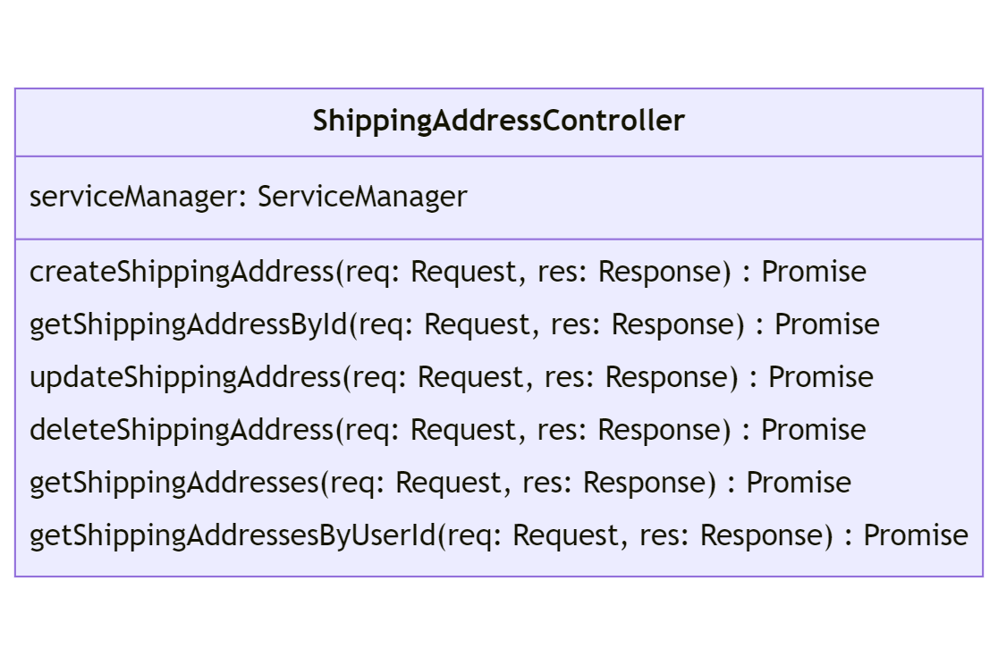

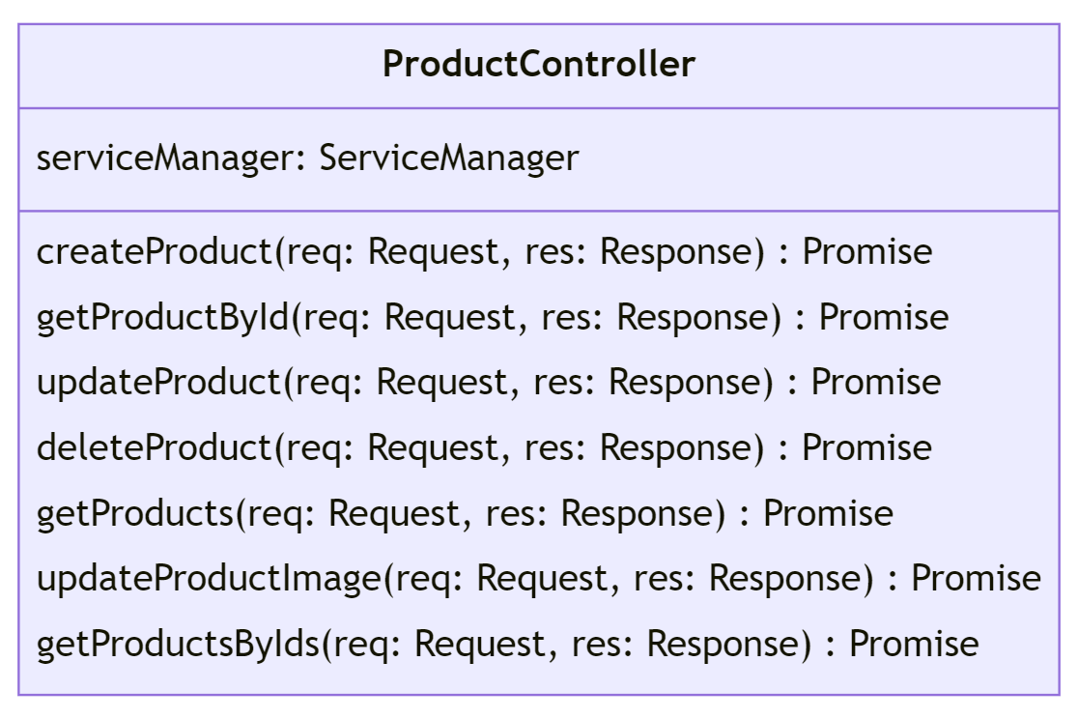

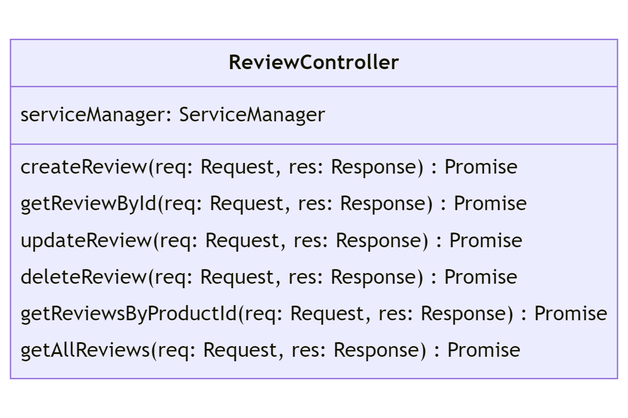

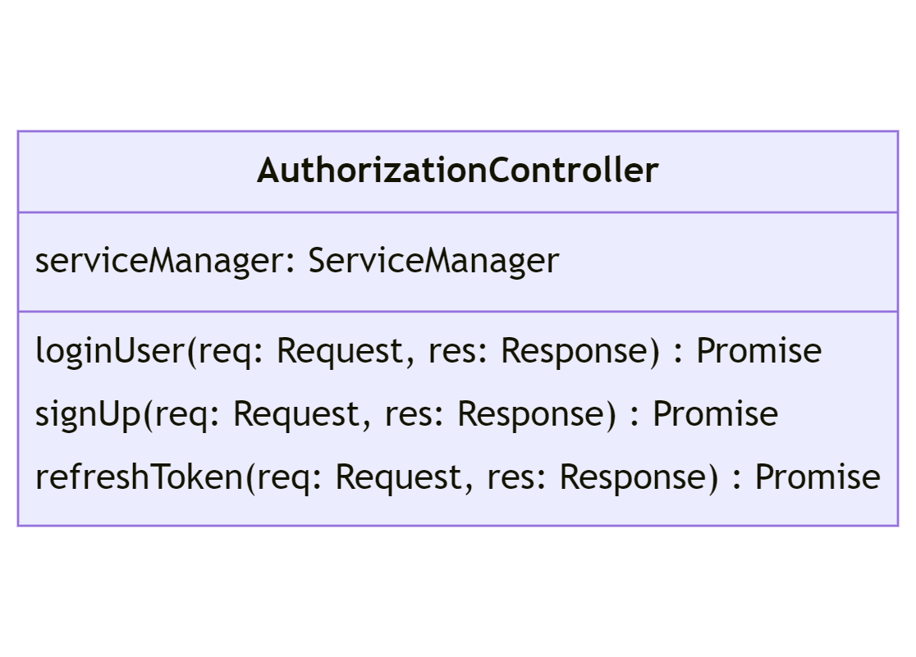

**Services**

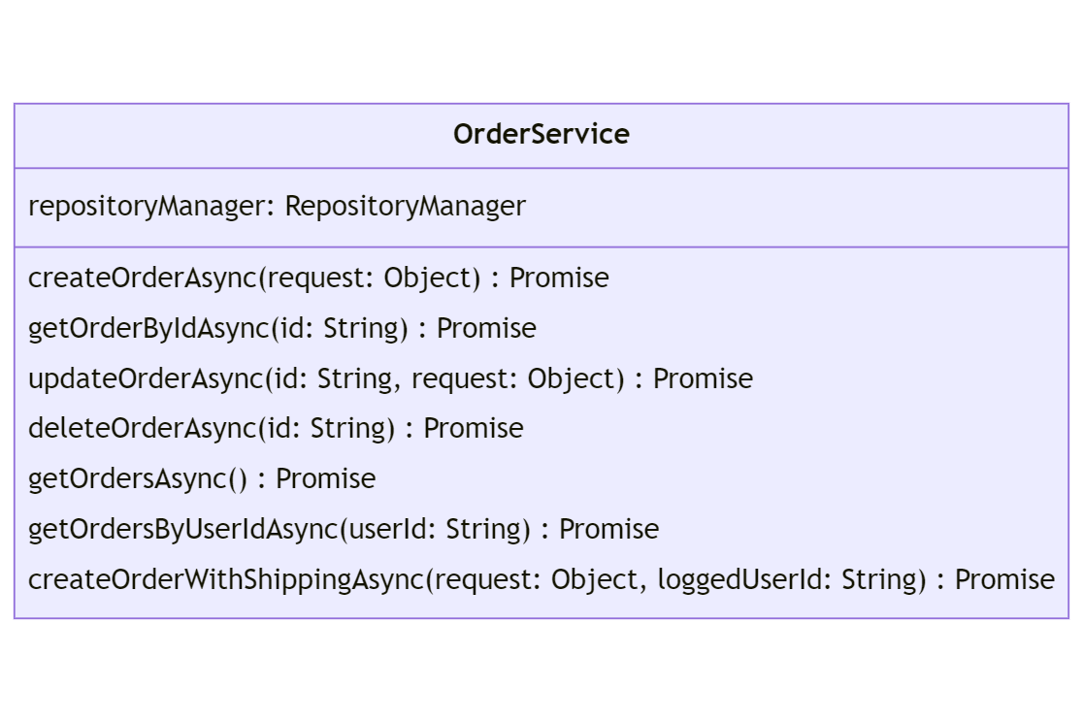

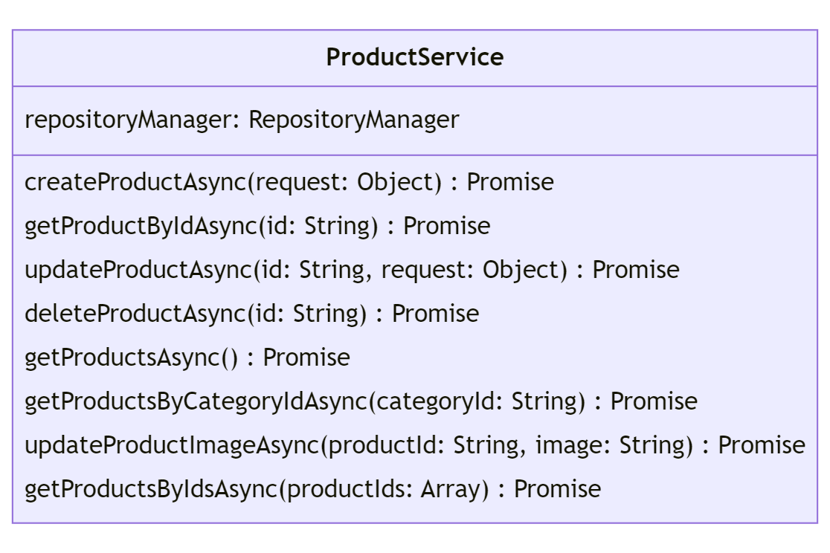

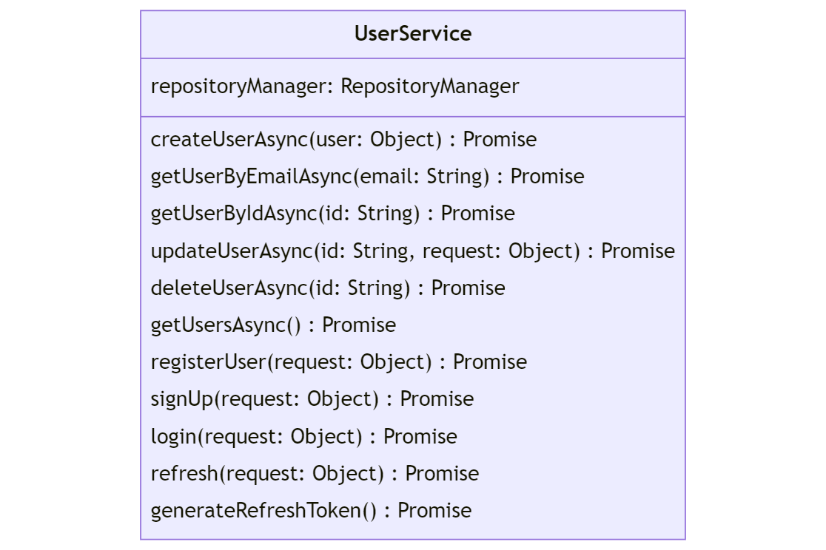

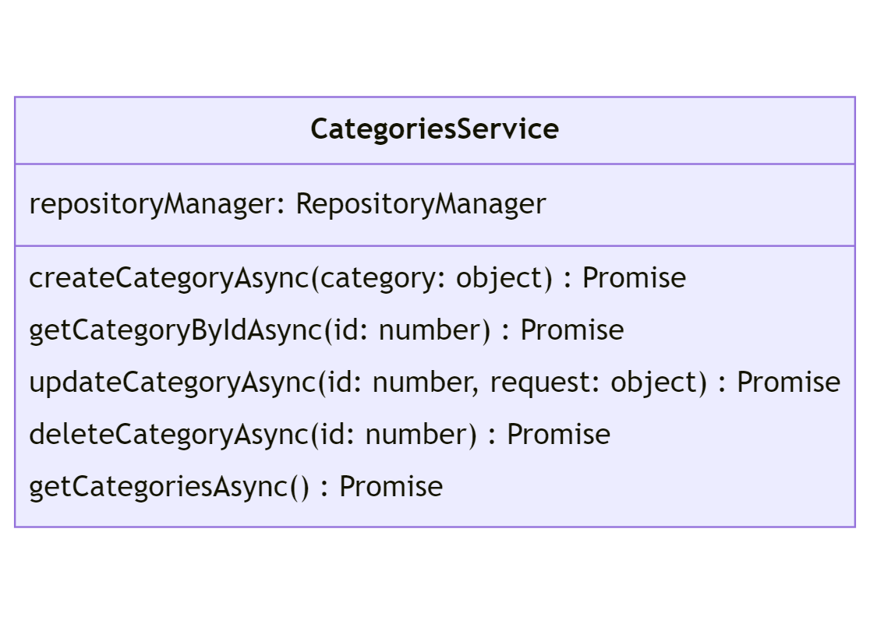

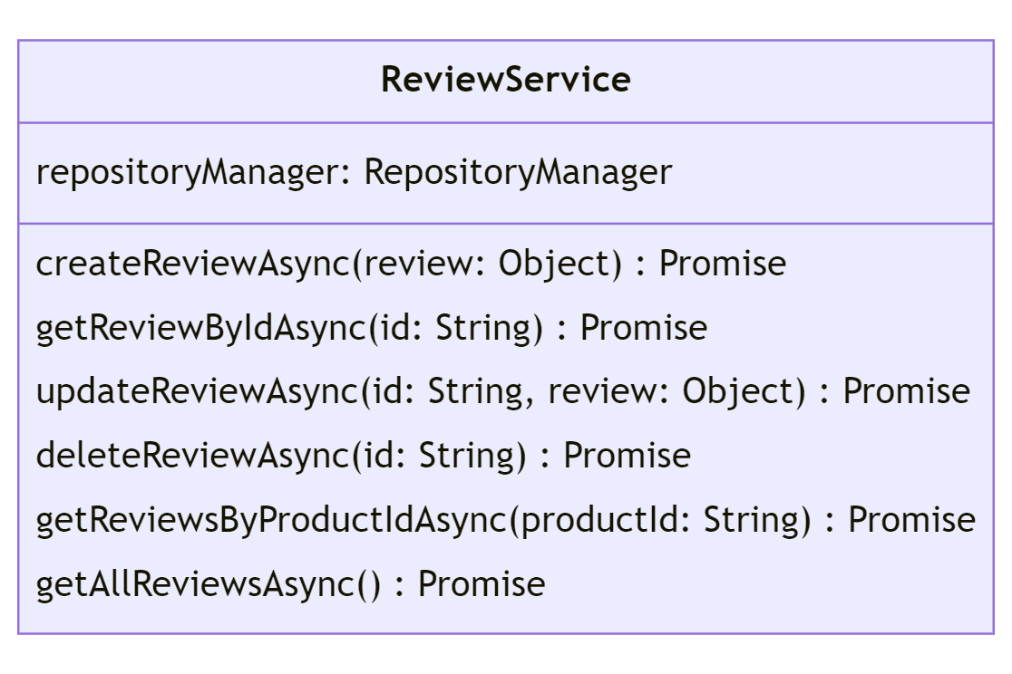

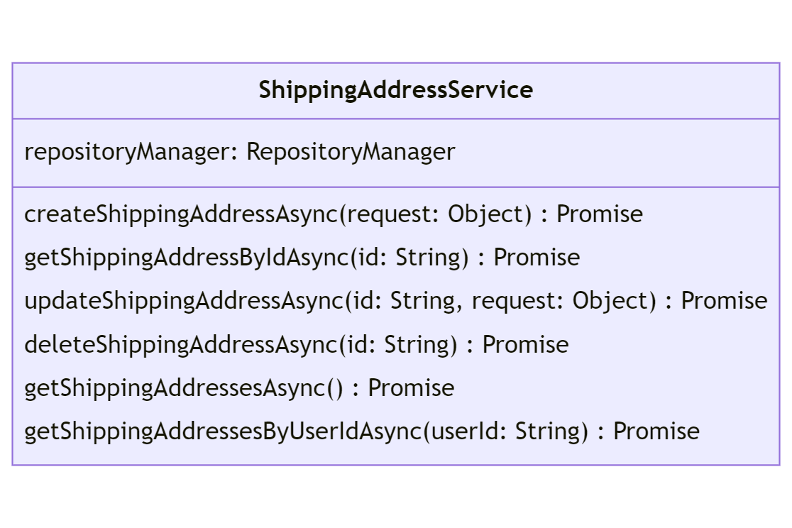

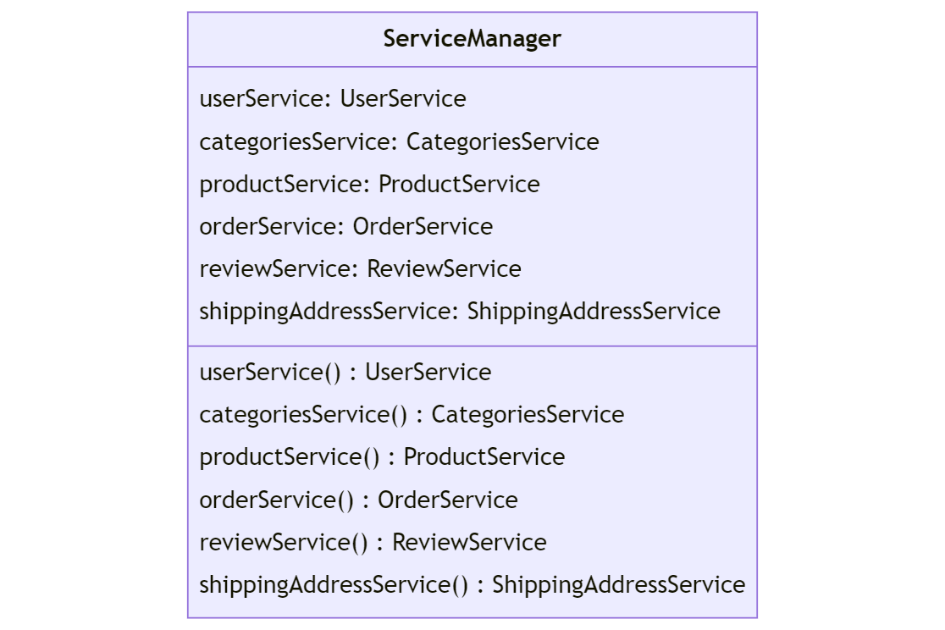

**Repositories**

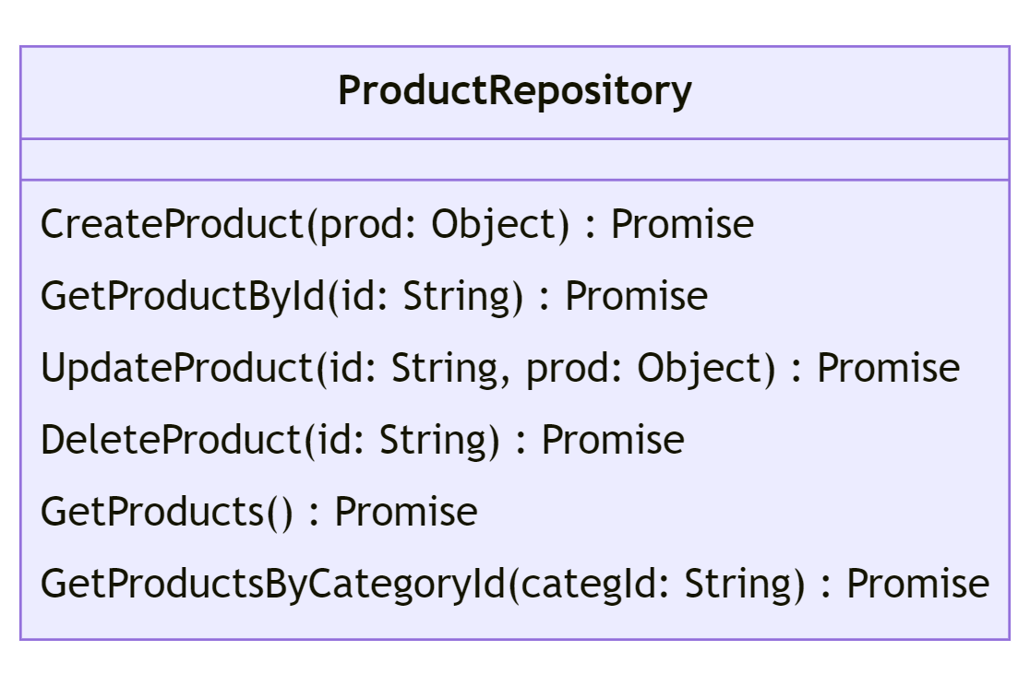

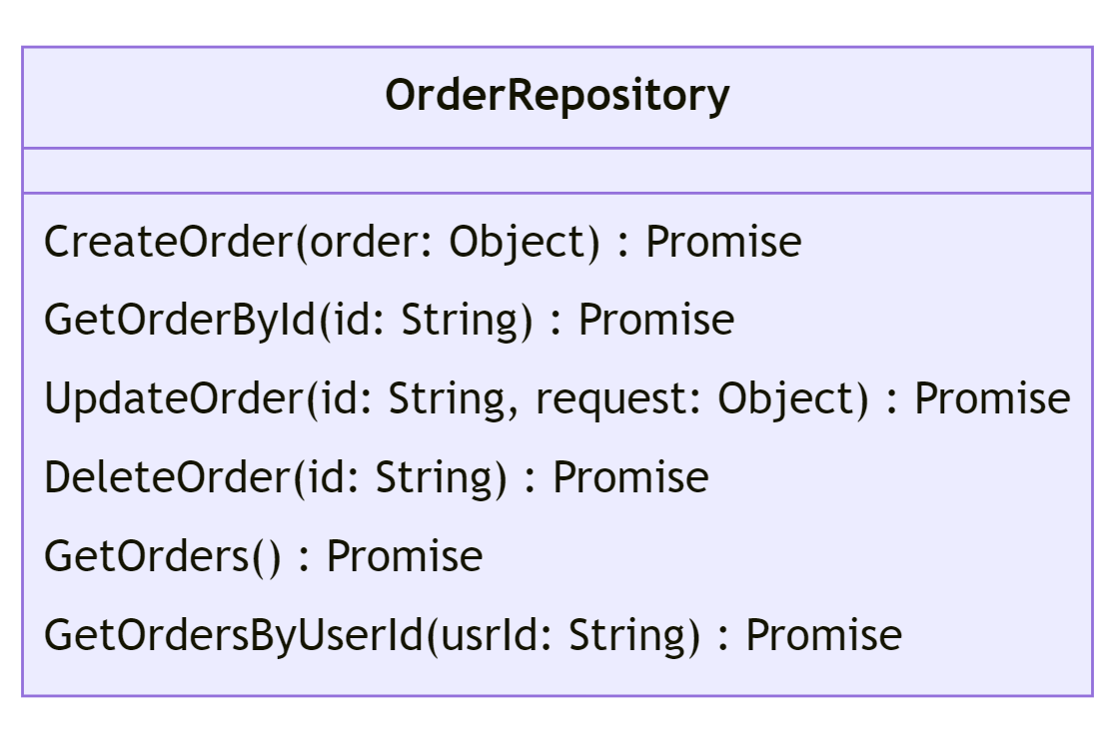

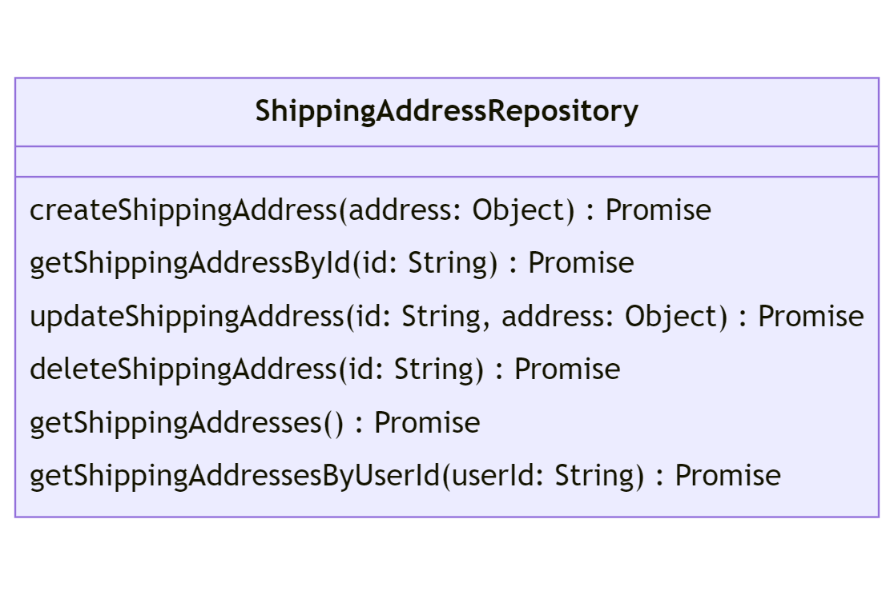

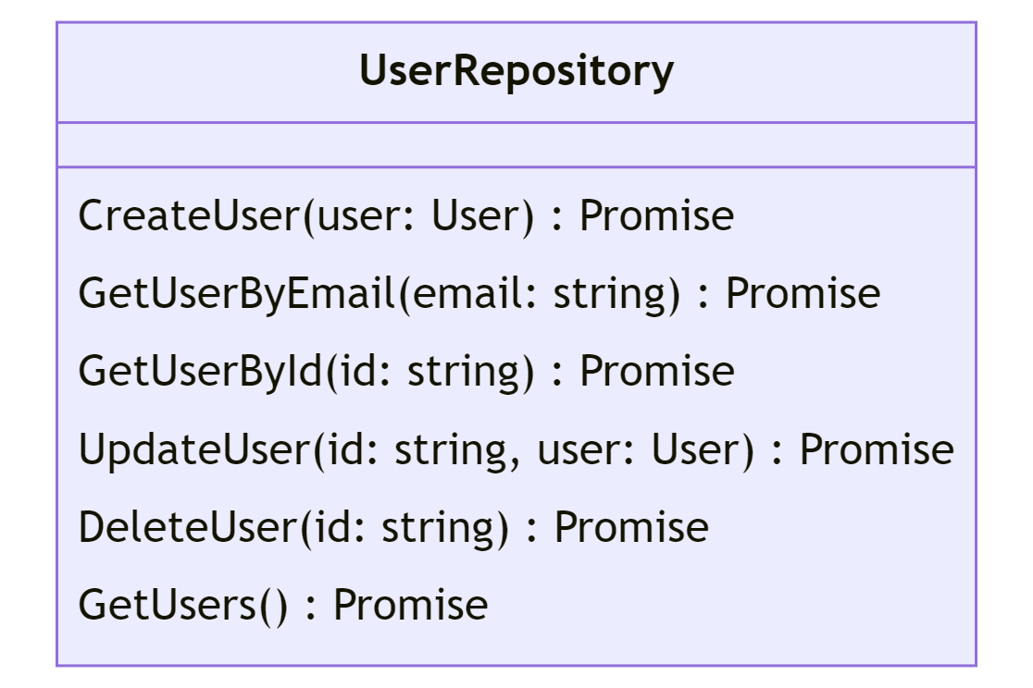

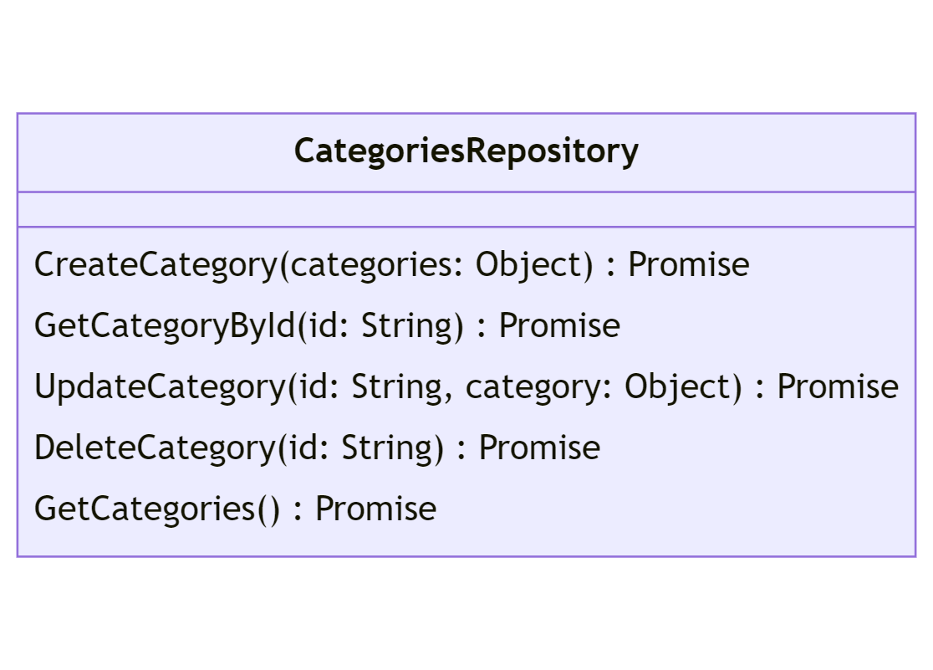

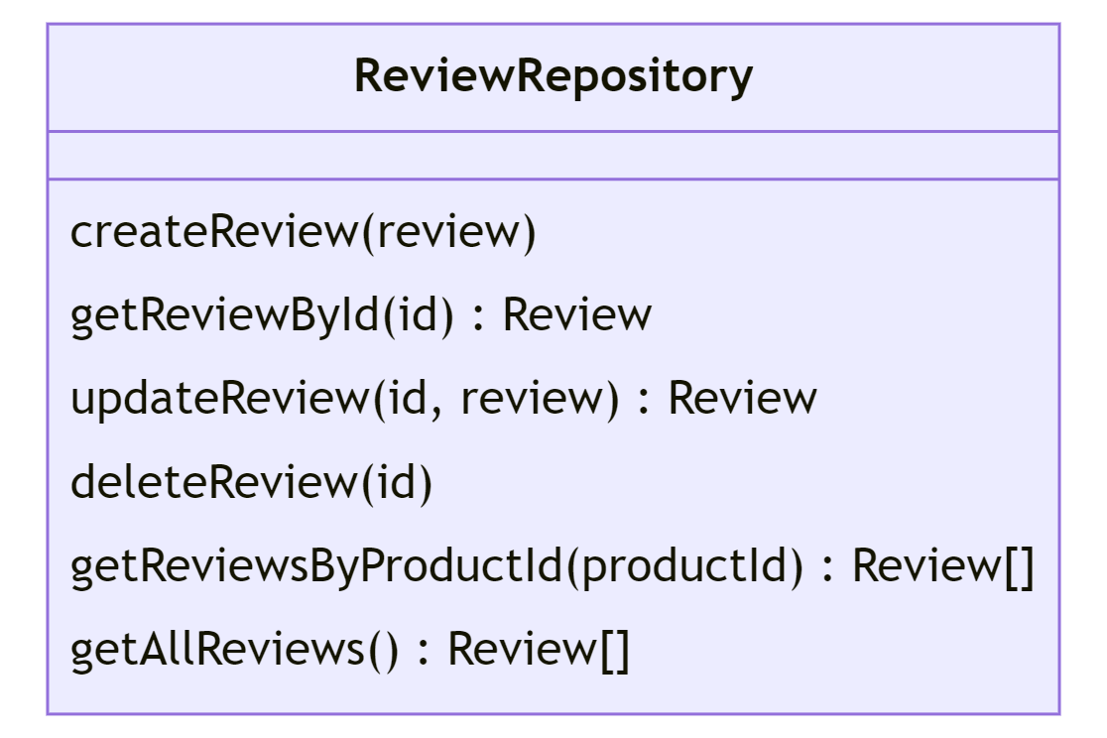

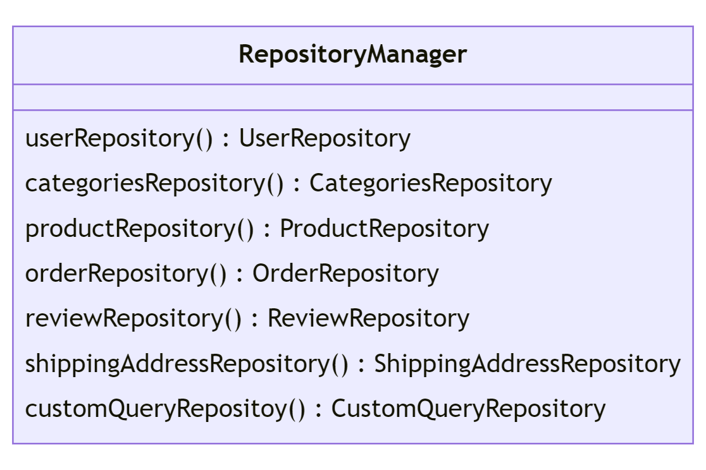

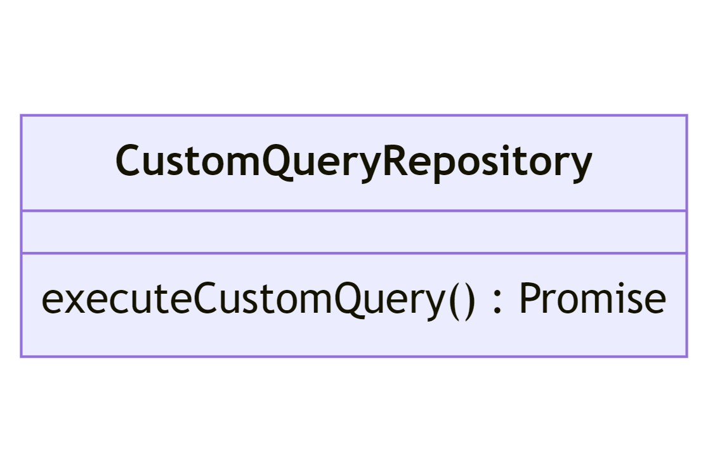

**Relationship between Presentation and Domain Layer (Product Example)**

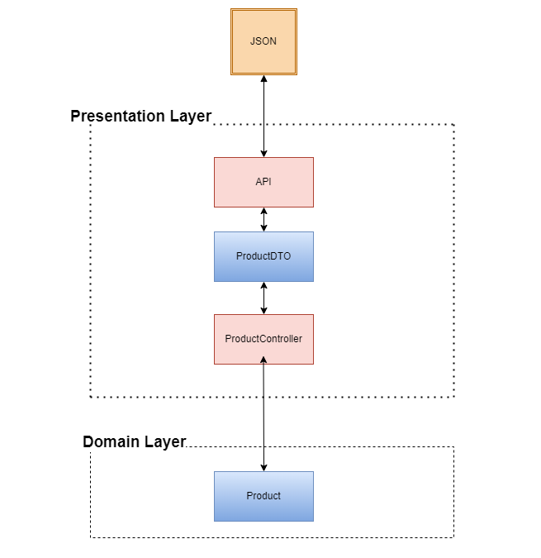

**Flow of our web application (User Example)**

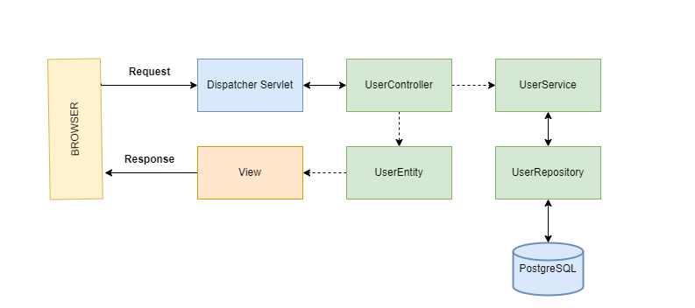

**Sequence Diagrams**

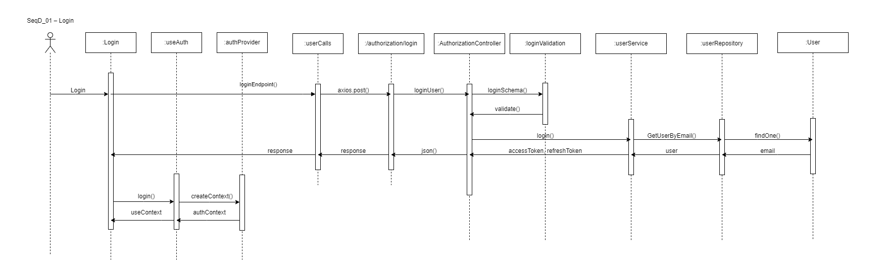

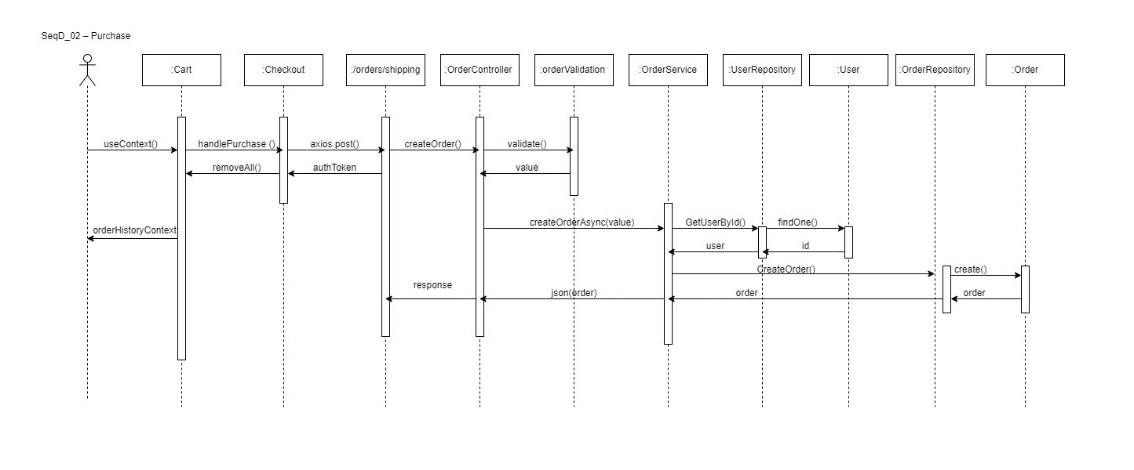

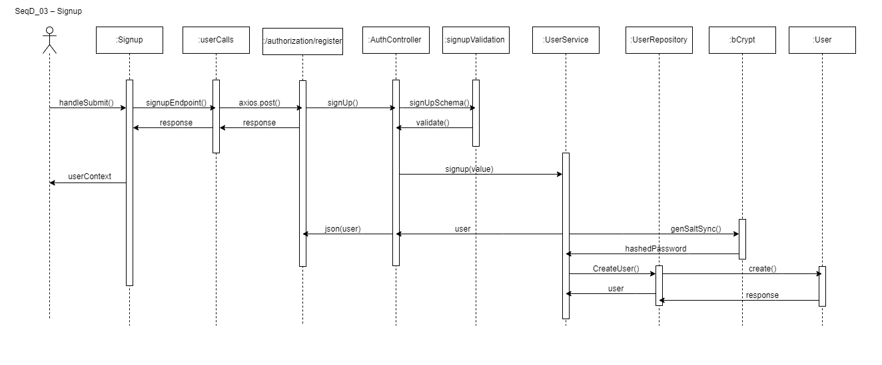

**Collaboration Diagrams**

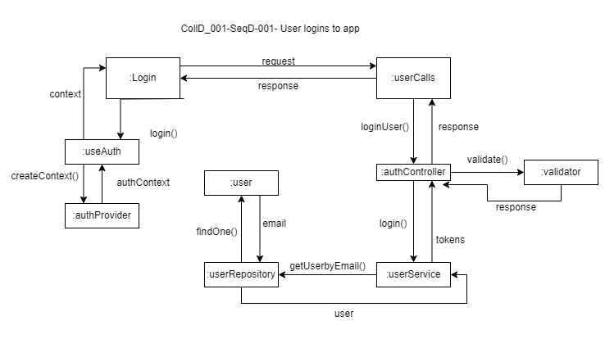

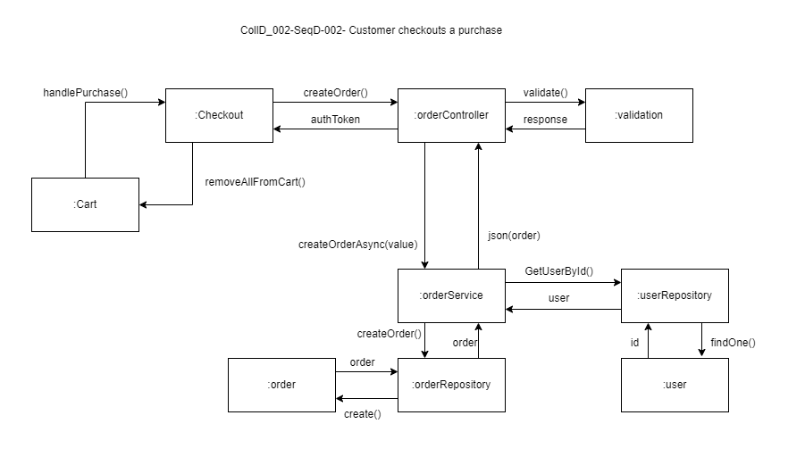

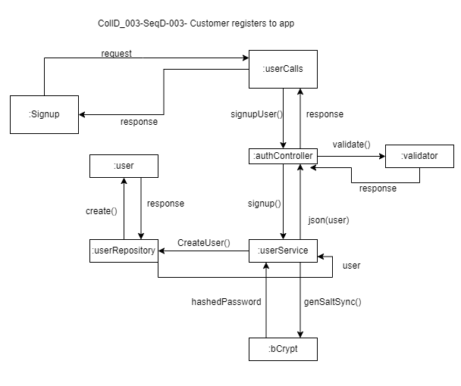

**Component Diagram**

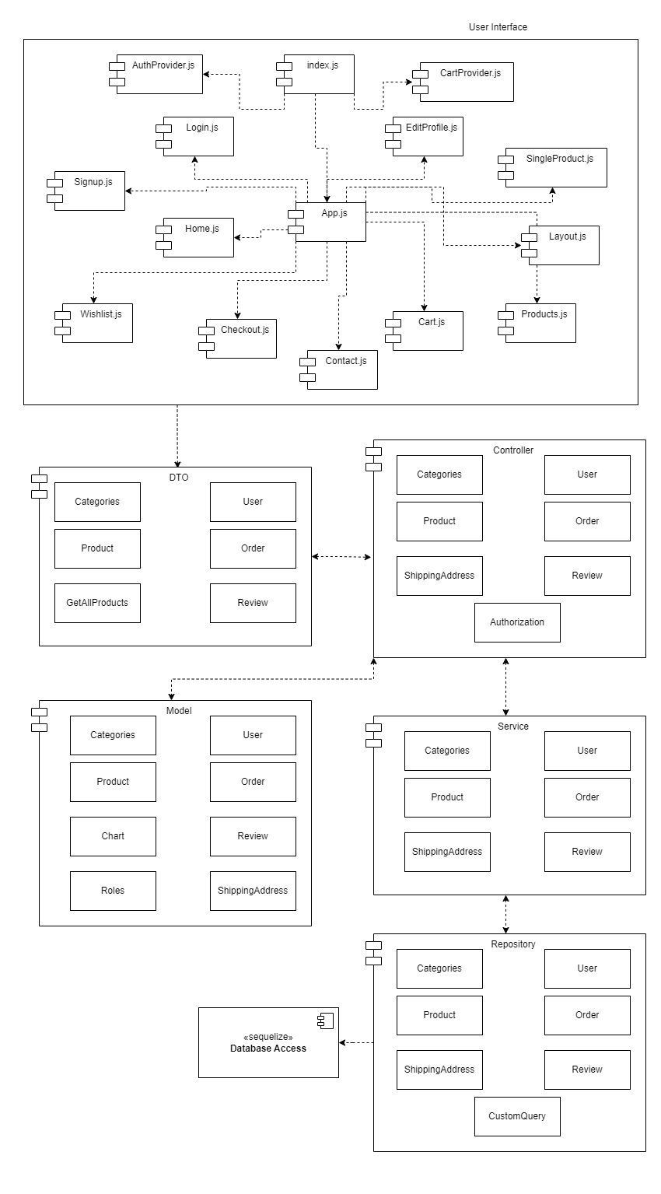

**Techplaza Architecture**

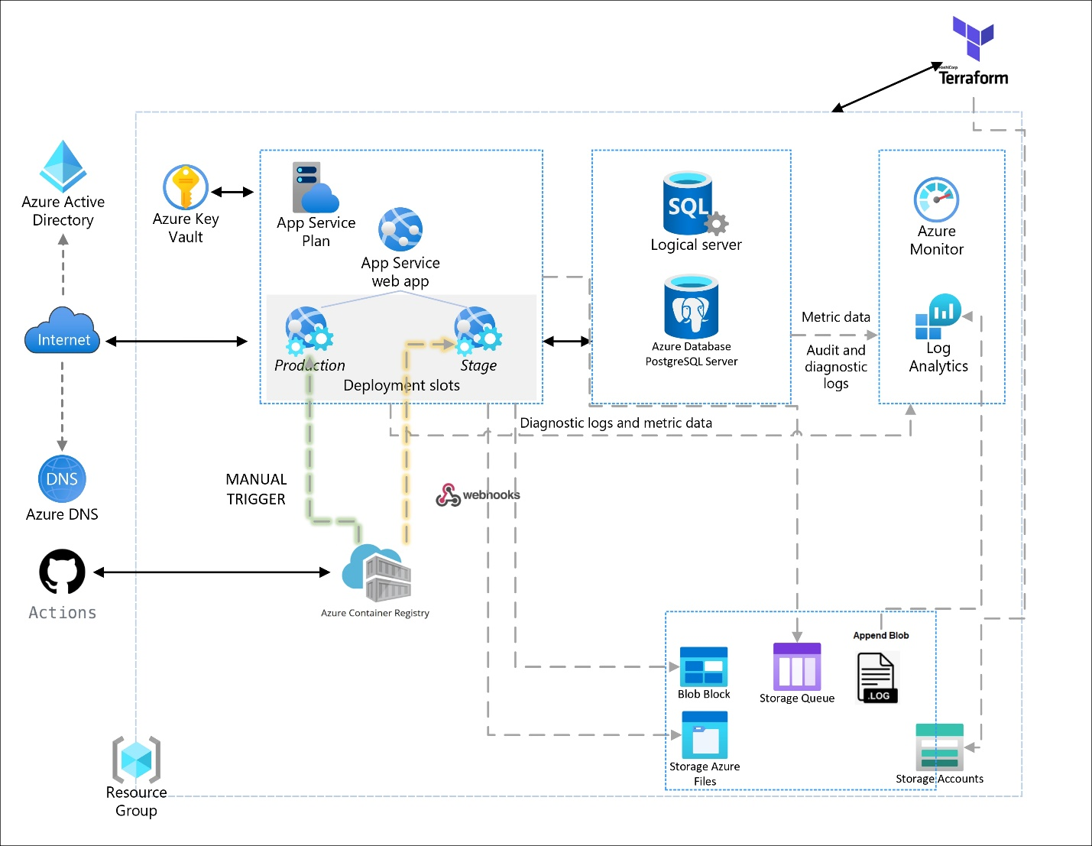

**Overview**

Techplaza, an e-commerce web application for tech products, leverages Express.js for its backend and React for its frontend. Let's dive into how these technologies contribute to the functioning of an e-commerce web app:

**React:**

React is a JavaScript library for building user interfaces, primarily for single-page applications. It's responsible for handling the view layer in the web app. It allows developers to create reusable UI components, leading to more efficient code.

**Advantages**: React has a virtual DOM that optimizes rendering and improves app performance. It also supports server-side rendering, which is beneficial for SEO. The component-based architecture promotes reusability and separation of concerns, making the code more maintainable. Its popularity also means a large community and abundant resources.

**Disadvantages**: The high pace of development means frequent updates, which can be a challenge to keep up with. Additionally, React only covers the UI layer of the app, and integration with other libraries is often necessary to complete the development stack.

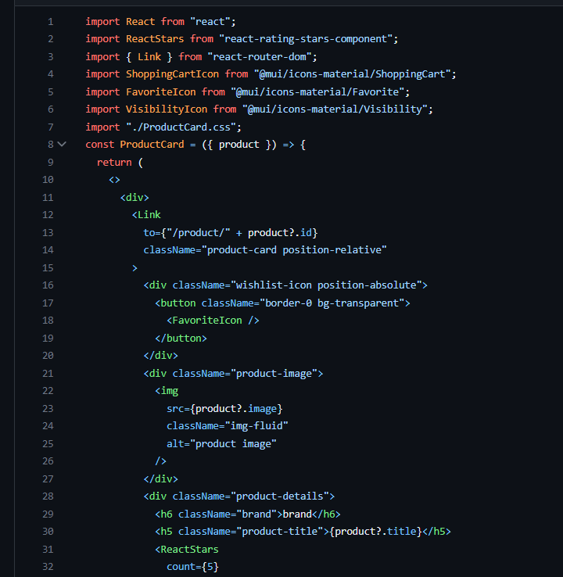

**Express.js:**

Express.js is a web application framework for Node.js. It helps to manage everything, from routes to handling requests and views. It speeds up the development process, as only one language (JavaScript) is used, making it a popular choice for systems with a large flow of inputs and outputs, like an e-commerce platform. Express.js is often used in combination with a database like MongoDB, which is also JavaScript-oriented.

**Advantages**: Express.js is capable of handling a huge number of simultaneous connections and concurrent actions, which is crucial for a busy e-commerce site. It does not generally impact performance, and in fact, when compared with servers like Java, Node.js (and by extension Express.js) was found to handle requests faster and reduce average response times​​.

**Disadvantages**: Express.js's event-driven nature can be difficult for developers coming from other languages, as it may lead to what's called "callback hell" if not properly managed. However, the latest versions of Node.js offer async/await features to help mitigate this issue​​. Also, Express.js's philosophy of using middleware (chained functions that run between the client request and server response) and its approach to code organization can require a learning curve for some developers​​.

For an e-commerce platform like Techplaza, Express.js is suitable because it can handle large amounts of simultaneous connections, which is useful for server-side applications interacting with third-party resources and gathering data from them. It's also a great choice for applications that track visitor actions, and for real-time applications, due to its event-based and non-blocking server architecture​.

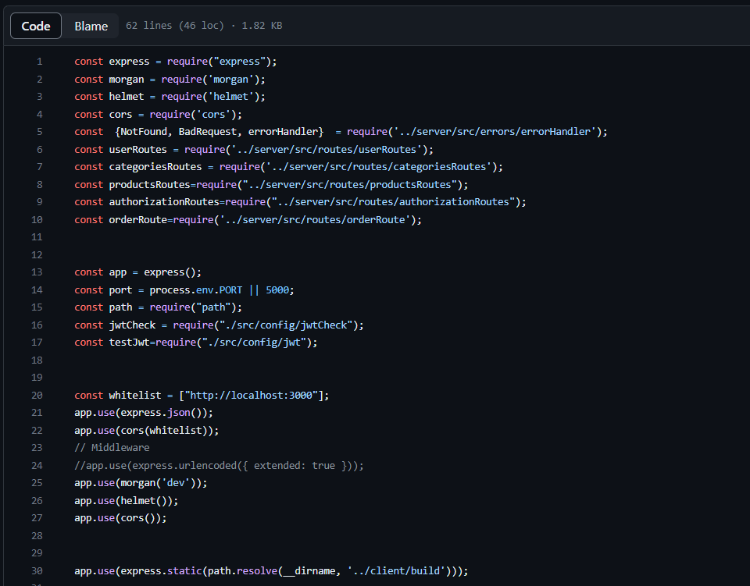

**Docker's Role in the Development Process**

Docker plays a pivotal role in the development, testing, and deployment process of Techplaza's application stack. Docker provides a standard way to package application code, configuration, and dependencies into a single object called a Docker image. These images can then be shared, deployed, and run across different environments, eliminating the "it works on my machine" problem.

**Consistency**: Docker provides a consistent environment for the application from development to production, reducing the chances of unexpected changes or issues due to environmental differences. This ensures that what works in development will work the same way in production.

**Isolation**: Docker's isolation features help to contain the application and its dependencies in a separate container. This minimizes conflicts between different applications or different components of the same application.

**Portability**: Docker images can be run on any machine that has Docker installed, regardless of the underlying operating system. This makes it easy to move applications across different environments and systems.

**Scalability**: Docker, when used in conjunction with orchestration tools such as Kubernetes or Docker Swarm, can easily scale applications based on the demand.

**Implementation of Docker Multi-Stage Builds in Techplaza**

Techplaza makes extensive use of Docker multi-stage builds to optimize the construction and deployment of the application. In the context of Techplaza, the Dockerfile.dev (the Dockerfile used in the development environment) is configured in such a way to achieve this.

The multi-stage build process has two primary stages:

**Build stage**: In the first stage, the Dockerfile specifies a base Node.js image, which is equipped with all the tools needed to compile and build the React frontend components. This build stage generates a build directory with all the compiled React static files.

**Runtime stage**: The second stage starts with a lighter Node.js base image (typically an Alpine-based image), which is suitable for running the application but doesn't contain build tools that are not needed in production. This stage primarily focuses on setting up the Express.js server and serving the React static files generated in the build stage. This separation ensures that the final Docker image used to run the application in production is as lean as possible, containing only the runtime necessities.

Furthermore, Docker Compose is used to orchestrate the application services during the development phase. Docker Compose simplifies the management of application services, volumes, and networks, ensuring the dev environment remains easily accessible and efficient for developers.

The advantage of this approach is that it optimizes the size and efficiency of the final Docker image, which reduces the runtime resource consumption and accelerates the startup time of containers. This makes Docker multi-stage builds a vital part of Techplaza's development process.

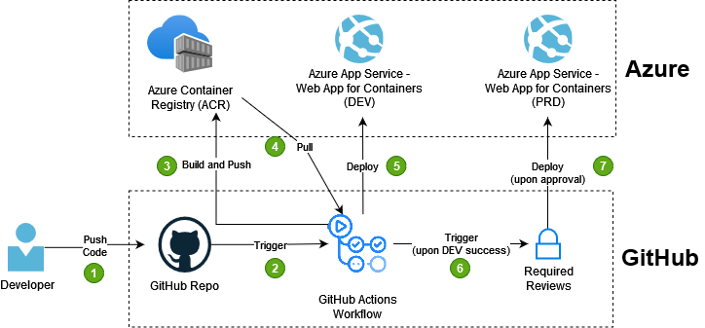

**Dev environment**

In Techplaza's development environment, docker-compose is used to run the services defined in the dockerfile.dev.

Looking at the docker-compose.yml content, it defines one service called app. Here's what each key represents:

build: This defines the build context and the Dockerfile that Docker should use to build the image for this service.

working_dir: This sets the working directory inside the container.

container_name: The name of the Docker container.

ports: Maps the host's port to the container's port.

environment: Specifies environment variables that should be available to the service.

deploy: Contains deployment-related configurations like restart policy.

volumes: Mounts host paths or named volumes, specified as source:destination, to the service's containers.

command: Overrides the default command for the service.

The dockerfile.dev is a Dockerfile used to build an image for the development environment. It starts with a node:14 base image, installs all the necessary server dependencies, and globally installs nodemon.

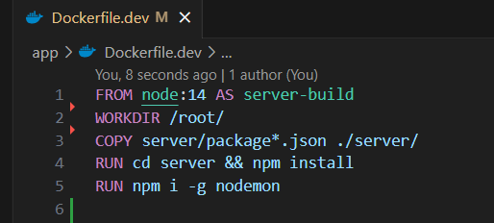

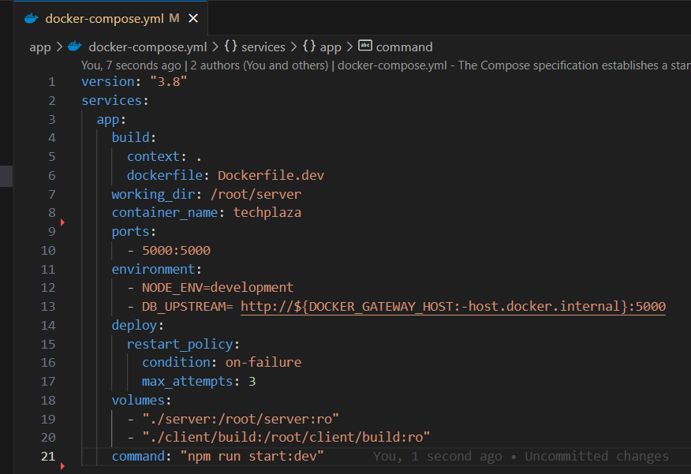

**Testing and Production Environment**

The Dockerfile used for testing and production environments is different from the dockerfile.dev and contains two stages to build the application:

ui-build stage: This stage is responsible for building the client-side React application. The Dockerfile first copies the client code to the working directory, installs necessary npm dependencies, and builds the React application.

server-build stage: This stage is responsible for building the server-side Node.js application. The Dockerfile first copies the built React application from the previous stage to the 'client/build' directory. It then copies the server's package*.json files, installs the necessary npm dependencies, and finally copies the server code to the working directory.

The Dockerfile then exposes port 5000 and sets the command to run the server.js file when a container is started from the built image.

This Dockerfile ensures that the production and testing images are optimized, with a clear separation between the build and runtime environments, making the final Docker image as light and efficient as possible.

In the CI/CD pipeline, GitHub Actions use this Dockerfile to build Docker images for testing and production environments, thus ensuring consistency and reproducibility across these environments.

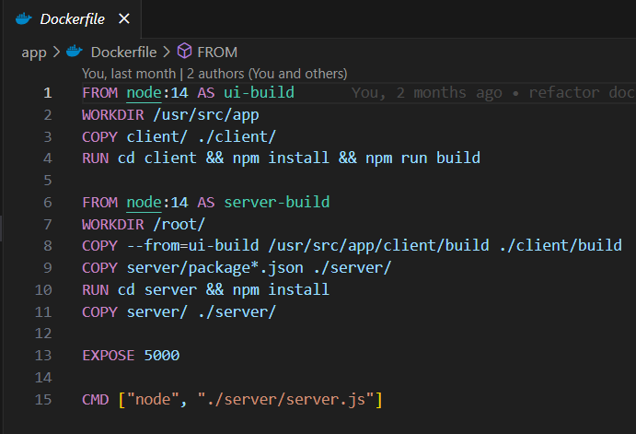

**Optimization techniques implemented.**

Mounting folders as volumes in Docker Compose is a crucial practice we've adopted in our development process, particularly as we're dealing with applications involving both server-side (Express.js) and client-side (React) components. Now, let's delve into the specifics of how this strategy optimizes our development workflow.

**Hot-Reloading**: We mount application directories as Docker volumes to facilitate "hot-reloading" of our application. This means that when we make changes to our application files on our local machine, these changes are immediately propagated to the Docker container. We don't need to manually restart the containerized application for these changes to take effect. We employ tools like nodemon and npm-watch which monitor file changes in the application directory and automatically restart the application whenever they detect a change.

**Faster Build Times**: Typically, React applications can have quite a lengthy build process, particularly as the size of the application increases. This is due to React needing to recompile and rebuild the entire application to create an updated static bundle each time a change is made. However, by using Docker volumes, we're allowing the build process to happen on our local machine rather than within the Docker container. This enables us to more effectively leverage incremental builds as only the components that have been modified need to be rebuilt rather than the entire application. Already built components reside on our local filesystem and are made available to the Docker container via the mounted volume.

**Preservation of Node_Modules**: We also need to consider the node_modules directory. Rebuilding this directory each time can be time-consuming and consume substantial resources. By using volumes, our container can utilize the node_modules from our local system, eliminating the need to rebuild this directory every time the container is started.

In our Docker Compose setup, we've defined two volumes:

./server:/root/server:ro – This mounts our local server directory to /root/server in the container.

./client/build:/root/client/build:ro – This mounts our local client build directory to /root/client/build in the container.

We use the :ro flag to make these volumes read-only within the container. This prevents the containerized application from making any changes to the files.

Through these optimizations, we've significantly reduced the rebuild time of React components - by a factor of five. The combination of Docker's isolation capabilities and the power of hot-reloading tools like nodemon and npm-watch has improved our development experience. We can now test changes immediately without having to wait for lengthy rebuild times, thereby enhancing our productivity and efficiency.

**Environment Configuration and Azure App Service**

Techplaza's infrastructure is designed to span across three distinct environments - development (dev), testing (staging), and production (prod). This multi-environment setup is crucial for managing the lifecycle of the application, from initial development and testing to the final deployment in production.

The development environment is primarily used by our developers to write and test their code. Here, Docker Compose is used to orchestrate our services. Docker Compose allows for defining and running multi-container Docker applications, with all our services and their configurations defined in a single docker-compose.yml file. A notable feature of our development environment is the use of mounted volumes, which provides developers with an efficient way to reflect changes in the running containers immediately without rebuilding them.

Once the application has been developed and locally tested, it transitions to the testing and production environments, which are deployed using Azure App Services. Azure App Service is a fully managed platform for building, deploying, and scaling web apps.

There are several benefits to using Azure App Services in our test and prod environments:

**Easy Deployment**: Azure App Service integrates well with Docker, and we use it to deploy our Dockerized application. It simplifies the deployment process, ensuring that our application can be quickly moved from testing to production.

**Scaling**: Azure App Service allows us to scale our application effortlessly. Whether it's scaling up to more powerful compute resources or scaling out to handle increased load, Azure App Service handles it seamlessly.

**Integrated DevOps Capabilities**: With Azure App Service, we can set up continuous integration and deployment pipelines with GitHub Actions, Azure Pipelines, and other popular DevOps tools. These integrations simplify our DevOps process, promoting faster and more reliable deployments.

**Managed Service**: Azure App Service is a managed service, which means Azure takes care of the underlying infrastructure, allowing us to focus solely on our application. Features such as automatic OS patching, capacity provisioning, and load balancing are all handled by Azure.

**Environment Variables and Secrets**: Azure App Service provides a secure way to manage application settings and secrets, such as connection strings, which is critical for our PostgreSQL database connection.

Through Azure App Services, we ensure smooth and standardized deployments across our testing and production environments, maintaining the reliability and availability of our Techplaza e-commerce web app.

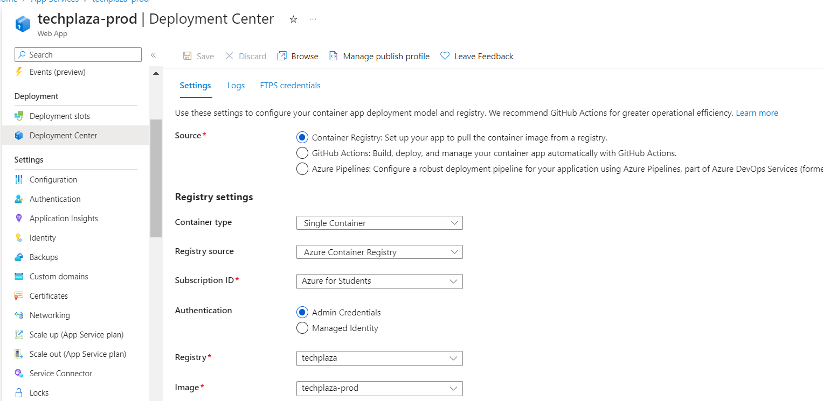

**Database and Azure PostgreSQL Flexible Server**

Techplaza utilizes PostgreSQL as its database solution, hosted on Azure PostgreSQL Flexible Server. PostgreSQL is an advanced, enterprise-class, and open-source relational database system. It has a strong reputation for its robustness, SQL compliance, and powerful features, which have made it a popular choice for many applications, including ours.

Choosing Azure PostgreSQL Flexible Server as our database hosting solution comes with numerous benefits:

**Scalability**: With Azure PostgreSQL Flexible Server, we can easily adjust the compute power and storage capacity to meet the needs of our application. We can start with modest resources during the development and testing phases, then scale up to more powerful servers as our application moves into production and begins serving real users. This scalability is not just vertical (adding more resources to a single server), but also horizontal (adding more servers to handle increased load), enabling our application to accommodate varying demand patterns efficiently.

**High Performance**: Azure PostgreSQL Flexible Server offers high performance with up to 99.99% availability, ensuring that our application's database is always ready to handle requests. It also features intelligent performance recommendations, allowing us to tune our database for optimal performance.

**Managed Service**: As a fully managed service, Azure PostgreSQL Flexible Server takes care of many administrative tasks, such as server maintenance, backups, and patching, freeing our team to focus more on application development and less on database administration.

**Security and Compliance**: Azure PostgreSQL Flexible Server includes built-in security features to protect our data. It offers firewall protection, encryption for data at rest, and SSL enforcement for data in transit. Additionally, Azure complies with a wide range of international and industry-specific compliance standards, providing additional assurance about the safety of our data.

**Cost-effective**: With Azure PostgreSQL Flexible Server's flexible pricing model, we only pay for the resources we use, making it a cost-effective solution for our database needs.

We handle the database connection through environmental variables across all three environments. This approach not only makes our application more portable and easier to configure but also enhances the security of our application. Instead of hardcoding sensitive database connection details into our application code, we store them securely as environment variables. In Azure App Service, these can be managed through the application settings, which are encrypted at rest and securely transmitted to the server.

By using Azure PostgreSQL Flexible Server, we're able to deliver a robust, secure, and high-performance database solution for Techplaza, ensuring that our e-commerce web application can reliably handle our customers' needs.

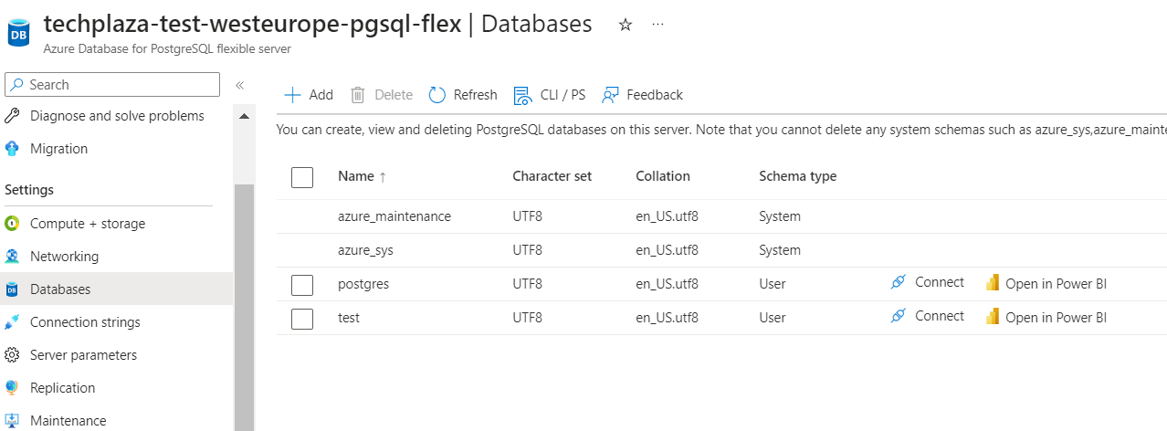

**Retention Policy of Azure Postgresql Server**

As the administrator of our Azure Database for PostgreSQL, I've chosen a retention policy of 7 days. This means that our system automatically creates server backups and keeps them for a period of 7 days. After this period, these backups are permanently deleted.

This choice provides us with a valuable safety net. If something goes wrong—say, unwanted changes are made or data is accidentally deleted—we can restore our database to any point within the last 7 days. This is known as Point In Time Restore (PITR), and it's a crucial tool for maintaining the integrity of our data.

Why did I choose a 7-day retention period? It's a balance between safety and cost. Keeping backups indefinitely isn't feasible—it would take up too much storage space, and the costs would add up over time. But at the same time, we need some period of "undo," some way to roll back mistakes or recover from unforeseen incidents.

A week strikes a good balance. It gives us enough time to spot and correct issues, without the costs and storage demands of a longer retention period. Of course, this is a decision that should be revisited periodically, taking into account our budget, our storage capacity, and the risks we face.

That being said, the 7-day retention policy is just one part of our data protection strategy. For long-term storage of our PostgreSQL Database Dump, we use the Archive tier in Azure Blob Storage. It's a cost-effective solution for data that we don't need to access frequently or immediately. It offers the lowest storage costs, although it comes with higher data retrieval costs and latency. It's a trade-off, but one that makes sense for our current needs.

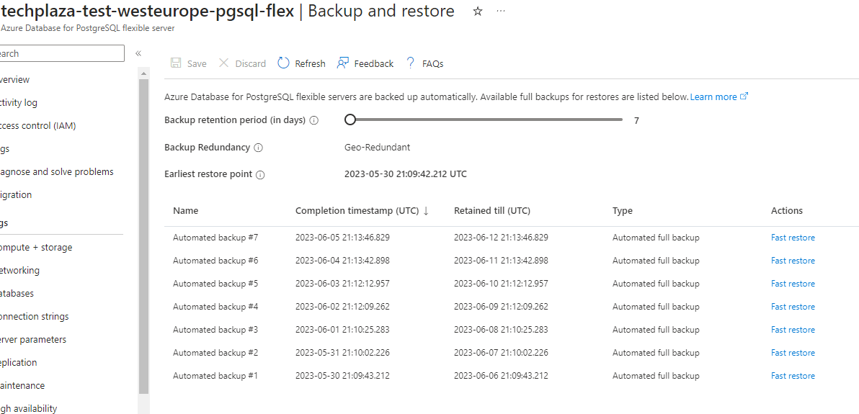

**CI/CD and Version Control**

Techplaza adheres to a Trunk-based development workflow, which is a widely-accepted software development methodology that advocates for continuous integration of changes into a single, shared mainline, or 'trunk'. This methodology promotes a collaborative and efficient development environment and helps prevent the problems that can arise when working on long-lived feature branches.

The Continuous Integration/Continuous Deployment (CI/CD) pipelines for Techplaza are managed by GitHub Actions, a robust automation tool provided by GitHub. The use of GitHub Actions facilitates automated testing and deployment, promoting consistent and reliable releases while minimizing the potential for human error.

The Testing Pipeline gets triggered each time a merge is made into the main branch. This pipeline carries out the following steps:

Builds the Docker image of the application using the Dockerfile.

Pushes the built Docker image to the Azure Container Registry, which is a managed Docker registry service for storing and managing our private Docker container images.

Once the new image is in the registry, a webhook triggers an update of the image tag used by the Azure App Service for testing.

This process ensures that our testing environment is always up-to-date with the latest changes and allows us to catch and fix any potential issues before they reach the production stage.

The Production Pipeline, on the other hand, is only triggered when a commit is tagged on GitHub. This process involves:

Building the Docker image similar to the testing pipeline.

Pushing the Docker image to the Azure Container Registry.

However, unlike the testing pipeline, the production pipeline does not automatically update the tag of the image used by the Azure App Service. Instead, the tag update process is manual for the production environment. This approach adds an additional layer of control over the production deployments, ensuring they are deliberate and reducing the risk of unintentional disruptions.

In essence, this DevOps methodology provides a highly controlled yet flexible workflow. It allows us to continuously integrate and deploy changes to our testing environment, ensuring rapid feedback and swift error detection. Meanwhile, it also provides an added level of control over our production environment, ensuring stability and reliability for our users. This strategy reflects the primary goals of DevOps, bridging the gap between development and operations teams, and promoting efficiency, agility, and collaboration.

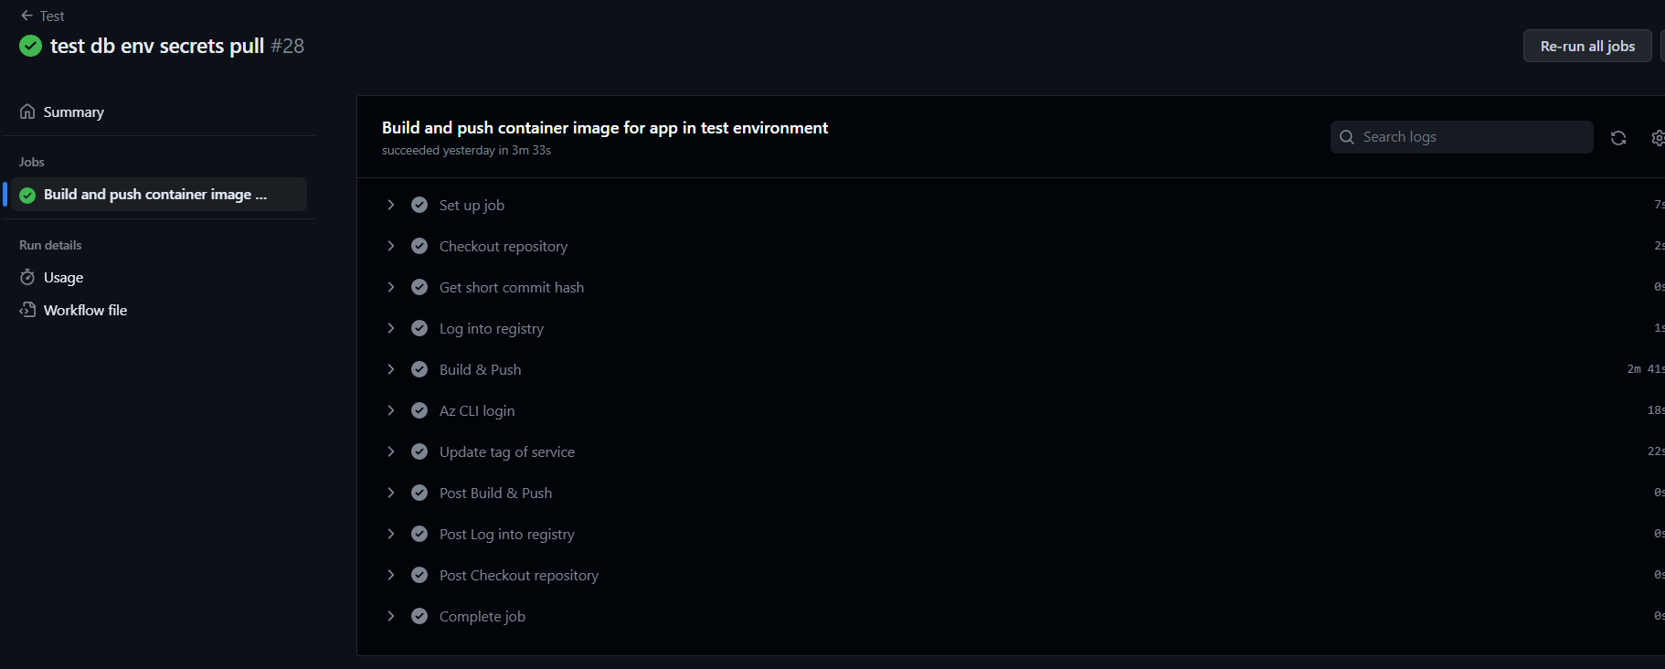

**Prod workflow**

This GitHub Actions workflow, named "Prod," is triggered whenever a new tag, which follows the semantic versioning convention ("v*.."), is pushed to the repository. The workflow consists of a single job, "build-prod", which is responsible for building and pushing the Docker image of the application for the production environment.

Here's a breakdown of each step:

**Checkout repository**: This step checks out the latest code from your GitHub repository using the actions/checkout@v2 action.

**Get tag**: The dawidd6/action-get-tag@v1 action is used to extract the version tag from the commit. This tag is used later to tag the Docker image.

**Log into registry**: The docker/login-action@v1 action logs into your Azure Container Registry (ACR) using the credentials stored as secrets in your GitHub repository. ACR_ENDPOINT is the URL of your ACR, and ACR_USERNAME and ACR_PASSWORD are the username and password used to authenticate with ACR.

**Build & Push:** The docker/build-push-action@v2 action builds a Docker image using the Dockerfile in the ./app directory, and then pushes this image to your ACR. The version build argument is set to the tag extracted in the "Get tag" step, and this tag is also used to tag the Docker image in the ACR.

The output of this workflow is a Docker image that is built and tagged with the version number of your application and then pushed to your Azure Container Registry. This image is ready to be pulled and deployed to your production environment when required. The decision to manually deploy to production (as opposed to automatically deploying upon a successful build) is a deliberate choice to ensure that production deployments are done at the right time and are not unintentionally disruptive.

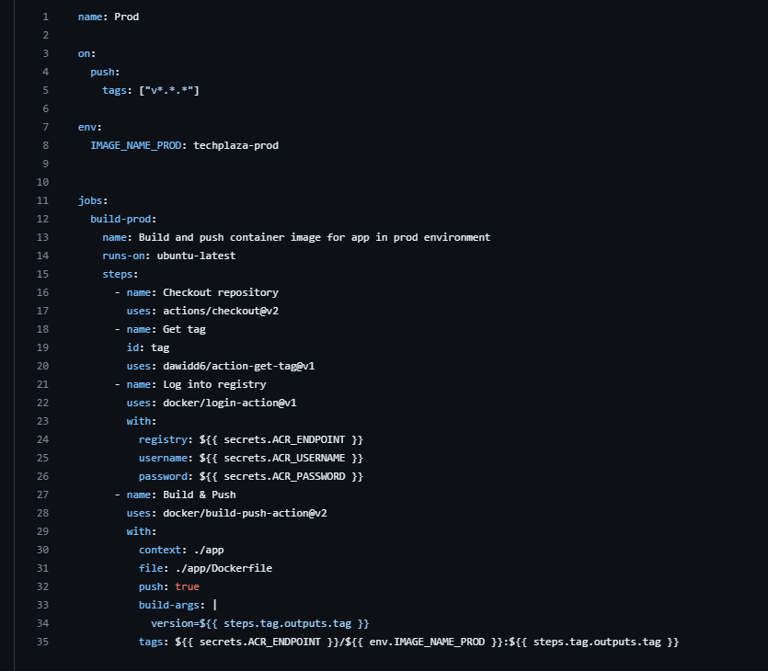

**Test workflow**

This GitHub Actions workflow, named "Test," is triggered whenever a push event occurs on the 'main' branch. The workflow is designed to build and push the Docker image of the application for the test environment and update the Azure Web App Service with the latest image.

Here's an explanation of each step in the workflow:

**Checkout repository**: This step checks out the latest code from your GitHub repository using the actions/checkout@v2 action.

**Get short commit hash**: The vars step uses a shell command to retrieve the short commit hash of the latest commit. This commit hash is stored as an output variable named sha_short for later use.

**Log into registry**: The docker/login-action@v1 action logs into your Azure Container Registry (ACR) using the credentials stored as secrets in your GitHub repository. The ACR_ENDPOINT is the URL of your ACR, and ACR_USERNAME and ACR_PASSWORD are the authentication credentials.

**Build & Push**: The docker/build-push-action@v2 action builds the Docker image using the Dockerfile in the ./app directory and then pushes the image to your ACR. The version build argument is set to the tag extracted in the "Get tag" step, and the image is tagged with the short commit hash as sha_short.

**Az CLI login**: The azure/login@v1 action logs into your Azure subscription using the Azure CLI. The necessary authentication credentials (AZURE_CLIENT_ID, AZURE_TENANT_ID, AZURE_SUBSCRIPTION_ID) are stored as secrets in your GitHub repository.

**Update tag of service**: This step uses the Azure CLI command az webapp config container set to update the tag of the Azure Web App Service in the test environment. It sets the Docker image for the specified Web App to the newly pushed image in the ACR, using the ACR credentials stored in secrets.

By executing this workflow, the application's Docker image is built and pushed to the Azure Container Registry. Then, the Azure Web App Service in the test environment is updated with the latest Docker image tagged with the short commit hash. This ensures that the test environment is continuously updated with the latest changes and allows for testing and verification of the application in an environment closely resembling the production setup.

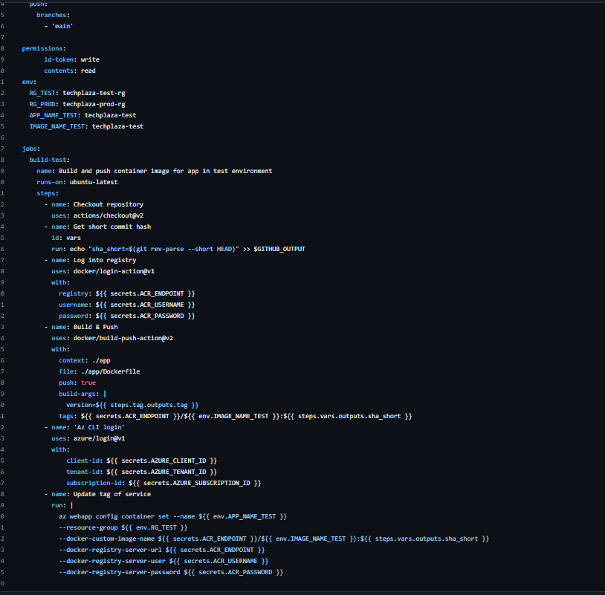

**Other workflow**

This GitHub Actions workflow, named "Other," is triggered whenever a push event occurs on any branch except for the 'main' branch. It serves as a dummy pipeline for a preliminary check before trunk commits are merged into the main branch through a pull request.

Here's an explanation of each step in the workflow:

**Checkout repository**: This step checks out the latest code from your GitHub repository using the actions/checkout@v2 action.

**Build dummy image**: The docker/build-push-action@v2 action is used to build a dummy Docker image for testing purposes. This step doesn't push the image to any container registry (push: false). Instead, it builds the image using the Dockerfile in the ./app directory and tags it as dummy:0. This dummy image can be used for preliminary checks and testing without affecting the main application image or deployment.

By using this workflow, you can have a separate pipeline dedicated to preliminary checks and tests for branches other than the main branch. This allows you to verify the changes made in feature branches or other development branches before merging them into the main branch through a pull request. It helps ensure that any potential issues or bugs are identified early on and can be addressed before merging the changes into the main branch, thus maintaining the stability and reliability of the application.

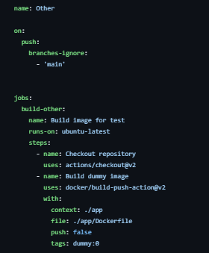

**Secrets Management with Azure Key Vault**

Techplaza utilizes Azure Key Vault for managing and securely storing application secrets and credentials. Azure Key Vault is a cloud service provided by Microsoft Azure that safeguards cryptographic keys, secrets, and certificates. It acts as a central repository for securely storing sensitive information, such as database connection strings, API keys, and other credentials, that are required by the application during runtime.

Here are the key aspects and benefits of using Azure Key Vault for secrets management:

**Centralized Management**: Azure Key Vault provides a centralized location for storing and managing secrets. This ensures that all sensitive information is stored in a secure and consistent manner, reducing the risk of accidental exposure or unauthorized access.

**Secure Storage**: Azure Key Vault employs industry-standard security practices to protect secrets at rest. Secrets stored in Key Vault are encrypted using hardware security modules (HSMs) and can only be decrypted by authorized applications and users with proper access controls. This helps ensure the confidentiality and integrity of the secrets.

**Access Control and Permissions**: Azure Key Vault allows fine-grained access control and permissions management. Access policies can be configured to grant specific permissions to different applications or users, ensuring that only authorized entities can access and manage secrets.

**Auditing and Monitoring**: Azure Key Vault provides detailed logging and auditing capabilities, allowing you to track access to secrets, monitor changes, and maintain an audit trail of operations performed on the vault. This helps meet compliance requirements and provides visibility into secrets management activities.

**Integration with Azure Services**: Azure Key Vault seamlessly integrates with other Azure services, such as Azure App Service, Azure Functions, and Azure Kubernetes Service (AKS), making it easy to securely retrieve and use secrets within these services without exposing them in configuration files or source code.

**Developer-friendly APIs and SDKs**: Azure Key Vault provides developer-friendly APIs and SDKs for accessing secrets programmatically. This allows applications to securely retrieve secrets during runtime, without the need to hardcode sensitive information in configuration files or source code. Integration with development frameworks and libraries, such as Azure SDKs and Azure Key Vault references, simplifies the process of retrieving secrets in a secure manner.

By leveraging Azure Key Vault, Techplaza ensures that sensitive information is securely stored, managed, and accessed by applications during runtime. This centralizes secrets management, enhances security, and simplifies the process of handling sensitive data, contributing to the overall robustness and protection of the application and its underlying infrastructure.

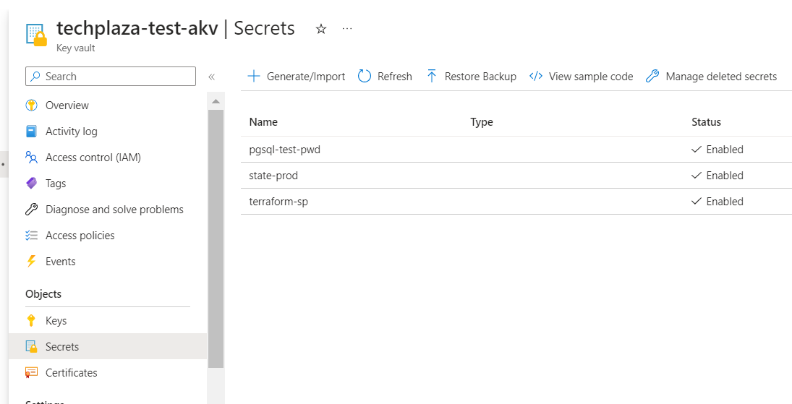

**Azure Container Registry for Storing Docker Images**

Azure Container Registry (ACR) is a fully managed container registry service provided by Microsoft Azure. It serves as a secure and private repository for storing and managing Docker container images. Techplaza leverages ACR to store Docker images in both the test and production environments. Here are the key benefits and features of using ACR:

**Secure and Private**: Azure Container Registry provides a secure and private environment to store Docker images. Images stored in ACR are accessible only to authorized users and can be secured using role-based access control (RBAC) and Azure Active Directory integration. This ensures that only trusted entities can access and deploy container images.

**Efficient Image Management**: ACR supports versioning, allowing multiple versions of Docker images to be stored and managed. This enables easy rollbacks, reverting to previous versions if necessary. Additionally, ACR provides features such as image replication and geo-replication, allowing images to be replicated across multiple regions for improved availability and faster image pull times.

**Integration with Azure Services**: ACR seamlessly integrates with other Azure services, such as Azure App Service, Azure Kubernetes Service (AKS), and Azure Functions. This integration enables straightforward deployment and scaling of applications using the stored Docker images. ACR provides built-in integration with Azure DevOps for streamlined CI/CD pipelines.

**Geo-Replication**: ACR offers geo-replication capabilities, allowing images to be replicated across multiple Azure regions. This ensures high availability and reduces latency for image retrieval, enabling faster deployment times in different regions.

**Image Scanning and Vulnerability Assessment**: ACR provides built-in image scanning and vulnerability assessment features. These features automatically scan Docker images for security vulnerabilities and known issues. This helps identify and mitigate potential risks before deploying the images into production environments.

**Registry Webhooks**: ACR supports webhook notifications, allowing integration with external services or custom workflows. Webhooks enable automation triggers based on specific events, such as image push or deletion, providing flexibility in implementing custom deployment or notification processes.

By utilizing Azure Container Registry, Techplaza ensures a secure and reliable solution for storing Docker images in the test and production repositories. ACR simplifies image management, integrates seamlessly with Azure services, and provides additional features like image scanning and replication to enhance the deployment and scalability of containerized applications.

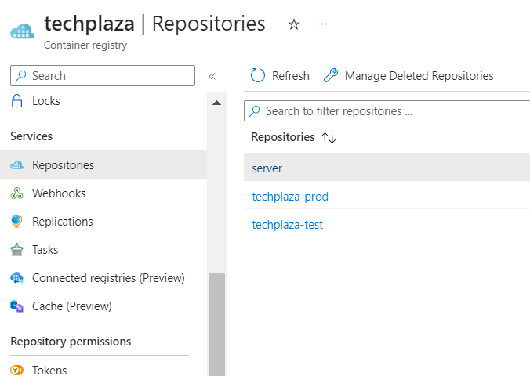

**Azure Storage Solutions for File, Image, and Log Storage**

Techplaza employs various Azure storage solutions to meet the file, image, and log storage needs of the application. Let's delve into each of these Azure storage services and their specific benefits:

**Azure Files**: Azure Files is a fully managed file share service that allows the application to store and access files in the cloud using the standard Server Message Block (SMB) protocol. It provides a scalable and highly available file storage solution that can be accessed from both cloud and on-premises environments. Azure Files is ideal for scenarios where shared file access is required, such as storing user-generated content, configuration files, or static assets.

**Storage Queue**: Azure Storage Queue is a message queuing service that enables reliable and asynchronous communication between application components. It allows for the decoupling of different parts of the application by sending messages between them. The queue guarantees at-least-once delivery, ensuring that messages are processed reliably. This makes Storage Queue suitable for managing tasks, background processing, and handling asynchronous operations.

**Blob Storage**: Azure Blob Storage is a massively scalable object storage service designed to store and serve large amounts of unstructured data. It is suitable for storing files, images, and any type of data that can be represented as a binary stream. Blob Storage offers different storage tiers, including Hot, Cool, and Archive, which allow for cost optimization based on data access frequency and retention requirements. This flexibility makes Blob Storage an excellent choice for storing media files, images, backups, and logs.

**Append Blob**: Append Blob is a specialized type of Blob Storage that allows for efficient appending of data to an existing blob. It is specifically designed for scenarios where data is continuously appended, such as logging or recording streaming data. Append Blob ensures that data is appended atomically and sequentially, making it suitable for scenarios where data integrity and sequential access are critical.

By utilizing these Azure storage solutions, Techplaza benefits from a scalable, secure, and cost-effective approach to storing files, images, and logs. Each service is designed to address specific storage requirements, providing the flexibility needed to handle various types of data within the application. Whether it's user-generated files, asynchronous messaging, unstructured data, or continuous appending of logs, Azure storage solutions offer the reliability and scalability necessary to support Techplaza's storage needs.

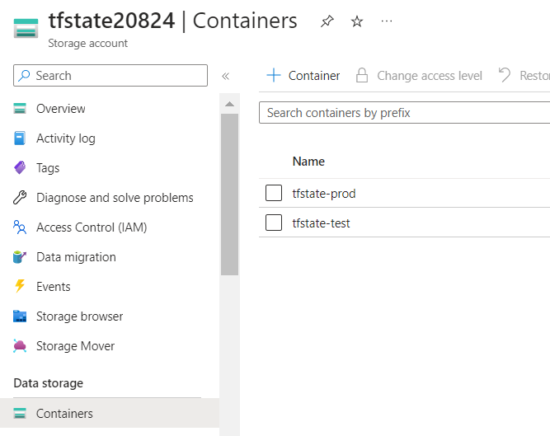

**Storing the Database Dump in Blog Storage**

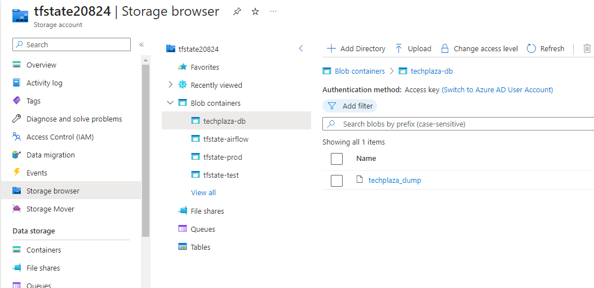

Microsoft Azure Blob Storage provides four access tiers: Hot, Cool, Cold, and Archive, each designed to support different usage scenarios based on the frequency of access, storage cost, and access cost:

**Hot tier**: This tier is optimized for data that is accessed or modified frequently. It has the highest storage costs but the lowest access costs. It's ideal for data in active use​​.

**Cool tier**: This tier is designed for data that is infrequently accessed or modified. It has lower storage costs and higher access costs compared to the Hot tier. Data stored in the Cool tier should ideally be kept for a minimum of 30 days. It's suitable for short-term data backup and disaster recovery, older data sets that are seldom used but expected to be immediately accessible, and large data sets that need to be stored cost-effectively while other data is being collected for processing​​.

**Cold tier**: Similar to the Cool tier, the Cold tier is for infrequently accessed or modified data, but with even lower storage costs and higher access costs. The data should be stored in this tier for a minimum of 90 days​​.

**Archive tier**: This tier is an offline storage option for data that is rarely accessed and has flexible latency requirements. It has the lowest storage cost but higher data retrieval costs and latency. Data stored in the Archive tier should be kept for a minimum of 180 days. It's suitable for long-term backup, secondary backup, archival datasets, original data that must be preserved even after processing, and compliance data that is hardly ever accessed. While a blob is in the Archive tier, it can't be read or modified; to do so, it must be rehydrated to an online tier (Hot, Cool, or Cold), which can take up to 15 hours depending on the priority specified for the rehydration operation​​.

For our PostgreSQL Database Dump, storing it in the Archive tier was analyzed to be the better choice from a cost perspective since:

* The database dump is infrequently accessed or not accessed at all. As the Archive tier has the lowest storage cost, it is cost-effective for storing data that isn't regularly accessed.
* We are okay with the higher latency for accessing the data. If the data in the dump is needed, it must be rehydrated to an online tier, which can take up to 15 hours, something time-consuming but not a big problem in the context of db size for the moment.
* The dump is stored for long-term purposes. The Archive tier is ideal for long-term storage (at least 180 days), and it's subject to an early deletion charge if the data is deleted or moved to another tier before the minimum storage period​​.

However, the drawback to this option is that the Archive tier doesn't support immediate read or write operations, and it isn't supported for advanced redundancy configurations.

**Infrastructure as Code (IaC) with Terraform**

Techplaza embraces Infrastructure as Code (IaC) principles, with Terraform being the chosen tool for managing and provisioning Azure resources. Terraform is an open-source infrastructure automation tool that enables declarative and version-controlled provisioning of infrastructure resources. It allows infrastructure configurations to be defined as code, providing a reliable and reproducible approach to managing infrastructure.

Here's how Techplaza utilizes Terraform in its application architecture:

**Terraform Modules**: Techplaza utilizes Terraform modules to define reusable and modular infrastructure components. Modules encapsulate a set of related resources and configurations, allowing for consistent provisioning across environments. This modular approach simplifies infrastructure management, promotes code reusability, and enhances maintainability.

**Azure Resource Provisioning**: With Terraform, Techplaza can provision and manage a wide range of Azure resources, including virtual machines, Azure App Services, Azure Container Registry, Azure Storage Accounts, and more. Terraform's extensive provider ecosystem provides access to the full spectrum of Azure services, allowing Techplaza to create a comprehensive infrastructure tailored to its needs.

**Declarative Configuration**: Terraform allows Techplaza to define infrastructure configurations declaratively using HashiCorp Configuration Language (HCL). This enables the team to express the desired state of the infrastructure and let Terraform handle the details of provisioning, modification, and destruction of resources. The declarative approach ensures that the infrastructure configuration is version-controlled and auditable, enhancing collaboration and repeatability.

**Terraform State Management**: Terraform state is a crucial component that keeps track of the current state of the infrastructure managed by Terraform. It records the relationships between resources, their configurations, and any dependencies. Techplaza utilizes an Azure Storage Account to store the Terraform state file, which serves as a reliable source of truth for the infrastructure. The remote state allows for collaboration, sharing of infrastructure information, and accurate tracking of changes over time.

By adopting Terraform and Infrastructure as Code practices, Techplaza benefits from the following advantages:

**Consistency and Reproducibility**: Infrastructure configurations defined as code ensure that the infrastructure is consistently provisioned across environments. It allows for easy replication and reusability of infrastructure components, facilitating reproducibility and reducing the risk of configuration drift.

**Scalability and Flexibility**: Terraform enables Techplaza to scale its infrastructure up or down effortlessly. It provides the flexibility to add or remove resources as needed, accommodating increasing workloads or adjusting the infrastructure based on business requirements.

**Security and Compliance**: Infrastructure as Code enhances security and compliance practices by incorporating security controls into the infrastructure configurations. Configuration files can be reviewed, audited, and subjected to security checks, ensuring that best practices are followed from the start.

**Efficiency and Collaboration**: Terraform's code-based approach allows for efficient collaboration among team members. Infrastructure configurations can be version-controlled, enabling easier collaboration, code reviews, and change management processes. It also fosters a culture of collaboration and knowledge sharing within the team.

In summary, Techplaza's adoption of Terraform and Infrastructure as Code principles provides a robust, scalable, and secure infrastructure. By defining infrastructure configurations as code and managing them with Terraform, Techplaza can effectively manage its Azure resources, maintain infrastructure consistency, and easily scale its infrastructure to meet the needs of its e-commerce web app.

**Terraform Modules explanations**

**azurerm_app_service:**

This resource represents an Azure App Service, which is a platform-as-a-service (PaaS) offering that hosts web applications, RESTful APIs, and mobile backends. It creates an App Service with the specified name, location, and resource_group_name. The app_service_plan_id specifies the ID of the Azure App Service Plan to which this App Service belongs. Inside the site_config block, configuration settings for the App Service are defined, such as the linux_fx_version (the runtime stack or framework used), always_on (determines if the App Service is always running), and use_32_bit_worker_process (specifies whether to use a 32-bit worker process).

The lifecycle block ensures that changes to the linux_fx_version property are ignored during updates.

**azurerm_app_service_plan:**

This resource represents the Azure App Service Plan, which defines the compute resources and pricing tier for the App Service. It creates an App Service Plan with the specified name, location, and resource_group_name.

The kind property specifies that it is a Linux-based App Service Plan, and reserved indicates that it is a dedicated plan. The sku block defines the pricing tier and size of the plan. data "azurerm_client_config": This data source retrieves the current Azure client configuration, which includes authentication and authorization information, such as the tenant_id.

**azurerm_key_vault:**

This resource represents an Azure Key Vault, which securely stores secrets, certificates, and keys.

It creates a Key Vault with the specified name, location, and resource_group_name.

The enabled_for_disk_encryption property indicates whether the Key Vault is enabled for disk encryption. The tenant_id is obtained from the data "azurerm_client_config" block. The network_acls block defines the network access control settings for the Key Vault, including the default action and bypass options. The tags block defines metadata tags for the Key Vault, such as the environment, product, and if it is Terraform-managed. The lifecycle block ensures that changes to the access_policy and network_acls properties are ignored during updates.

**azurerm_postgresql_flexible_server:**

This resource represents an Azure PostgreSQL Flexible Server, which is a fully managed and scalable PostgreSQL database service. It creates a PostgreSQL Flexible Server with the specified name, resource_group_name, location, and other configuration settings. The version and sku_name specify the version and SKU of the PostgreSQL server. The administrator_login and administrator_password are used to set the login credentials for the PostgreSQL server.

The backup_retention_days defines the number of days to retain backups. The geo_redundant_backup_enabled enables geo-redundant backups for the server. The tags block defines metadata tags for the PostgreSQL server, such as the environment, product, and if it is Terraform-managed. The authentication block specifies the authentication settings, including the ability to enable Active Directory authentication and password authentication. The lifecycle block ensures that changes to certain properties, such as zone, administrator_password, and high_availability, are ignored during updates.

These Terraform resources collectively define and provision the necessary Azure resources for Techplaza, including the App Service, App Service Plan, Key Vault, and PostgreSQL Flexible Server. Each resource has specific properties and settings that are configured to meet the requirements of the application and infrastructure.

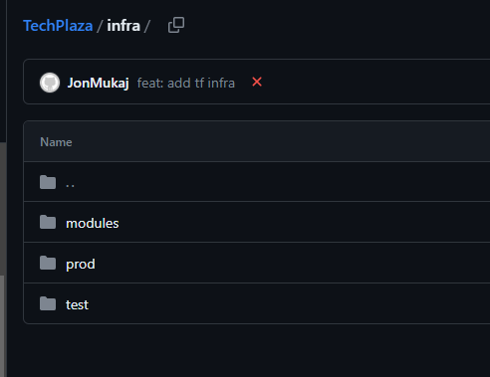

**Future Considerations**

**Microservices Architecture**

Adopting a microservices architecture entails decomposing the Techplaza application into smaller, loosely coupled services that can be developed, deployed, and scaled independently. Some key benefits of a microservices architecture include:

**Flexibility**: Microservices offer flexibility in technology choices, allowing different services to be developed using different programming languages, frameworks, or data storage solutions, based on their specific requirements.

**Scalability**: With microservices, individual services can be scaled independently based on demand. This means that resources can be allocated specifically to the services experiencing high traffic or workload, resulting in efficient resource utilization and better performance.

**Maintainability**: Smaller, isolated services are easier to understand, develop, and maintain. Changes or updates can be made to a specific service without impacting the entire application, making it easier to iterate, deploy new features, and fix issues.

**Fault Isolation**: In a microservices architecture, if one service fails or experiences issues, it does not impact the entire application. Faults can be isolated and contained, ensuring that other services continue to function properly, increasing the overall resilience of the application.

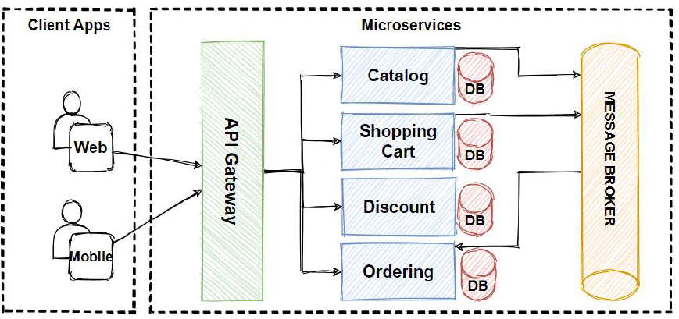

**Azure Kubernetes Service (AKS)**

Azure Kubernetes Service provides a managed platform for deploying, managing, and scaling containerized applications using Kubernetes. Key considerations for leveraging AKS in Techplaza's architecture include:

**Container Orchestration**: AKS uses Kubernetes as the underlying container orchestration system, which automates the deployment, scaling, and management of containerized workloads. Kubernetes ensures that containers are running in a desired state, handles load balancing, self-healing, and scaling of services, and facilitates seamless rollouts and rollbacks.

**Scalability and Availability**: AKS simplifies horizontal scaling by allowing multiple instances of microservices to run across a cluster of nodes. It enables Techplaza to scale resources efficiently based on demand, ensuring that the application can handle increased traffic or workload. AKS also provides built-in features for high availability, enabling the application to maintain resilience and availability even during failures or disruptions.

**Monitoring and Management**: AKS integrates with Azure Monitor, providing comprehensive monitoring capabilities for the microservices. Metrics, logs, and performance insights can be collected, analyzed, and visualized, enabling Techplaza to proactively monitor the health and performance of the application. AKS also integrates with Azure DevOps for streamlined CI/CD pipelines, enabling automated deployments, continuous integration, and delivery.

**Horizontal Scaling**: Horizontal scaling, also known as scaling out, involves running multiple instances of each microservice across a cluster of nodes. This approach allows Techplaza to dynamically allocate resources to handle increased load or traffic. Horizontal scaling ensures that resources are efficiently utilized, providing better performance and responsiveness to users. Additionally, it enables Techplaza to distribute the workload across multiple instances, improving fault tolerance and reducing the impact of failures.

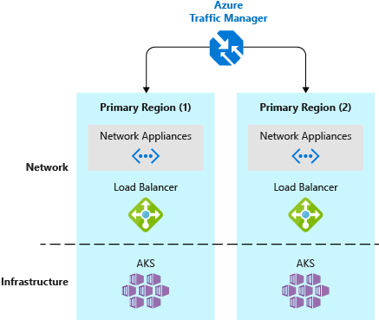

**Service Mesh**

A service mesh, such as Azure Service Fabric or Istio, can be implemented to enhance communication, observability, and resilience within the microservices architecture. Some key aspects of using a service mesh include:

**Traffic Management**: Service meshes provide advanced traffic management capabilities, such as intelligent routing, load balancing, and canary deployments. These features enable fine-grained control over service-to-service communication and allow Techplaza to implement sophisticated deployment strategies and gradually roll out new features or changes.

**Observability**: Service meshes provide built-in monitoring and observability features, including distributed tracing, metrics collection, and logging. These capabilities allow Techplaza to gain insights into the behavior of microservices, identify performance bottlenecks, and troubleshoot issues efficiently.

**Resilience and Circuit Breaking**: Service meshes facilitate the implementation of circuit-breaking patterns and resilience mechanisms. They can automatically handle service failures, retries, timeouts, and timeouts to ensure that the application remains responsive and resilient in the face of failures or degraded services.

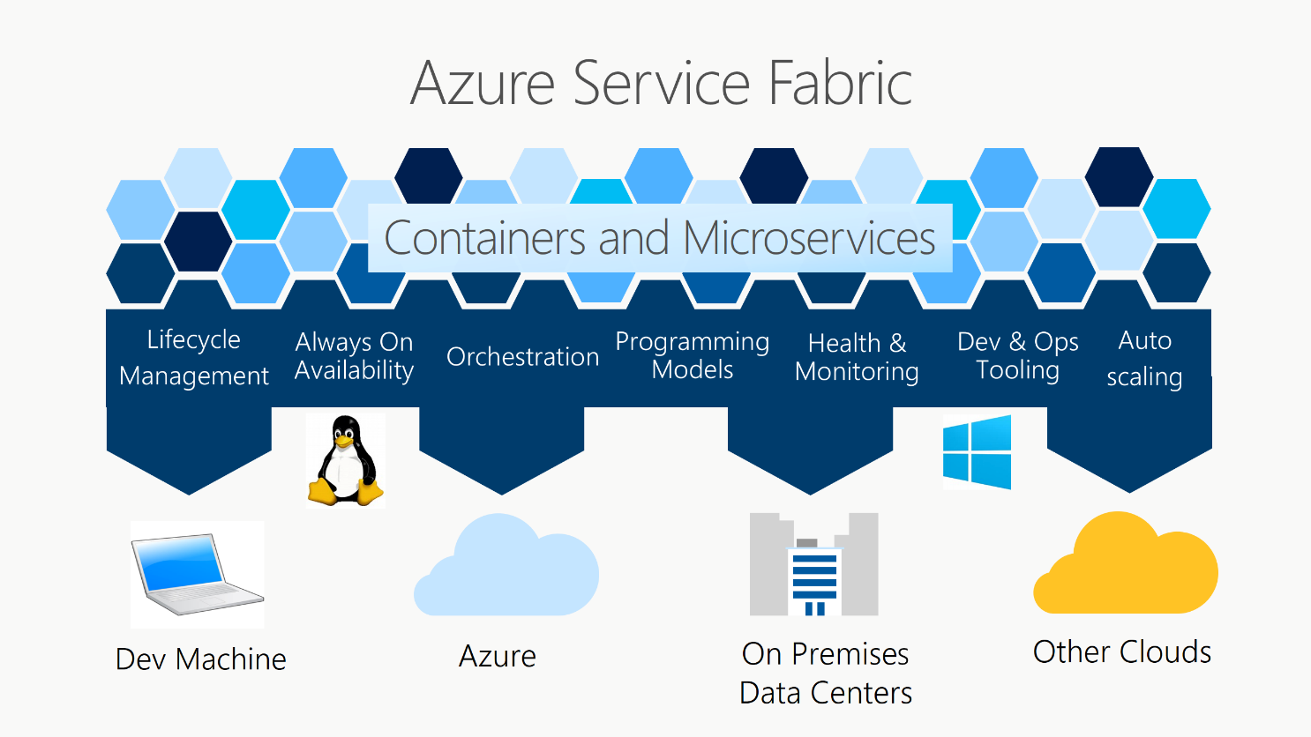

**Azure Application Gateway**

Azure Application Gateway can serve as a load balancer and provide secure and efficient traffic routing to the microservices running in AKS. It enables features like SSL termination, URL-based routing, and cookie-based session affinity.

By considering these future considerations, Techplaza can lay the foundation for a scalable, resilient, and feature-rich application architecture. The adoption of a microservices architecture and Azure Kubernetes Service can ensure that Techplaza can efficiently handle increasing workloads, accommodate additional features, and maintain high availability and responsiveness for its users.

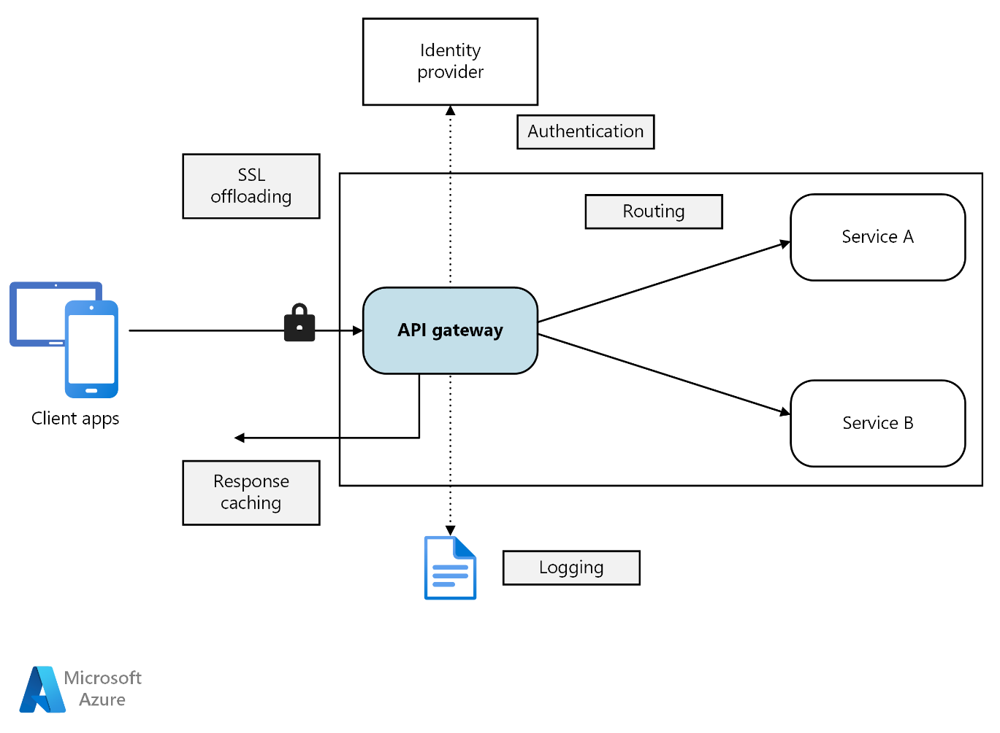

**Project management**

At TechSystems, we leverage JIRA, a comprehensive project management tool from Atlassian, to streamline our software development process. This tool becomes our companion from conceptualization to the completion of our e-commerce web app, ensuring our team stays coordinated and efficient. Let's see how we use JIRA's features in our context:

Kanban for sprints: We run sprints, each of which involves a specified amount of work to be completed within a given timeframe. We use JIRA's Kanban boards to visually manage these sprints. For instance, if we're working on the product page for our TechPlaza app, we'll create tasks for each component, like the product description view, pricing information, review section, etc. We keep track of our progress by moving these tasks across different stages on our Kanban board. This board becomes our real-time project status snapshot, helping us spot bottlenecks and manage our workload effectively.

Scrum boards: In addition to the Kanban boards, we also utilize JIRA's Scrum boards, particularly when our work is structured around sprints. With Scrum boards, we create, estimate, and prioritize user stories that compose the functionality of our TechPlaza app. Following the planning phase, we commit to a sprint and work diligently to complete these user stories.

Backlog management: JIRA is our go-to tool for managing our backlog, where we list out and prioritize tasks like adding new features, fixing bugs, or improving existing system components. This helps us ensure that we're always tackling the tasks that add the most value to our TechPlaza web app first.

Dashboards and reporting: One of the powerful features we appreciate in JIRA is its robust reporting capabilities. It helps us monitor our sprint progress, release status, and team performance. This provides us insights that we use to keep our project on track and make necessary adjustments along the way.

Integrations: To simplify our work, we integrate JIRA with other tools we use at TechPlaza. For example, we connect it with Bitbucket for code repository, Confluence for documentation, and Slack for communication. This enables us to manage our entire project from one place, ensuring that our team is always updated on all project aspects.

By leveraging JIRA and methodologies like Kanban or Scrum, we ensure better communication, transparency, and efficiency in our team. This is particularly important for a complex project like TechPlaza, where various features often interdependent need to be developed and delivered in a coordinated manner.

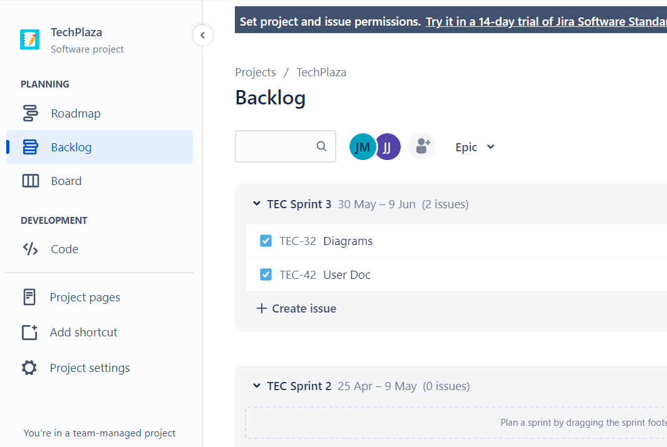

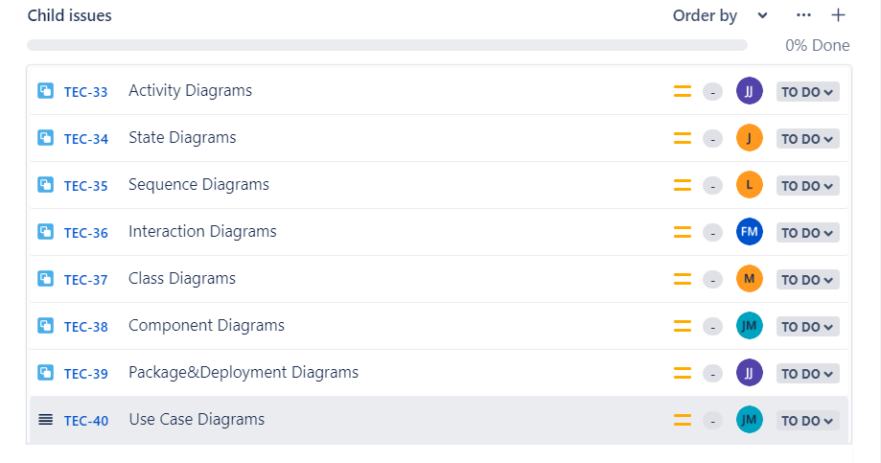

**Project Documentation**

At our organization, we understand the importance of comprehensive and accessible documentation. It not only supports our current work but also ensures that knowledge is preserved and easily transferred for future reference or for new team members. That's why we use JIRA Confluence and Google Docs as key tools for our software documentation.

**JIRA Confluence**: Confluence is an Atlassian tool like JIRA, and they integrate seamlessly together. It's a powerful platform for creating, organizing, and discussing work across our team.We utilize Confluence for various aspects of our documentation, including creating and managing technical specs, project plans, meeting notes, and product requirements. This allows us to link documentation directly to related tasks, epics, or sprints in JIRA, ensuring that the right information is available in the right context.

For instance, when working on a new feature for our TechPlaza web app, we can document the technical design on a Confluence page, link it to the corresponding JIRA task, and share it with the entire team for feedback and collaboration. The page history feature in Confluence is also incredibly useful as it allows us to track changes and updates made to the documents over time.

**Google Docs**: While Confluence is excellent for structured documentation linked to our project management, we also utilize Google Docs to enhance our team's collaborative efforts. Google Docs allows real-time collaboration, which means multiple team members can work on the same document simultaneously. This capability is especially useful when we're drafting initial ideas, brainstorming, or creating working documents that require input from several team members at the same time.

For example, while crafting user stories or drafting initial wireframes for a new feature, we might create a shared Google Doc. This way, all relevant team members can contribute their thoughts and ideas in real time, improving the speed and quality of our decision-making process.

The commenting and suggesting features in Google Docs also come in handy when we need to review or give feedback on a document. The real-time nature of Google Docs means that revisions are immediate, and discussions can happen right in the context of the work.

In conclusion, by combining the structured, project-linked documentation capabilities of JIRA Confluence with the real-time, collaborative nature of Google Docs, we ensure that our software documentation at TechPlaza is thorough, accessible, and enables efficient team collaboration. This ultimately supports the successful development and delivery of our e-commerce web app.

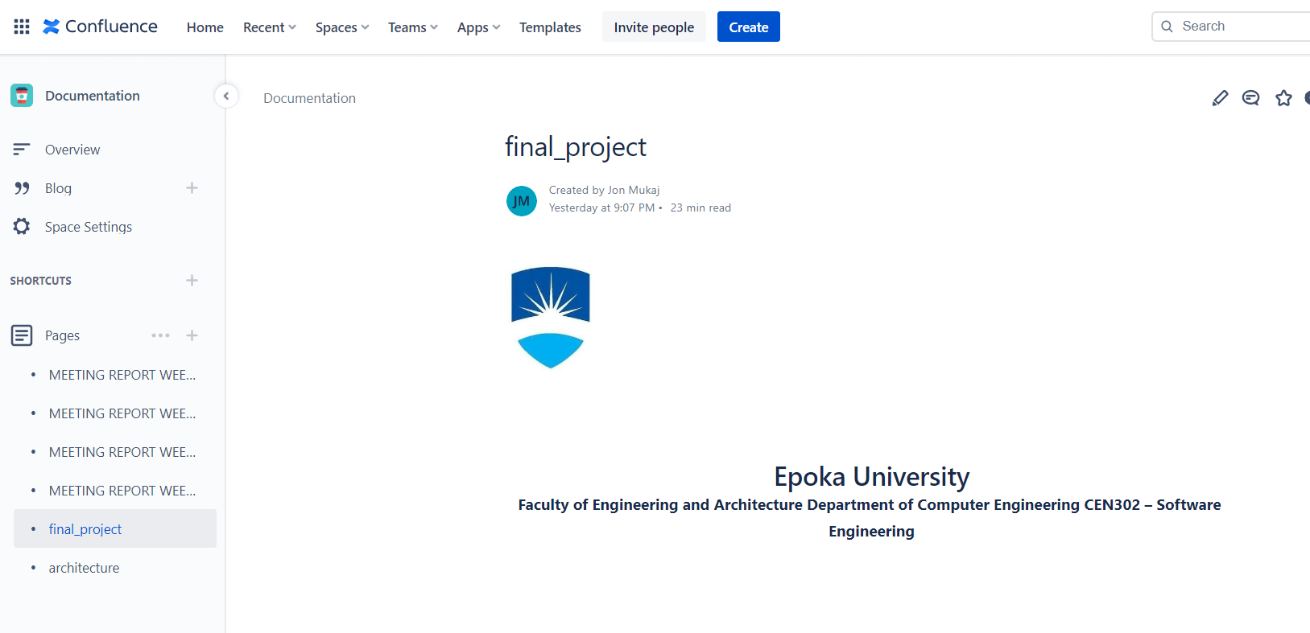

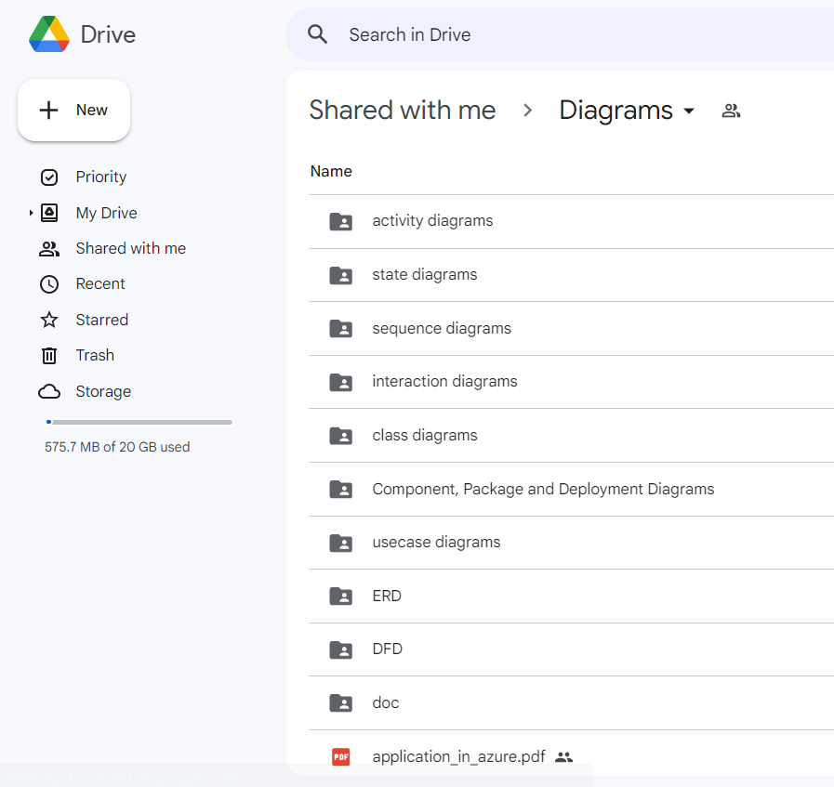

**Testing our software**

When developing TechPlaza, we must ensure robust testing to maintain the quality and reliability of our platform. We adopt a well-rounded approach to testing, incorporating functional testing, usability testing, load testing, and security testing, with each bringing a unique perspective and contributing to the app's overall robustness. Here's how we accomplish each using tools well-suited to our tech stack:

**Functional Testing**

Functional testing verifies the operational aspect of TechPlaza, ensuring that every feature behaves as expected. Given that our frontend is built with React, we make use of Jest, a JavaScript testing framework, in combination with Enzyme or React Testing Library, which provide utilities for testing React components. For instance, in our product page, we can write tests to ensure the display of correct product details, the functionality of the "Add to Cart" button, and successful addition of items to the cart.

On the server side, which is powered by Express.js, we can utilize tools like Mocha or Jest along with a library like Supertest for performing HTTP assertions. This helps us verify our API endpoints and middleware functions, ensuring the backend operations, such as user authentication and payment processing, function smoothly.

**Usability Testing**

Usability testing focuses on the user-friendliness of our web app, aiming to ensure an intuitive and pleasant user experience. This involves real users performing tasks on TechPlaza and providing feedback. A tool like Storybook can be a great help in this aspect for a React-based application like ours. Storybook allows us to develop and design UI components outside our app in an isolated environment, making it easier to gather early feedback on the usability of these components.

**Load Testing**

Load testing is vital for ensuring our web app can handle high traffic loads. Given the asynchronous, event-driven nature of Node.js (which powers Express.js), it's especially important to understand how our server behaves under heavy load. Tools like Artillery.io or K6 can be used to simulate thousands of concurrent users and evaluate the app's performance under these conditions. This helps us prepare our platform for peak traffic situations, ensuring consistent user experience even during high-demand periods.

**Security Testing**

In the realm of security testing, it's crucial to ensure our e-commerce platform is resilient against potential attacks and safe for users. Since we are working with JavaScript, a tool like OWASP ZAP can be beneficial. It allows us to automatically find security vulnerabilities in our web app. For Node.js specific security testing, npm packages like Helmet can help secure Express.js apps by setting various HTTP headers, reducing the attack surface area.

By adopting a broad range of testing methodologies and tools tailored to our tech stack, we ensure a high-quality, reliable, and user-friendly e-commerce platform. This comprehensive testing approach, aligned with our technology choices, supports the development and maintenance of a robust and successful application: TechPlaza.

**Demo Application (Alpha Release)**

